

What are the benefits of
Forest School sessions?

The aim of Forest School
is to enable children to
develop confidence and
self-esteem through hands-
on experiences. Children are ‘set up to achieve’ in every session, and their successes are celebrated. Learning about the natural world in this practical way benefits many learning styles, and can be made accessible for children of all ages. Research carried out on children that regularly attend Forest School sessions has highlighted many benefits including:

- Improved physical and motor skills
- Improved language and communication
- Improved social skills and cooperation
- Increased self-confidence
- Increased motivation + concentration

“The best classroom … is roofed only by the sky.”
(Margaret McMillan)
What do children do at
Forest School?

All Forest School sessions are structured, however
within this, children are encouraged to choose the activities they wish to
participate in and initiate some of their own. Learning takes place through a range of achievable activities, each of which is carefully tailored to suit the needs of the group. All sessions incorporate a selection of woodland experiences and team building games, which aim to consolidate and extend skills and knowledge learnt in previous sessions. Specific activities may include bug hunting, collecting, plant, bird, insect and animal identification, woodland crafts, games and much more.

“Forest School is not a survival course for children and they are not expected to ‘take something home’ at the end of a session, except, hopefully a love of the great outdoors, new skills and abundant self esteem.”
(Oswestry School 2010)
What is Forest School?

“Forest School is an inspirational process that offers children, young people and adults, regular opportunities to achieve, and develop confidence and self-esteem through hands on learning experiences in a local woodland environment.”
(Forest Education Initiative 2007)

The idea of Forest Schools originated in Scandinavia in the 1950’s as a way of teaching children and young people about the natural world. The concept spread to Denmark, and the first UK Forest School was set up at Bridgwater College, Somerset after a team from the early years department visited these settings.
Forest Schools are now widespread across the UK and aim to encourage and promote children’s physical, social and emotional development through positive outdoor experiences – all of which can be linked to both the National Curriculum and Early Years Foundation Stage Curriculum.

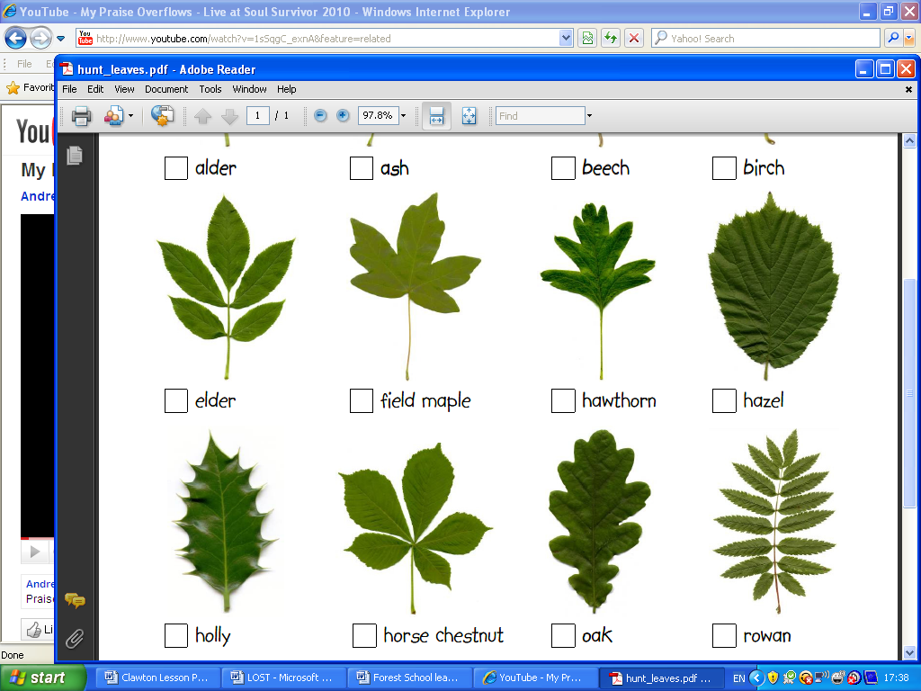
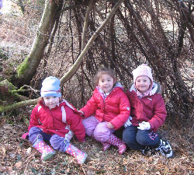

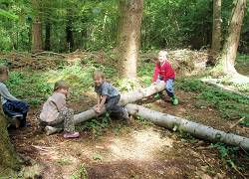

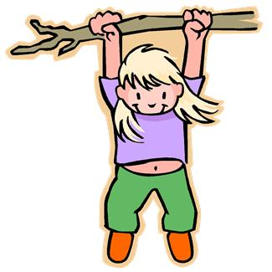
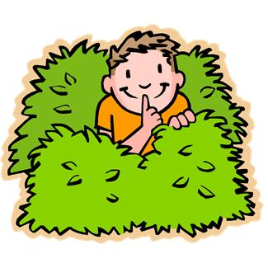
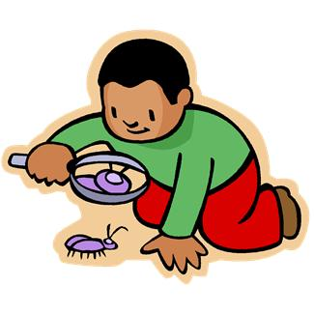


Forest School
Information Leaflet

Developing children’s confidence and self-esteem through achievable,
hands-on experiences.

Widewell Primary Academy

Who supervises the children?

Forest School sessions are planned and led by a level 3 Forest School leader (Mrs Toni Hambly). The class teacher and/or teaching assistant(s) will support the leader during each session. In addition, where activities require a higher adult to pupil ratio, parents/guardians or volunteers may also be asked to work with the group (however in all instances, adults will be required to obtain a DBS disclosure first).

Throughout all woodland experiences, the leader’s/teacher’s role is to facilitate learning and to observe and assess children’s progress and development.

At times throughout the academic year the Forest School leader and teachers will liaise to plan sessions that reflect current classroom topics and learning.

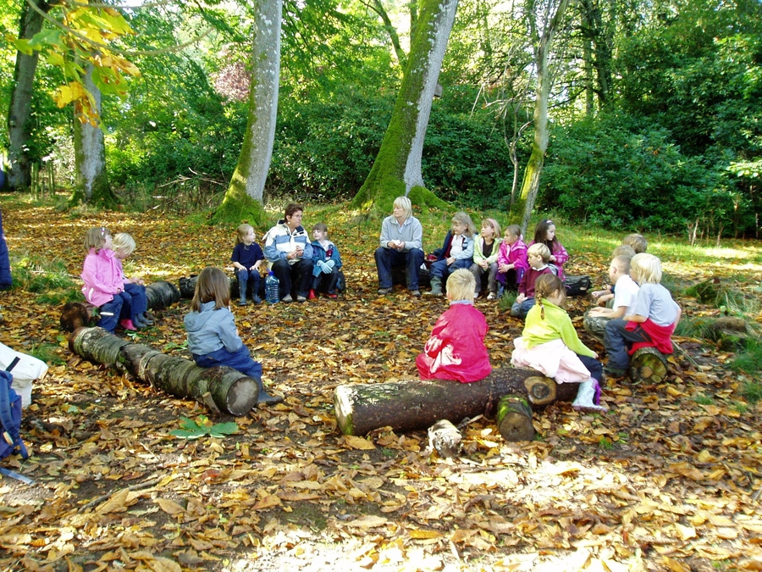

What do children need to wear?

“There is no such thing as bad weather, just bad clothing.”

Forest School sessions will take place regularly throughout all seasons, except when there are high
winds and storms. Therefore, it is essential that children have appropriate clothing for all weathers. If children are not suitably dressed they may not be able to attend the session.

The following list gives an indication of the clothing that children should bring with them to wear on Forest School days:
- A change of clothes that are warm and allowed to get muddy. This must include long trousers (not shorts) and a long-sleeved top, to protect limbs.
- A waterproof coat
- Waterproof trousers (or all-in-one suit) if you have them
- Wellies, sturdy boots or old trainers
- A wooly hat and gloves (winter)
- A sunhat and sun cream (summer)

NOTE: Please ensure all clothes are labeled.



