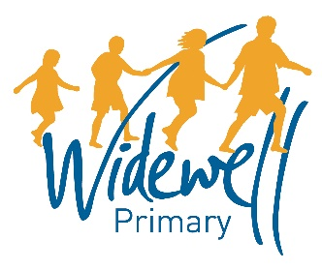

Headteacher’s Update 12.9.19
Dear Parents and Carers
You will notice that I am sending my update now direct via email, rather as part of the newsletter, as I am hoping you may all find this easier to read so you will know what’s going on at school throughout the year. As part of this term’s parents’ evenings, we offer you the chance to complete a parental questionnaire and I hope this will help to show that communication from the school improves. If you have any other ideas about how we can communicate better with you please let me know. If you have a Facebook or Twitter account, please find and ‘like’ the school’s pages so you can also be informed of all the great work that is going on around the school and celebrate it with us.
I have added the key dates for this term on the front of the newsletter and am hoping to have the school calendars ready by next week which will have all of the dates we currently know about for the whole year. We only ask for £1 to cover the cost of producing these so I hope you will find them useful.
If we do not yet have your email address please contact the school office as soon as possible and update us, as this is hopefully a more reliable way of communicating with you rather than finding letters at the bottom of a school bag at the end of term (I’m thinking of my own son here!).
I am really pleased to see that some off-site school visits are already taking place for more than half of the school already this term. These opportunities really help to inspire the children with their learning as well as giving them a memorable experience with their classmates. Thank you to any parents who have offered to support the staff with these trips, and of course to the staff for organising them.
One of the projects we will be working on this year is to produce a pack of things to do in the local area and the wider city. If you have any ideas of what you wish you’d known about the local area when you first moved here please send me a list so it can be included. It could be a fantastic walk you’ve discovered, a local place of interest, your favourite place to visit in the city or on the moors etc. I am going to set up a working group of children to help with this as they will also have their favourite things to do which they can pass on to other children. In my assembly on Monday one of the children has already asked that we don’t send the packs home in plastic wallets, as another school does, but we make something using recycled fabric instead – what a great idea! Watch out for a request for support for this in the future, especially if you have any sewing skills!
Thank you to parents who have approached the school offering help with the library and reading in particular. I am excited to see what we can do again together this year for the benefit of all your children.
Kind regards,
C. Prynne

