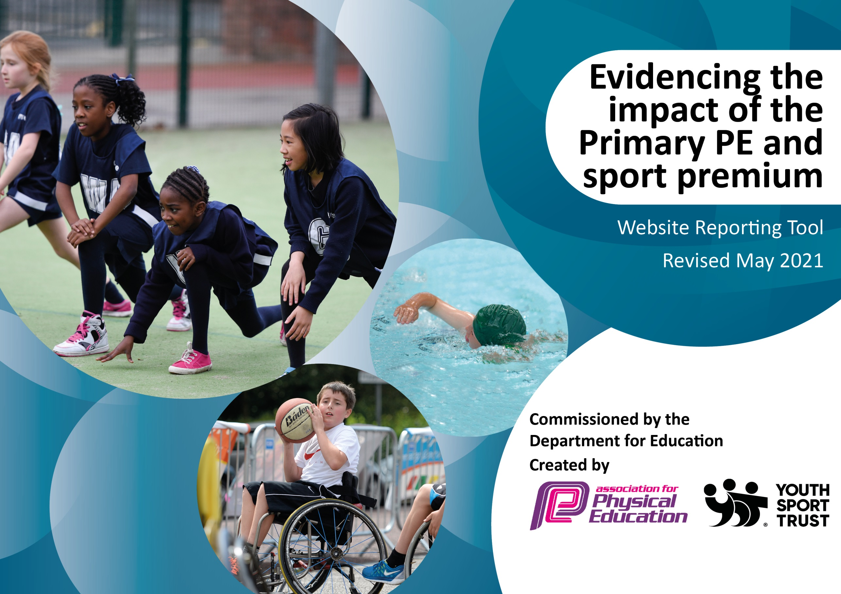

It is important that your grant is used effectively and based on school need. The Education Inspection Framework (Ofsted 2019 p64) makes clear there will be a focus on ‘whether leaders and those responsible for governors all understand their respective roles and perform these in a way that enhances the effectiveness of the school’.

Under the Quality of Education criteria (p41) inspectors consider the extent to which schools can articulate their curriculum (INTENT), construct their curriculum (IMPLEMENTATION) and demonstrate the outcomes which result (IMPACT).

To assist schools with common transferable language this template has been developed to utilise the same three headings which should make your plans easily transferable between working documents.

Schools must use the funding to make additional and sustainable improvements to the quality of Physical Education, School Sport and Physical Activity (PESSPA) they offer. This means that you should use the Primary PE and sport premium to:

- Develop or add to the PESSPA activities that your school already offer
- Build capacity and capability within the school to ensure that improvements made now will benefit pupils joining the school in future years
- The Primary PE and sport premium should not be used to fund capital spend projects; the school’s budget should fund these.
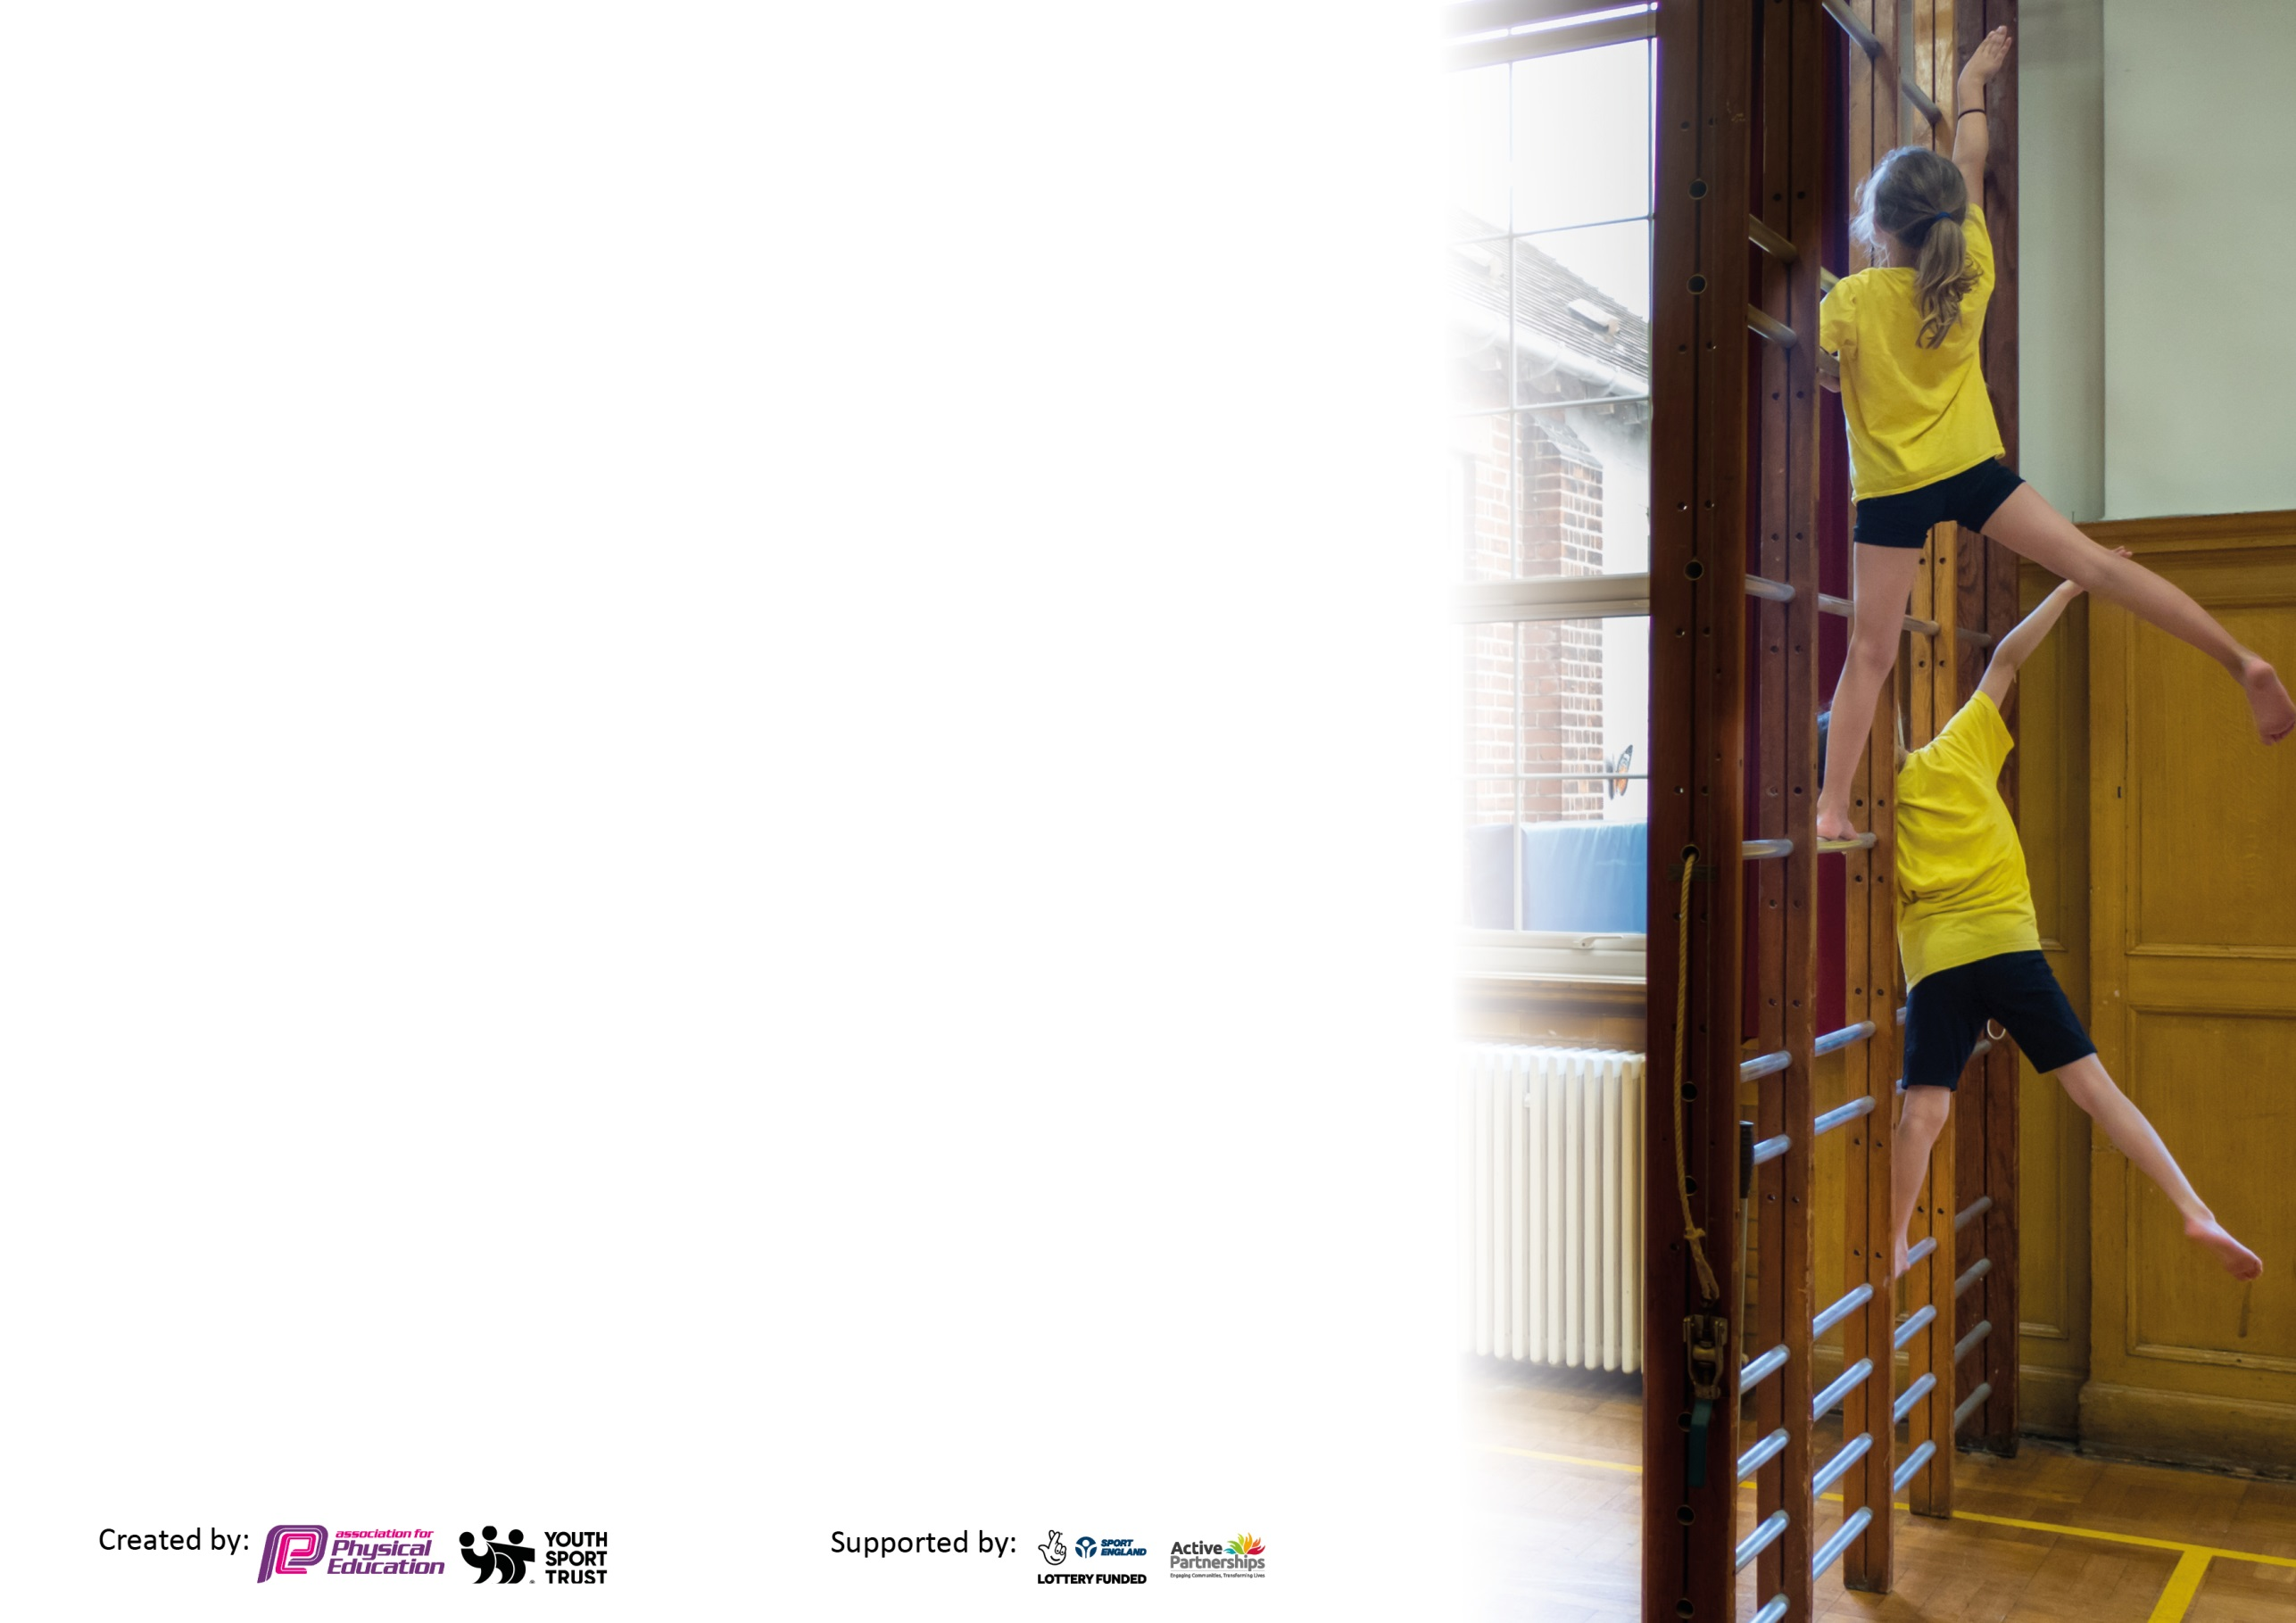
Please visit gov.uk for the revised DfE guidance including the 5 key indicators across which schools should demonstrate an improvement. This document will help you to review your provision and to report your spend. DfE encourages schools to use this template as an effective way of meeting the reporting requirements of the Primary PE and sport premium.

We recommend you start by reflecting on the impact of current provision and reviewing the previous spend.

Schools are required to publish details of how they spend this funding, including any under-spend from 2019/2020, as well as on the impact it has on pupils’ PE and sport participation and attainment by the end of the summer term or by 31st July 2021 at the latest.

We recommend regularly updating the table and publishing it on your website throughout the year. This evidences your ongoing self-evaluation of how you are using the funding to secure maximum, sustainable impact. Final copy must be posted on your website by the end of the academic year and no later than the 31st July 2021. To see an example of how to complete the table please click HERE.

Please note: Although there has been considerable disruption in 2020 it is important that you publish details on your website of how you spend the funding - this is a legal requirement.
Support for review and reflection - considering the 5 key indicators from DfE, what development needs are a priority for your setting and your pupils now and why? Use the space below to reflect on previous spend and key achievements and areas for development.

N.B. In this section you should refer to any adjustments you might have made due to Covid-19 and how these will influence further improvement.
Key achievements to date until July 2020: | Areas for further improvement and baseline evidence of need:
- Gold School Games Mark awarded for 2 consecutive years  - Increased numbers of children attending extra-curricular clubs through the employment of specialist coaches and diverse range of activities  - Increased numbers of children accessing competitive events  - Increased opportunities for less active children and children with SEND to attend events/competition  - Increased activity levels during lunch times through investment in equipment and structured play  - Staff confidence in the delivery of PE through ongoing CPD and inset  - Enhanced delivery of PE and skill development through investment in equipment and resources for PE lessons | - Continue to use the Activity Tracker to monitor activity levels to identify the least active population. Activity Tracker maintained throughout, children identified to take part in Level 1 competition and some Level 2 (Summer Term). Will continue this next year and identify the least active population for a C4L club.  - Continue to provide a broad range of extra-curricular clubs to engage as many children as possible – within bubbles only due to COVID restrictions. Plans in place for a full extra-curriucular offer next year.  - Continue to develop the C4L club to engage the least active population. Due to Covid 19, this did not take place this year as it would have meant mixing bubbles. Plans in place to establish this again next year.  - Continued affiliation to the PSSP to access competitive opportunities for all children, ongoing staff CPD and support from PE specialist teachers. We have continued to work with the PSSP all year and have accessed 1:1 CPD for teachers, as well as virtual competition, support for the PE Coordinator and Level 1 & 2 competitions.  - Investment in outdoor learning equipment to enhance our PE curriculum and provide additional opportunities to be active. This was initiated this year but will be further developed next year in order to provide more opportunities for activity throughout the school day.

Did you carry forward an underspend from 2019-20 academic year into the current academic year? NO
Total amount carried forward from 2019/2020 £......
+ Total amount for this academic year 2020/2021 £17,750
= Total to be spent by 31st July 2021 £17,750
Meeting national curriculum requirements for swimming and water safety.

N.B Complete this section to your best ability. For example you might have practised safe self-rescue techniques on dry land which you can transfer to the pool when school swimming restarts.
Due to exceptional circumstances priority should be given to ensuring that pupils can perform safe self-rescue even
if they do not fully meet the first two requirements of the NC programme of study.
What percentage of your current Year 6 cohort swim competently, confidently and proficiently over a distance of at least 25 metres?  N.B. Even though your pupils may swim in another year please report on their attainment on leaving primary school at the end of the summer term 2021.  Please see note above. | 76%
What percentage of your current Year 6 cohort use a range of strokes effectively [for example, front crawl, backstroke and breaststroke]?  Please see note above. | 61%
What percentage of your current Year 6 cohort perform safe self-rescue in different water-based situations? | 76%
Schools can choose to use the Primary PE and sport premium to provide additional provision for swimming but this must be for activity over and above the national curriculum requirements. Have you used it in this way? | Yes

Action Plan and Budget Tracking
Capture your intended annual spend against the 5 key indicators. Clarify the success criteria and evidence of impact that you intend to measure to evaluate for pupils today and for the future.

Academic Year: 2020/21 | Total fund allocated: £17,750 | Date Updated: September 2020  Review date: July 2021
Key indicator 1: The engagement of all pupils in regular physical activity – Chief Medical Officers guidelines recommend that primary school pupils undertake at least 30 minutes of physical activity a day in school |  |  |  | Percentage of total allocation:
 |  |  |  | 3.4%
Intent | Implementation |  | Impact
Your school focus should be clear what you want the pupils to know and be able to do and about  what they need to learn and to  consolidate through practice: | Make sure your actions to achieve are linked to your intentions: | Funding allocated: | Evidence of impact: what do pupils now know and what can they now do? What has changed? | Sustainability and suggested next steps:
All children able to swim a minimum of 25 meters before the end of Y6. | Provide top-up Swimming sessions for those children who did not reach the minimum requirement during their curriculum swimming block.  Y5 x 29 + Y6 x 28 children provided with swimming session 14.6.21 + 2 hrs extra for Y6 x 28. Key group of 10 supported by adult to increase water confidence & aim to swim 25m. | £600  hire Marjons swimming pool for 3 x 1hr Y6 sessions | Assessment data provided by the Life Centre will highlight any children who require further top-up sessions.  School was not allocated any swimming provision, due to backlog after COVID restrictions. Ran our own top-up sessions at local pool. | Using the assessment data to identify children requiring top-up sessions will provide more opportunities for all children to be successful.

Key indicator 2: The profile of PESSPA being raised across the school as a tool for whole school improvement |  |  |  | Percentage of total allocation:
 |  |  |  | 12.3%
Intent | Implementation |  | Impact
Your school focus should be clear what you want the pupils to know and be able to do and about  what they need to learn and to  consolidate through practice: | Make sure your actions to achieve are linked to your intentions: | Funding allocated: | Evidence of impact: what do pupils now know and what can they now do? What has changed? | Sustainability and suggested next steps:
All children engaged in PE lessons and provided increased opportunities to develop their skills/be active during break times. | Equipment audit to be undertaken during Autumn Term 2, when new PE Lead took up post, and resources ordered to ensure that lessons and clubs are well resourced. Investment in outdoor learning equipment.  8.1.21 £200  PE items needed to compete in Virtual Devon Games  14.5.21 £545 KS1&2 athletics/KS1 striking equipment + EY outdoor blocks  21.6.21 £1,543 EYFS + OAA  Repairing Trim Trail £3000 | £2,184.42 | PE Coordinator to work alongside the KS1 teacher to identify suitable equipment. Impact monitored through staff survey, student voice and observations.  PE Lead planned & resourced KS1 PE. Striking a ball & athletics throwing equipment ordered to develop provision during Term 5&6.  Following consultation with staff & talking to children, EYFS equipment for swinging, sliding, low level climbing & creative physical play ordered.  MUGA completed 14.5.21 & available for break times, in addition to curriculum slots, to provide more space + use of more equipment. Repairs to Trim Trail did not take place this year but plans in place to address this next year. | Investment in robust equipment will ensure that future classes are able to benefit. Developing the outdoor areas will encourage children to be more active, develop motor skills and impact healthy, active lifestyles.  Introducing Daily Mile initiative across KS1&2 from September 2021.  Monitoring impact of outdoor equipment

Key indicator 3: Increased confidence, knowledge and skills of all staff in teaching PE and sport |  |  |  | Percentage of total allocation:
 |  |  |  | 4.4%
Intent | Implementation |  | Impact
Your school focus should be clear | Make sure your actions to | Funding | Evidence of impact: what do | Sustainability and suggested
what you want the pupils to know | achieve are linked to your | allocated: | pupils now know and what | next steps:
and be able to do and about | intentions: |  | can they now do? What has
what they need to learn and to |  |  | changed?
consolidate through practice:
Engagement in a broad, balanced curriculum. Skill development through access to clubs and competition. Opportunities to develop leadership skills. | Write comprehensive development plans for PE. Monitor the planning and delivery of PE and provide CPD opportunities. Maintain all standards and collect evidence to complete a successful application for the Gold School Games Mark. Provide training and support for young leaders. Provide clubs, events and competitive opportunities for all children. | £781  Travel to OAA days & events | Review last years’ PE Development Plan in September and write new plan for this year. Review the Schools Games action plan from last year and write new one for this year.  Completed 09.09.2020.  Maintain the Activity Tracker to monitor attendance to clubs and events. Use student voice survey to review offered opportunities.  PE Student Survey Spring 2021 used to update Long Term PE  Planning – Benchball, Dodgeball, Handball, Archery, Ultimate Frisbee, Y6 Health Related Fitness, OAA Games & Challenges units added to curriculum + ‘On Wheels’ Days scheduled for each year group.  Travel to OAA days & events:-  90 children attended OAA days  38 children attended inter-school Athletics events to represent the school01 | Release time from class will ensure that we can continue to develop the PE curriculum, extra-curricular program and competition offer. Applying for the Gold School Games Award will ensure that we continue to positively impact activity levels, sports leaders and the engagement as many children as possible in healthy, active lifestyles.

Key indicator 4: Broader experience of a range of sports and activities offered to all pupils |  |  |  | Percentage of total allocation:
 |  |  |  | 53.5%
Intent | Implementation |  | Impact
Your school focus should be clear | Make sure your actions to | Funding | Evidence of impact: what do | Sustainability and suggested
what you want the pupils to know | achieve are linked to your | allocated: | pupils now know and what | next steps:
and be able to do and about | intentions: |  | can they now do? What has
what they need to learn and to |  |  | changed?
consolidate through practice:
Positively impact teaching and learning in PE. | Employ a PE Specialist Teacher through the PSSP to work alongside staff in PE lessons to provide high quality CPD. | £3,500 | Staff surveys used to understand staff confidence levels in delivering the PE curriculum. Staff to complete feedback forms following and CPD/Inset.  PSSP Teacher supported by providing competition at the end of Y3&4 netball blocks to develop staff confidence.  Level 1/2 competitions run by PSSP Teacher:  Boccia  Duathlon  New Age Kurling  KS2 Cross Country Event  Orienteering | Continued affiliation to the PSSP will ensure that we have access to a specialist teacher to run bespoke CPD for staff as well as whole staff inset. Increased knowledge and confidence of staff will impact teaching and learning for all children.
Positively impact teaching and learning in PE. | Employ Premier Sport to work alongside teachers in PE as CPD for all staff in a broad range of activity areas. | £5,792.52 | Staff surveys used to understand staff confidence levels in delivering the PE curriculum. Staff to complete feedback forms following any CPD/Inset.  PE Lead planned, resourced & supported class teachers to deliver quality PE from 7th March 2021, according to needs identified in Staff survey.  PE units provided for NR, CS, VW & TH in terms 4 and 5. Positive feedback from all & raised confidence levels to provide quality PE sessions (discussion & evaluated planning with PE lead).  INSET booked to introduce updated Long Term PE Curriculum & Progression of Skills in PE | Investing in staff is a priority as this is our most sustainable resource. Staff knowledge and confidence will benefit children in years to come.
Positively impact teaching and learning in PE. | PE Coordinator to research and source an outdoor learning scheme of work to support teachers.  New PE scheme of work embedded within restructured/bespoke curriculum, further work required next year with a specific focus on outdoor learning. | £195 Cambridge Primary PE Scheme | Staff surveys to be used following the implementation of the new scheme to monitor impact. Student voice surveys to be completed to review engagement and enjoyment.  Y5&6 children requested further opportunities to ride their bikes in school, following Bikeability & so this was planned in for their Outdoor Adventure Week 14th-18th June. | Investing in a new scheme of work will support teachers in the delivery and help to ensure they are more knowledgeable and confident in their delivery of high-quality PE.  PE Leader to do Forest Schools training & resource to enhance Outdoor Learning Provision.

Key indicator 5: Increased participation in competitive sport |  |  |  | Percentage of total allocation:
 |  |  |  | 0%
Intent | Implementation |  | Impact
Your school focus should be clear | Make sure your actions to | Funding | Evidence of impact: what do | Sustainability and suggested
what you want the pupils to know | achieve are linked to your | allocated: | pupils now know and what | next steps:
and be able to do and about | intentions: |  | can they now do? What has
what they need to learn and to |  |  | changed?
consolidate through practice:
Increased activity levels through engagement in extra-curricular clubs. Increased numbers of children involved in sports leadership. Playeladers training completed in Term 6 to deploy in September 2021. | Employ Premier Sport to provide extra-curricular clubs, including a C4L and support the sports leaders in leading activities.  Provision adapted within COVID restrictions.  Premier Sports ran a Multi-Sports Club for a 3 week block with Y3-6 over summer term.  PE Lead ran Multi-Sports for Y2 during Sum 1 & Athletics Y4 Sum 2  Class teachers ran clubs for their bubble.  ST & BH ran running clubs for KS2 to compete in Plymouth half marathon. | *Cost in KI3 | Club registers to be maintained – run in class bubbles only in Terms 4,5,6. Activity Tracker used to monitor engagement, including events prior to, & during educare in Term 3: school borrowed balance bikes, pedal bikes & rowing machines for those in Edu-care.  Children at home were provided with PE videos to engage them in physical activity with resources available to them.  Inclusion events such as New Age Kurling/Boccia run in school to engage the least active before & after lockdown. | Continued use of the Activity Tracker will help to ensure that the least active population can be identified and provided for. Employing specialist coaches to provide a diverse range of clubs/opportunities will ensure that we engage as many children as possible.  Student voice surveys used to understand requirement and adapt offer.
Develop life skills and leadership skills and increase activity levels. | Employ the PSSP to deliver Balanceability/Bikeability/OAA opportunities/Training for sports leaders. | *Cost in KI3 | PSSP provide termly reports on the number of events attended. Assessment data will be provided following the completion of the Balanceability and Bikeability Courses. 100% of children involved in the training successfully completed.  Children who successfully complete the Playleaders course will receive a certificate. 11 Playleaders trained. | Continued affiliation with the PSSP will ensure that we are able to access these and other opportunities to inspire more children to be active.
Increase the number of children attending an extra-curricular club. | Employ specialist coaches to deliver a diverse range of extra-curricular clubs. PE Coordinator to book a Skipping Workshop/Devon Cricket/Argyle and Premier Sports. | *Cost in K13 | Club registers to be maintained and Activity Tracker used to monitor participation. Student voice surveys used to understand requirement and adapt offer. Due to Covid 19, we have had to adapt our extra-curricular club offer this year to account for bubbles. Plans in place to provide a full offer next year. | Employing specialist coaches will ensure that we can continue to offer a broad range of extra-curricular clubs in order to engage as many children as possible. Providing enjoyable experiences will encourage children to continue participating and lead healthy, active lifestyles.  Booked Dance Club for September 2021 onwards at £45 per week.
Carry forward | Set aside for repairs to KS1 Trim Trail | £4697.06

Signed off by
Head Teacher:
Date: | 14.7.21
Subject Leader:
Date: | 14.7.21
Governor:
Date: | 15.7.21

