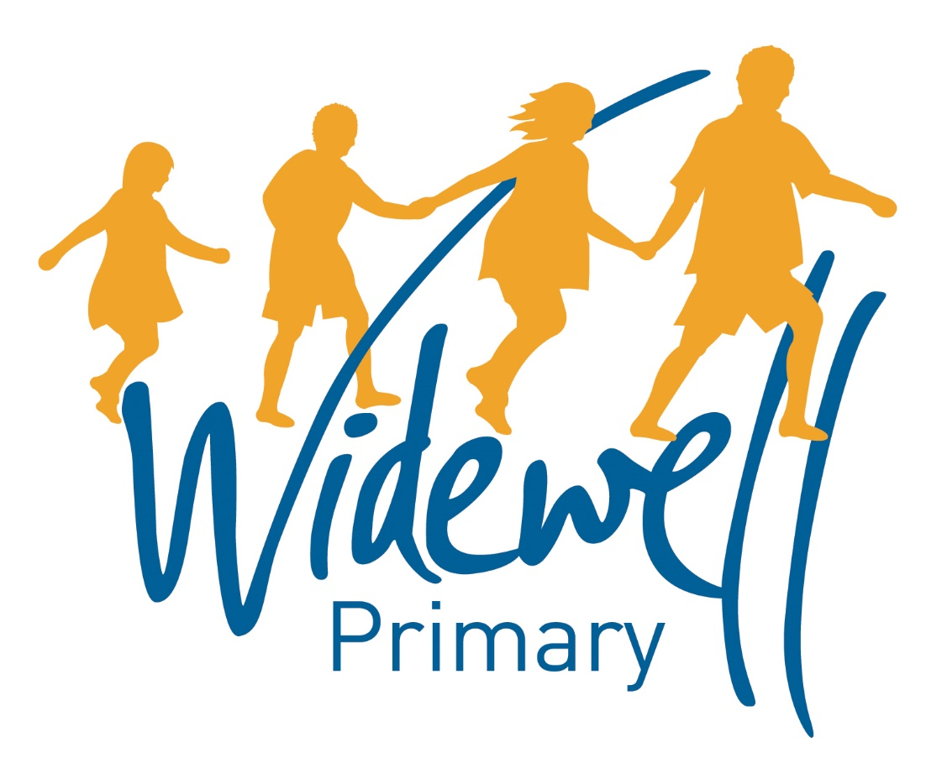

Nursery
Homework Card
Spring 2

Name _________________________________
Class: Robin

Reading is starred and must be completed each week as this supports your child’s learning in class.

Set – Due in: | 28.2.– 6.03.2020 |  | 6.3.2020-13.3.20 |  | 13.3.20-20.3.2020
Reading  At least 5 times each week | Please record reading in the Reading Record.
 | Reading Record completed (home) |  | Reading Record completed (home) |  | Reading Record completed (home)
 | Reading Record checked (school) |  | Reading Record checked (school) |  | Reading Record checked (school)
Sounds, Talk and Mark Making | Talk  Look at some baby photos of yourself with an adult. Have you grown? How have you grown? What is different about you now and then? |  | Mark Making  Using materials you’re your home, can you make your own measuring tape or ruler with an adult? |  | Sounds  Can you think of any words that rhyme with  cat,  dog  pen?
Maths | Number  Using the number problem sheet provided, can you play the game with an adult? |  | Shape  Can you make a tall and short tower using objects from your home?  Can you make a middle-sized tower in the middle? |  | Measure  With some help from an adult, can you weigh ingredients to make a meal?
Topic activity | What can grow? |  | What can grow? |  | What can grow?
 | Can you measure yourself with the help of an adult? How tall are you? Can you write this down? |  | Take a photo of someone in your family. Take another photo in a few weeks. Have they changed? Do they look different? |  | Can you plant a seed in your home or garden? Can you take a photo of it each day?
Wow Activities!
Let us know what else you’ve achieved this week.

.3.2020

20.3.2020-27.3.2020 |  | Easter Holidays |  | Easter Holidays
Please record reading in the Reading Record. |  |  |  |  |  | Reading  At least 5 times each week
Reading Record completed (home) |  | Reading Record completed (home) |  | Reading Record completed (home)
Reading Record checked (school) |  | Reading Record checked (school) |  | Reading Record checked (school)
Sounds  Can you think of any words that start with  a  s  m  t? |  | Talk  Can you read your favourite story and talk about what happened at the beginning, middle and end? |  | Mark Making  Using the mark making sheet provided, can you draw these shapes?  Can you use a pencil, pen, paintbrush, stick?  Can you write them in sand, in mud, in flour? |  | Sounds and  Talk Time
Number  Using the number problem sheet provided, can you play the game with an adult? |  | Shape  Using objects from you home, can you build a bed for a small person and a tall person? Are they going to be different? |  | Measure  Using objects from your home, can you measure yourself in  sticks  tin cans  pillows? |  | Maths
What can grow? |  | What can grow? |  | What can grow? |  | Topic activity
Can you find a photo of a baby animal and an adult animal? Do they look different? Have they grown or changed? |  | Have you planted a seed in your garden or home? Has it grown? Has is changed? |  | Can you measure how tall you are with the help of an adult? Have you grown? Have you not? What is your height now?
Wow Activities!
Let us know what else you’ve achieved this week.

Please record and share photos or videos of these activities using Tapestry.

The topic activity is optional, and you may choose to complete it as it will also help your learning in your class topic this term.

Wow Activities can be filled in by you to show us what else you do outside school e.g. taking part in a club; cooking a meal with your family; building a den; playing an instrument.

Thank you for your support.

