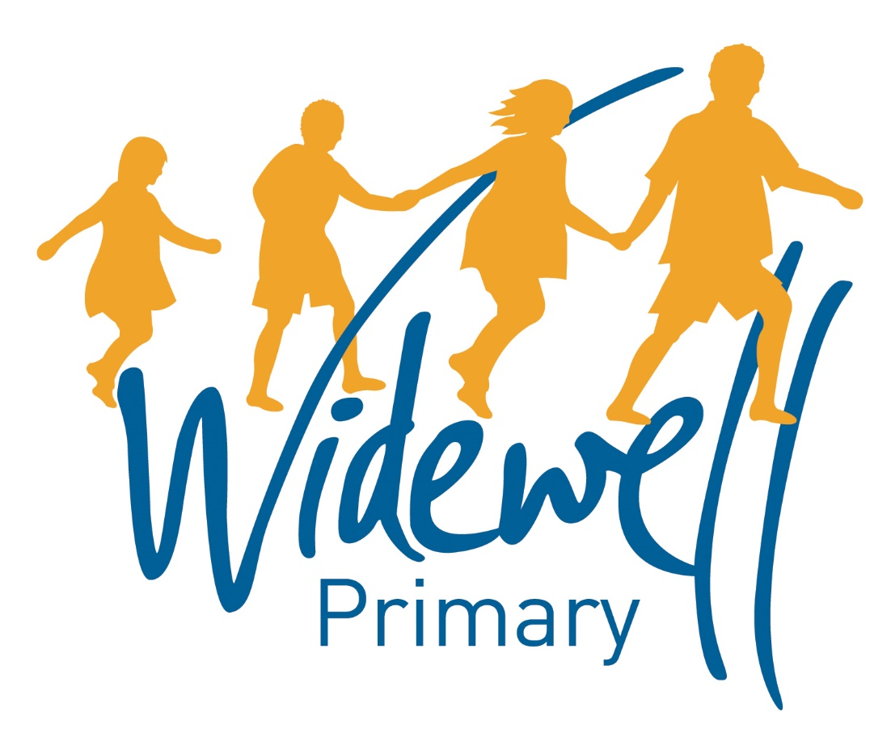
KS2
Homework Card
Autumn Term 1 2018

Name: ______________________
Class: Nightingale Year 3

Reading, spelling and maths activities are starred and must be completed each week as they support your learning in class.
Topic activities are optional and you may choose to complete them as they will also help your learning in your class topic this term.
Wow activities can be filled in by you to show us what else you do outside school e.g. taking part in a club; cooking a meal with your family; building a den; playing an instrument.
Homework club is taking place every Friday from 3.30pm to 4.30pm. You can drop in to get advice about your homework or stay for the hour and complete lots of your homework before the weekend!

Set – Due in | 07.09.18 – 14.09.18 |  |  |  |  |  |  | 14.09.18 – 21.09.18 |  |  |  |  |  |  | 21.09.18 – 28.09.18
Reading  At least 5 times each week | Please add your comments to the reading record each week and encourage your child to add their own comments. These should be brought to school daily.
 | TICK
 | Parent Signature |  |  |  |  |  |  | Parent Signature |  |  |  |  |  |  | Parent Signature
 | Teacher Signature |  |  |  |  |  |  | Teacher Signature |  |  |  |  |  |  | Teacher Signature
Spellings | Adding the prefixes dis- and in  incomplete  invisible  incapable  independent  dishonest  disagree  disappear |  |  |  |  |  |  | NC Words  grass edge  watch write  dry bottle  magic  race  change  knee |  |  |  |  |  |  | Adding im to root words beginning with m or p  impossible  imperfect  immature  impatient  immortal  impolite  immaterial
 | Test Result |  |  |  |  |  |  | Test Result |  |  |  |  |  |  | Test Result
Maths  Don`t forget Times tables Rock stars! | Write and learn the 2x table |  |  |  |  |  |  | Write and learn the 5x table |  |  |  |  |  |  | Write and learn the 4x table
 | Test Result |  |  |  |  |  |  | Test  Result |  |  |  |  |  |  | Test Result
Topic activity  Extra house points for extra homework! | Learn a song about the weather and sing it to the class. |  |  |  |  |  |  | Tell the class a real-life experience you have had about bad weather. |  |  |  |  |  |  | Draw a picture about the weather of your choice.
 | Find out the difference between a tornado and a hurricane. |  |  |  |  |  |  | Paint a beautiful rainbow. Can you name all the colours? |  |  |  |  |  |  | Make a rain stick to use in music.
Wow Activities!
Let us know what else you’ve achieved this week.

28.09.18 – 05.10.18 |  |  |  |  |  |  | 05.10.18 – 12.10.18 |  |  |  |  |  | 12.10.18 – 19.10.18 |  |  |  |  |  |  | Set – Due in
Please add your comments to the reading record each week and encourage your child to add their own comments. These should be brought to school daily. |  |  |  |  |  |  |  |  |  |  |  |  |  |  |  |  |  |  |  | Reading  At least 5 times each week
TICK
Parent Signature |  |  |  |  |  |  | Parent Signature |  |  |  |  |  | Parent Signature
Teacher Signature |  |  |  |  |  |  | Teacher Signature |  |  |  |  |  | Teacher Signature
NC Words  walked brother  travel climb  careful clothes  dropped world  station  quiet |  |  |  |  |  |  | Adding the suffix ous  dangerous  poisonous  perilous  mountainous  venomous  pompous  hazardous / jealous |  |  |  |  |  | Revision of all rules taught so far this term |  |  |  |  |  |  | Spellings
Test  Result |  |  |  |  |  |  | Test Result |  |  |  |  |  | Test  Result
Write and learn the 3x table |  |  |  |  |  |  | Write and learn the 10x table |  |  |  |  |  | Write and learn the 8x table |  |  |  |  |  |  | Maths
Test Result |  |  |  |  |  |  | Test Result |  |  |  |  |  | Test Result
Make up a new kind of weather. What will you name it? What will it be like? |  |  |  |  |  |  | Write a story about a bad storm or a rainbow. |  |  |  |  |  | Draw a picture of things that you would link to summer  e.g. flowers, beach, sun etc…. |  |  |  |  |  |  | Topic activity  Extra house points for extra homework!
Make your own weather symbol cards. |  |  |  |  |  |  | Research three countries that have contrasting weather / climates. |  |  |  |  |  | Create a cloud picture or design a new snowflake.
Wow Activities!
Let us know what else you’ve achieved this week

