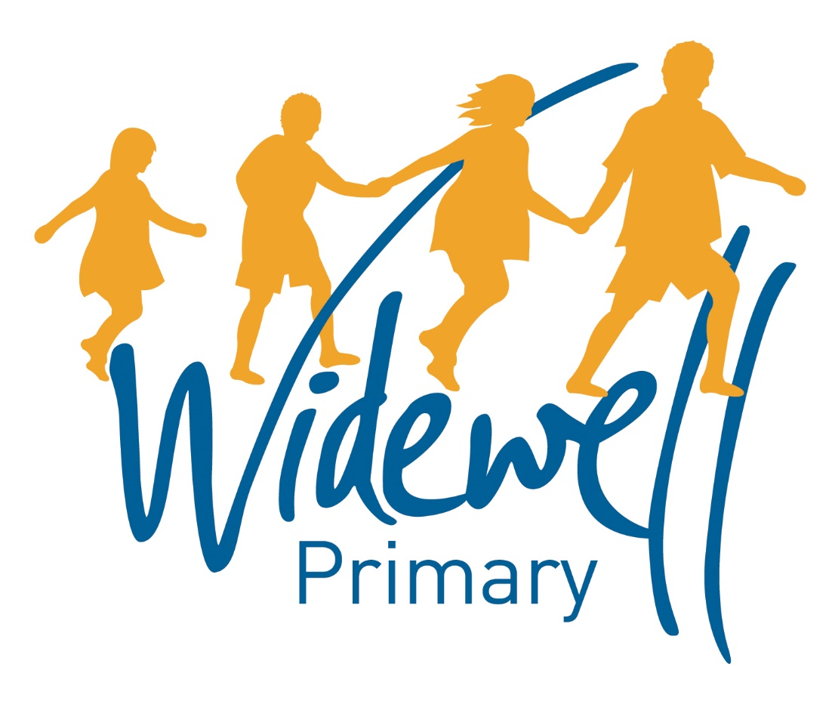

Nursery
Homework Card
Autumn 2

Name _________________________________
Class: Robin

Reading is starred and must be completed each week as this supports your child’s learning in class.

Set | 1.11.19 -8.11.2019 |  | 8.11.19- 15.11.2019 |  | 15.11.19- 22.11.2019
Reading  At least 5 times each week | Please record reading in the Reading Record.
 | Reading Record completed (home) |  | Reading Record completed (home) |  | Reading Record completed (home)
 | Reading Record checked (school) |  | Reading Record checked (school) |  | Reading Record checked (school)
Sounds and  Talk Time | Talk Time  Talk to an adult about Bonfire Night.  - What are you going to do for it?  - What can you hear/see/smell? |  | Sounds  See how many words you can think of that rhyme with ‘mat’. |  | Talk Time  Talk to an adult about Autumn.  - How is the weather changing?  - How does our clothing change?
Maths | Counting  Practise counting from 1 to 10 and back down again using your fingers.  Can you do it all by yourself? |  | Patterns  Can you find any patterns in your home?  On your clothes, in a picture?  Can you make a pattern with objects from your house? |  | Shape recognition  Have a go at writing the numerals 1, 2 and 3.  Parents can draw the shape for you to trace.
Topic activity
 | Talk to your family if they come from or have family members and friends in another country.  Using technology or a book can you find a picture of this place? Does it look like where you live? |  | Using materials from your home, can you make a picture of a landmark from Plymouth or Cape Town? |  | Using the sheet provided, can you make your own colourful South African Patterns?
Wow Activities!
Let us know what else you’ve achieved this week.

22.11.19- 29.12.2019 |  | 29.11.19-6.12.2019 |  | 6.12.19-13.12.2019
Please record reading in the Reading Record. |  |  |  |  |  | Reading  At least 5 times each week
Reading Record completed (home) |  | Reading Record completed (home) |  | Reading Record completed (home)
Reading Record checked (school) |  | Reading Record checked (school) |  | Reading Record checked (school)
Sounds  How many words can you think of that rhyme with ‘car’? |  | Talk  Talk to an adult about Christmas!  What are you going to be doing?  How is the weather changing?  What decorations have you seen? |  | Sounds  Use technology available at home to listen to festive songs.  OR  Try some Christmas food such as a mince pie or Brussel sprout and talk about what you like/dislike. |  | Sounds and  Talk Time
Shape recognition  Can you draw the patterns we have been learning about?  - Bumblebee.  - Tiger.  - Zebra? |  | Patterns  Look at Christmas pictures or even decorations in your house.  What patterns can you see?  What colours can you find?  Can you make your own Christmas pattern? |  | Counting  Try learning about the “Twelve days of Christmas” song.  How many of the 12 days can you learn and remember?  Record a video for Tapestry. |  | Maths
 |  |  |  |  |  | Topic activity
Using a book or technology can you find out an interesting fact about Plymouth and Cape Town? |  | Using materials from your home, can you make a junk model of your house? |  | Using a book or technology, can you find out how people from Cape Town celebrate Christmas?
Wow Activities!
Let us know what else you’ve achieved this week.

Please record and share photos or videos of these activities using Tapestry.

The topic activity is optional, and you may choose to complete it as it will also help your learning in your class topic this term.

Wow Activities can be filled in by you to show us what else you do outside school e.g. taking part in a club; cooking a meal with your family; building a den; playing an instrument.

Thank you for your support.

