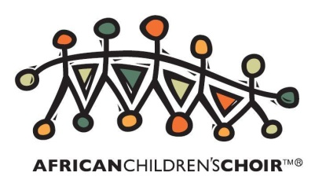

THE AFRICAN CHILDREN’S CHOIR ARE COMING TO THE UK

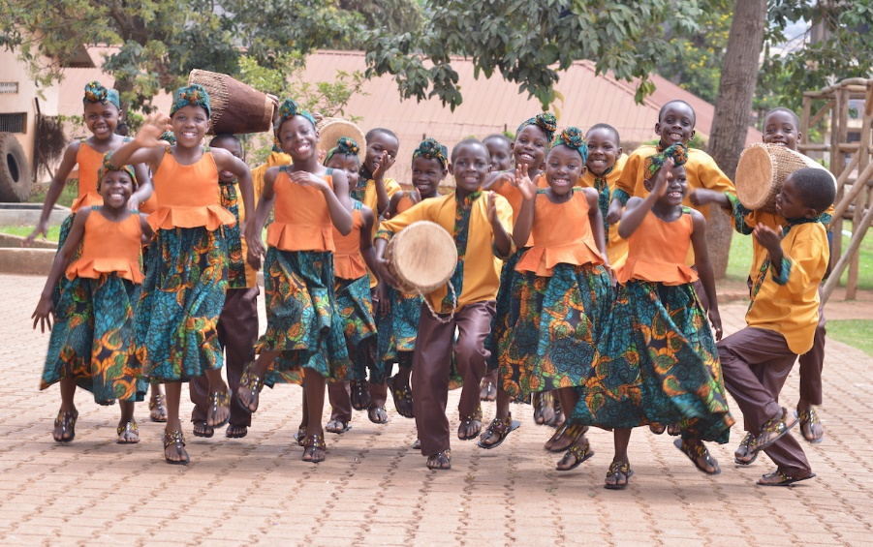

After stealing the hearts of the world during their uplifting performance of the number one single ‘Sing’ with Gary Barlow at the Queen’s Diamond Jubilee celebrations, the famous African Children’s Choir have been invited back to tour their inspirational talents, and are coming to Plymouth!

The choir have been invited by Plymouth Mayflower Rotary Club to perform with local children from Widewell Primary School on Wednesday 14 June. The exciting event takes place at 7pm in the Edgcumbe Theatre, Devonport High School for Boys, Paradise Road, Plymouth, PL1 5QP.
Tickets are priced at £5 adults, £3 children and £12 for families, with all money raised going to support the African Children’s Choir. Tickets and further information can be obtained from Barbara on 01752 402250, or David on 07905 102057.

Music for Life, the official fundraising charity of the African Children’s Choir, work in seven African countries, and have educated over 52,000 children as well as impacting the lives of over 100,000 people through relief and development programmes during its 32 year history.

The African Children’s Choir travels the world, acting as the ambassador for Africa’s most vulnerable children, raising much needed awareness as they go. Funds raised contribute towards not only the entire education and care of all the touring children, but also to the continued development and support of the Music for Life programmes that help some of the continent’s most in-need children, providing them with better opportunities; creating ChangeMakers for the future of Africa.

The Choir has attracted fans from all over the world, including some celebrity admirers. Talking about the Choir, International superstar Annie Lennox said “I first encountered the African Children’s Choir as they were heading towards the stage to perform for Nelson Mandela’s 46664 campaign ... Since then I’ve come to appreciate more and more, just how uniquely special they are.”

The concerts reflect the energy, beauty, dignity and unlimited ability of these incredible children through song, music and dance. Many of the Choir Children have lost one or both parents to poverty and disease. The performances are both uplifting and humbling and are an opportunity to experience the vitality of the youth from this challenged continent.

Facebook: https://www.facebook.com/africanchildrenschoir
Twitter: https://twitter.com/acchoir

