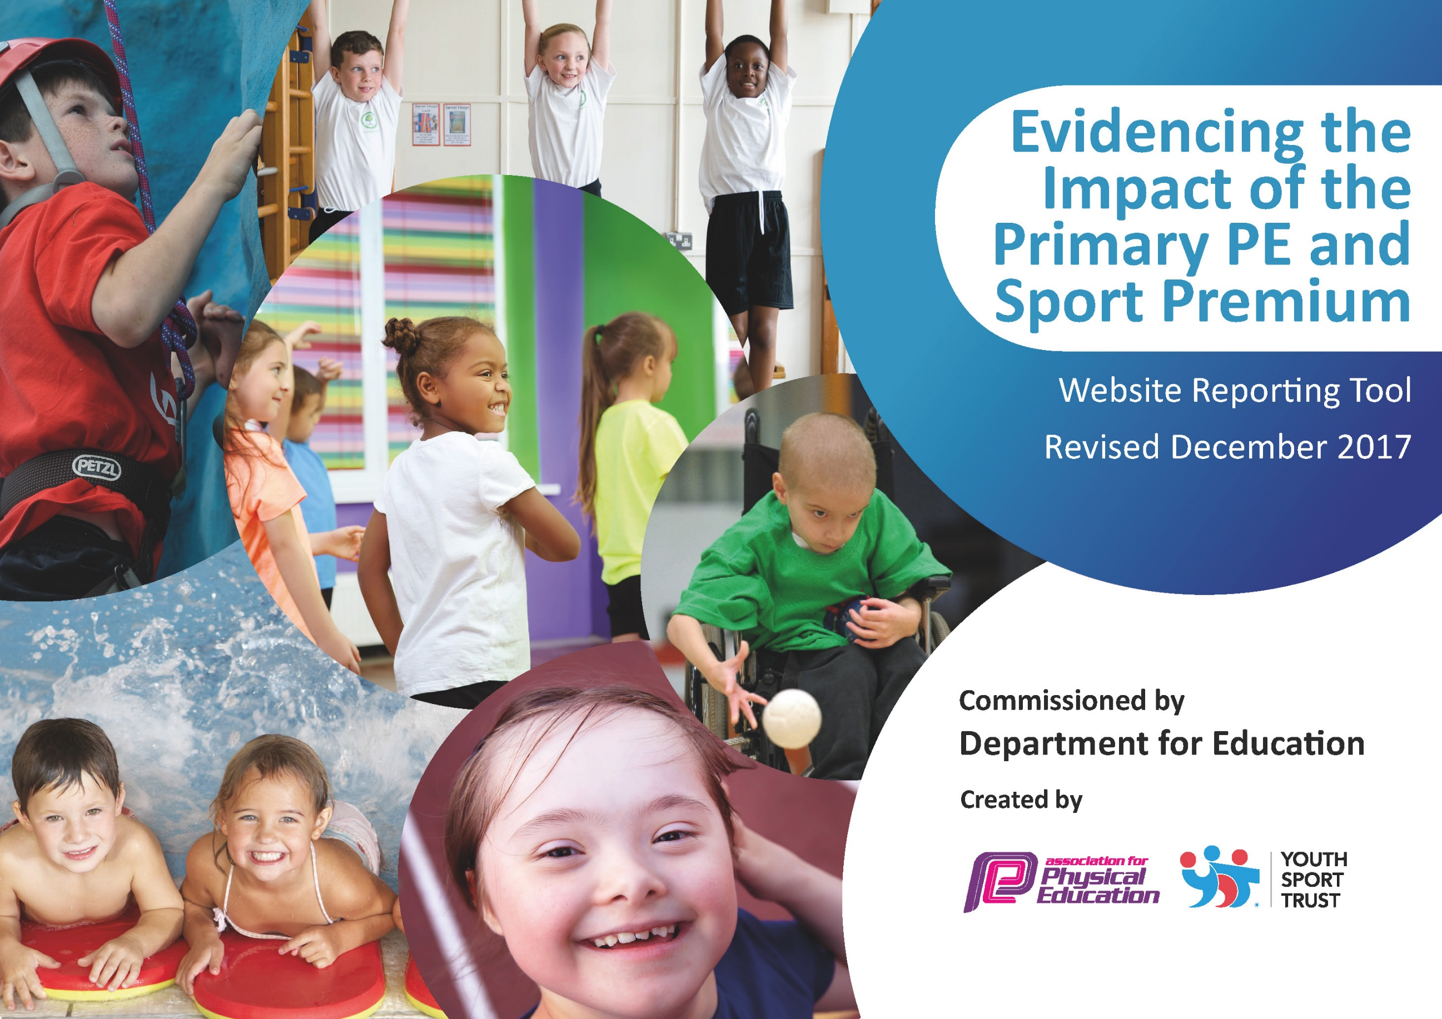

Schools must use the funding to make additional and sustainable improvements to the quality of PE and sport they offer. This means that you should use the Primary PE and Sport Premium to:
- develop or add to the PE and sport activities that your school already offers
- build capacity and capability within the school to ensure that improvements made now will benefit pupils joining the school in future years

Please visit gov.uk for the revised DfE guidance including the 5 key indicators across which schools should demonstrate an improvement. This document will help you to review your provision and to report your spend. DfE encourages schools to use this template as an effective way of meeting the reporting requirements of the Primary PE and Sport Premium.

We recommend you start by reflecting on the impact of current provision and reviewing the previous spend.
Under the Ofsted Schools Inspection Framework, inspectors will assess how effectively leaders use
the Primary PE and Sport Premium and measure its impact on outcomes for pupils, and how effectively governors hold them to account
for this.

Schools are required to publish details of how they spend this funding as well as on the impact it has on pupils’ PE
and sport participation and attainment.
We recommend regularly updating the table and
publishing it on your website as evidence
of your ongoing review into how you are using the money
to secure maximum, sustainable impact. To see an example of how to complete the table please click HERE.

Support for review and reflection - considering the 5 key indicators from DfE, what development needs are a priority for your setting and your students now and why? Use the space below to reflect on previous spend, identify current need and priorities for the future.

Key achievements to date: | Areas for further improvement and baseline evidence of need:
- Plymouth School Sports Partnership membership: increased and consistent participation in school games events; CPD opportunities for teaching staff; availability of a PE Specialist to assist with delivery and organisation of PE- creation of development plans, CPD for teaching staff, training of Young Playleaders to organise and run lunchtime activities to encourage and engage all children to take part in physical activity, audit and ordering new equipment to deliver PE.  - Dave Hilling PE Specialist Teacher employment: as a result of opportunities for CPD for all teaching staff to observe, plan and work alongside DH to deliver PE lessons. As a result, teacher’s knowledge and confidence has increased which has led to higher quality PE lessons that engage children in their learning.  - Equipment: Audit carried out with Plymouth School Sports Partnership Specialist Teacher; new equipment purchased such as gymnastic benches, replacement of old/damaged resources, new netballs to provide high quality equipment to deliver high quality lessons; new storage unit to store field gun in order to give more convenient access for children to access equipment to practice for events.  - PE Coordinator release time- opportunities to oversee PE delivery and School Sport across the school; to monitor extra-curricular club participation to ensure all pupils have access to sporting clubs to encourage a healthy active lifestyle; identify areas of CPD staff require to enhance their knowledge and confidence; the profile of PE and School Sports has been raised which culminated in the award of the Sainsbury school Games Gold Award in recognition of the school’s commitment to active sporting lifestyles.  - School kit: purchase of polo shirts/vests with school name and logo which has created a feeling of belonging and being part of a school team competing against other schools.  - Staff release time and transport: more sporting events have been attended both during and after the school day; more children have an opportunity to be active whilst representing the school at sporting events.  - Coaches employed for extra-curricular clubs: a wider range of clubs are provided which has led to greater participation and opportunities for an active healthy lifestyle.  - Balance bikes for Foundation stage: the bikes have provided opportunities for children to develop motor skills, balance and coordination. | - Provision of increased variety of activities in curriculum PE eg. boccia, Outdoor and Adventurous Activities, dance, Well- Being.  - Provision of an increased variety of activities for extra-curricular clubs eg. fencing, archery, tri golf, lacrosse.  - Increase opportunities for all children to be active eg. Attending Inclusion Events focusing on less active children, increase opportunities to attend extra-curricular clubs.  - Increase opportunities for less active children to be physically active by organisation of Change4Life lunchtime clubs run by Year 5 and 6 Playleaders.  - Purchase of additional sports kit to be worn at sporting events to further raise the profile of PE and School Sport.  - Continued regular attendance at inter-school competitive events organized by Plymouth School Sports Partnership by releasing staff to accompany pupils.  - Continued CPD provision for teaching staff.

Meeting national curriculum requirements for swimming and water safety | Please complete all of the below*:
What percentage of your current Year 6 cohort swim competently, confidently and proficiently over a distance of at least 25 metres? | 69%
What percentage of your current Year 6 cohort use a range of strokes effectively [for example, front crawl, backstroke and breaststroke]? | 65%
What percentage of your current Year 6 cohort perform safe self-rescue in different water-based situations? | 100%
Schools can choose to use the Primary PE and Sport Premium to provide additional provision for swimming but this must be for activity over and above the national curriculum requirements. Have you used it in this way? | Yes/No
*Schools may wish to provide this information in April, just before the publication deadline.

Action Plan and Budget Tracking
Capture your intended annual spend against the 5 key indicators. Clarify the success criteria and evidence of impact that you intend to measure to evaluate for students today and for the future.

Academic Year: 2018/19 | Total fund allocated: £17,750.00 | Date Updated: September 2018
Key indicator 1: The engagement of all pupils in regular physical activity – Chief Medical Officer guidelines recommend that primary school children undertake at least 30 minutes of physical activity a day in school |  |  |  | Percentage of total allocation:
 |  |  |  | 28%
School focus with clarity on intended impact on pupils: | Actions to achieve: | Funding allocated: | Evidence and impact: | Sustainability and suggested next steps:
- Employment of Premier Sport  - Lunch-time play equipment | - Organise and lead curricular PE lessons. Plan and deliver a sequence of lessons for all classes to be shared with the class teachers with assessments at the end of every half term eg. Well-Being, gymnastics and dance  - Organise and run, with the assistance of Year 5 and 6 Playleaders, a PlayActive Change4Life club at lunch-times for KS1 and KS2 pupils focusing on encouragement of all children to be physically active.  - Purchase of new lunch-time play equipment eg. mini football goals, netball posts  - Purchase of storage equipment for lunch-time play equipment. | £4200.00  £1000.00 | - Increased participation as a result of the opportunities to experience different extra-curricular sports clubs.  - More pupils are physically active at lunch-times as a result of an organised clubs for KS1 and KS2 pupils.  - Provision of a broad and balanced PE curriculum that focuses of aesthetic and creative skills as well as games to engage all abilities and interest of all pupils.  - Increased opportunities for pupils to be physically active linked to the PlayActive/Change4Life clubs. | - From lists of extra-curricular club attendees, keep track of less active children and focus on involving them in lunch-time physical activity and extra  - Annually train new Playleaders from year 5 and 6 to continue lunch-time physical activity club provision.  - Continue to offer a broad and balanced PE curriculum that caters for all interests and abilities eg. invasion games, aesthetic and creative activity such as dance and gymnastics, OAA.
Key indicator 2: The profile of PE and sport being raised across the school as a tool for whole school improvement |  |  |  | Percentage of total allocation:
 |  |  |  | 41%
School focus with clarity on intended impact on pupils: | Actions to achieve: | Funding allocated: | Evidence and impact: | Sustainability and suggested next steps:
- Annual membership to the Plymouth School Sports Partnership  - New sports kit  - PE and School Sport equipment | - PSSP to run a broad spectrum of Level 2/3 competitions for children across all year groups.  - Match reports/photos/league tables supplied by the PSSP. Participation in School Games events tracked. Engagement by all children tracked by PE Coordinator. Development of the whole child celebrated through School Games values linked with various competitive events. More children participating.  - Sporting achievements celebrated in assemblies eg. presentation of certificates.  - Expert advice to help monitor to identify strengths and weaknesses in the provision of PE and to help write development plans to assist school improvement.  - To provide further training for new generation of Year 5 and 6 Playleaders to organise and lead play activities to encourage all children to be active that will have a positive impact at lunch-times.  - Annual Primary PE Conference to provide up to date pedagogy and practice as well as CPD opportunities for PE Co-ordinator and extended staff.  - Purchase of new sports kit to be worn at inter-school Plymouth Sports Partnership events eg. football, tag rugby, basketball etc.  - Purchase of new PE equipment to assist teachers in the delivery of high quality PE lessons and extra-curricular sports clubs. | £3,500.00  £2890.00  £2000.00 | - Increased participation in School Games events as organised by the Plymouth School Sports Partnership.  - PE development plans linked with whole school plan to raise the profile of PE and Sport and healthy lifestyles.  - Inactive children involved in extra-curricular sport and lunch-times C4L clubs – encouraged to make healthy decisions, leading to more active lifestyles.  - More active playtimes and a wider range of games learned by children.  - Attendance to the annual conference has provided up to date/significant training for the PE Coordinator. New skills developed has enabled them to implement programmes back in school. Impact can be seen through more children involved in leadership and organisation in PE lessons and other competitive opportunities.  - Profile of School Sport raised as a result of pupils looking smart and being proud to be members of a team to represent the school.  - New equipment displays a value in physical activity which creates a positive environment to learn from the effective delivery of high quality PE lessons eg. Every child has the opportunity to learn football skills each with their own ball. | - Annual subscription will mean that all children, regardless of year group/ability will have access to a broad spectrum of competition.  - To sustain opportunities for pupils to be physically active by participating in inter-school events within the School Sports Partnership in addition to PE.  - PE Specialist to annually train up new Year 5 and 6 Playleaders to sustain the lunch-time play activities to offer opportunities for pupils to be physically active.  - Continued assistance from the PE Specialist with monitoring PE and School Sport across the school to help ensure a progressive development plan which will affect whole school improvement.  - Increased skill set/knowledge and confidence brought back to the school - leads to progress in PE. Continued support/training from the PSSP will continue to develop staff.  - Continued future enthusiasm and pride to represent the school at inter-school events highlighting the ethos of teamwork and family.  - Sustained progression of achievement across all age groups.

Key indicator 3: Increased confidence, knowledge and skills of all staff in teaching PE and sport |  |  |  | Percentage of total allocation:
 |  |  |  | 19%
School focus with clarity on intended  impact on pupils: | Actions to achieve: | Funding  allocated: | Evidence and impact: | Sustainability and suggested  next steps:
- Annual membership to the Plymouth School Sports Partnership. | - PE specialist teachers to provide CPD training for teaching staff, support to increase knowledge and confidence in the delivery of high quality PE. Teachers to highlight areas of weakness and decide what CPD they would like eg. OAA, athletics, gymnastics. | As Key indicator 2. | - Confidence and knowledge raised will result in teachers being more able to deliver higher quality teaching that will engage all pupils in a variety of sports within a broad and balanced curriculum.  - Following each 1:1 CPD block, staff are asked to complete a feedback form which is reviewed by the PE Coordinator to establish the need for any additional support. | - Continued subscription to the PSSP will ensure specialist support and training for all staff leading to increased confidence in delivery/teaching and learning.  - Teachers have the opportunity to experience progression across age ranges which will assist planning and assessment.
Key indicator 4: Broader experience of a range of sports and activities offered to all pupils |  |  |  | Percentage of total allocation:
 |  |  |  | 17%
School focus with clarity on intended  impact on pupils: | Actions to achieve: | Funding  allocated: | Evidence and impact: | Sustainability and suggested  next steps:
- Employment of Premier Sport- Extra-curricular sports clubs.  - Employment of sports coaches eg. Plymouth Argyle/ Extra-curricular sports clubs | - Organise and run extra-curricular clubs offering a variety of different physical activities eg. boccia, fencing, archery, lacrosse, tri golf.  - Organise and run extra-curricular clubs offering a variety of different physical activities eg. boccia, fencing, archery, lacrosse, tri golf. | £1,050.00  £2000.00 | - Greater variety of sports available to experience.  - Increased pupil participation.  - Club registers maintained to highlight levels of participation. A broader range of clubs, led by specialist should ensure that more children are participating. Able and talented children identified and signposted to local clubs. Aim is to maintain Gold standard (School Games Mark) of 50% of all KS2 children attending a sports club each week.  - Greater variety of sports available to experience.  - Increased pupil participation. | - Conference children on what clubs they would like.  - Developing links with specialist coaches will provide the school with pathways for children to participate. Varied clubs/ experiences will increase the likelihood of children continuing  to participate and enjoy physical activity later in life.
Key indicator 5: Increased participation in competitive sport |  |  |  | Percentage of total allocation:
 |  |  |  | 5%
School focus with clarity on intended  impact on pupils: | Actions to achieve: | Funding  allocated: | Evidence and impact: | Sustainability and suggested  next steps:
- Staff release and transport costs | - Staff, including non-teaching staff, released to accompany pupils to Plymouth School Sports Partnership sporting events to ensure increased opportunities for pupils to participate in inter-school sporting events.  - Payment for transport costs eg. taxis to transport pupils to sporting events | £1000.00 | - Pupils regularly attend Plymouth School Sports Partnership inter-school sporting activities, increasing opportunities to be competitive. | - Continued opportunities to be physical active as a result of inter-school competitions which contributes to 30 minutes a day/150 minutes a week physical activity.  - Sustained positive impact of team work to continually influence the family ethos of the whole school.

