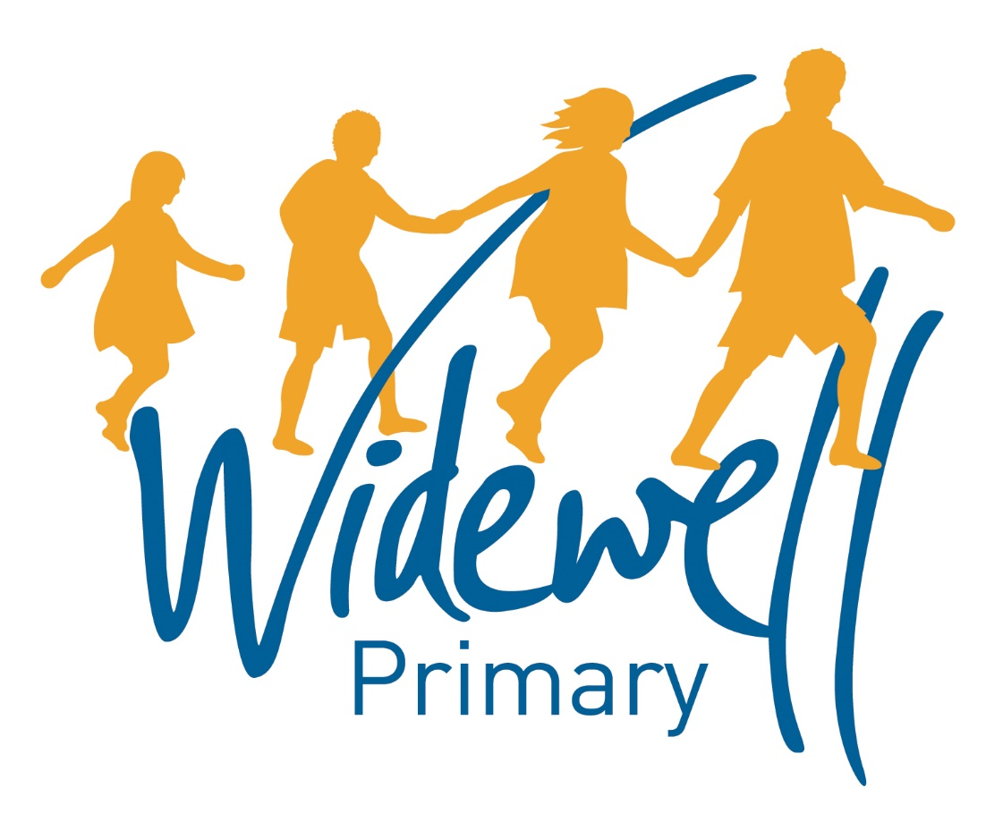
KS2
Homework Card
Autumn Term 1 2017

Name: ______________________
Class: Kestrel Year 5

Reading, spelling and maths activities are starred and must be completed each week as they support your learning in class.
Topic activities are optional and you may choose to complete them as they will also help your learning in your class topic this term.
Wow activities can be filled in by you to show us what else you do outside school e.g. taking part in a club; cooking a meal with your family; building a den; playing an instrument.
Homework club is taking place every Friday from 3.30pm to 4.30pm. You can drop in to get advice about your homework or stay for the hour and complete lots of your homework before the weekend!

Set – Due in | 08.09.17 – 15.09.17 |  |  |  |  |  |  | 15.09.17 – 22.09.17 |  |  |  |  |  |  |  | 22.09.17 – 29.09.17
Reading  At least 5 times each week | Please add your comments to the reading record each week and encourage your child to add their own comments. These should be brought to school daily.
 | TICK
 | Parent Signature |  |  |  |  |  |  | Parent Signature |  |  |  |  |  |  |  | Parent Signature
 | Teacher Signature |  |  |  |  |  |  | Teacher Signature |  |  |  |  |  |  |  | Teacher Signature
Spellings | To investigate words with the silent b letter.  e.g.  comb  thumb |  |  |  |  |  |  | How many words can you find which contain the silent b? |  |  |  |  |  |  |  | To investigate words that contains the letter string ough.  e.g.  thorough  enough
 | Test Result |  |  |  |  |  |  | Test Result |  |  |  |  |  |  |  | Test Result
Maths | Choose:  a) Continue to improve your times and money score on TT Rockstars  OR  b) Work through activities on MyMaths |  |  |  |  |  |  | Choose:  a) Continue to improve your times and money score on TT Rockstars  OR  b) Work through activities on MyMaths |  |  |  |  |  |  |  | Choose:  a) Continue to improve your times and money score on TT Rockstars  OR  b) Work through activities on MyMaths
 | Test Result |  |  |  |  |  |  | Test Result |  |  |  |  |  |  |  | Test Result
Topic activity  (in any order)  Extra house points for extra homework! | Create a 3D model of an Anderson shelter. You can use any material you like. |  |  |  |  |  |  |  |  |  |  |  |  | Research and write a short biography about a famous character from WW2 e.g. Winston Churchill.
Wow Activities!
Let us know what else you’ve achieved this week.

29.09.17 – 06.10.17 |  |  |  |  |  |  |  | 06.10.17 – 13.10.17 |  |  |  |  |  | 13.10.17 – 20.10.17 |  |  |  |  |  |  | Set – Due in
Please add your comments to the reading record each week and encourage your child to add their own comments. These should be brought to school daily. |  |  |  |  |  |  |  |  |  |  |  |  |  |  |  |  |  |  |  |  | Reading  At least 5 times each week
TICK
Parent Signature |  |  |  |  |  |  |  | Parent Signature |  |  |  |  |  | Parent Signature
Teacher Signature |  |  |  |  |  |  |  | Teacher Signature |  |  |  |  |  | Teacher Signature
How many words can you find with ough? |  |  |  |  |  |  |  | Looking at words ending in –ible.  e.g.  impossible  horrible. |  |  |  |  |  | How many words can you find with –ible? Can you make a wordsearch using only ible words? |  |  |  |  |  |  | Spellings
Test  Result |  |  |  |  |  |  |  | Test Result |  |  |  |  |  | Test  Result
Choose:  a) Continue to improve your times and money score on TT Rockstars  OR  b) Work through activities on MyMaths |  |  |  |  |  |  |  | Choose:  a) Continue to improve your times and money score on TT Rockstars  OR  b) Work through activities on MyMaths |  |  |  |  |  | Choose:  a) Continue to improve your times and money score on TT Rockstars  OR  b) Work through activities on MyMaths |  |  |  |  |  |  | Maths
Test Result |  |  |  |  |  |  |  | Test Result |  |  |  |  |  | Test Result
Draw and explain what 6 things you would want to take with you if you were evacuated. |  |  |  |  |  | French – create a board game using numbers 1 – 50 in French. |  |  |  |  | ICT- Write a set of rules about keeping safe on the internet. You can present this in any way you like. |  |  |  |  |  |  |  |  |  | Topic activity  (In any order)  Extra house points for extra homework!
Wow Activities!
Let us know what else you’ve achieved this week

