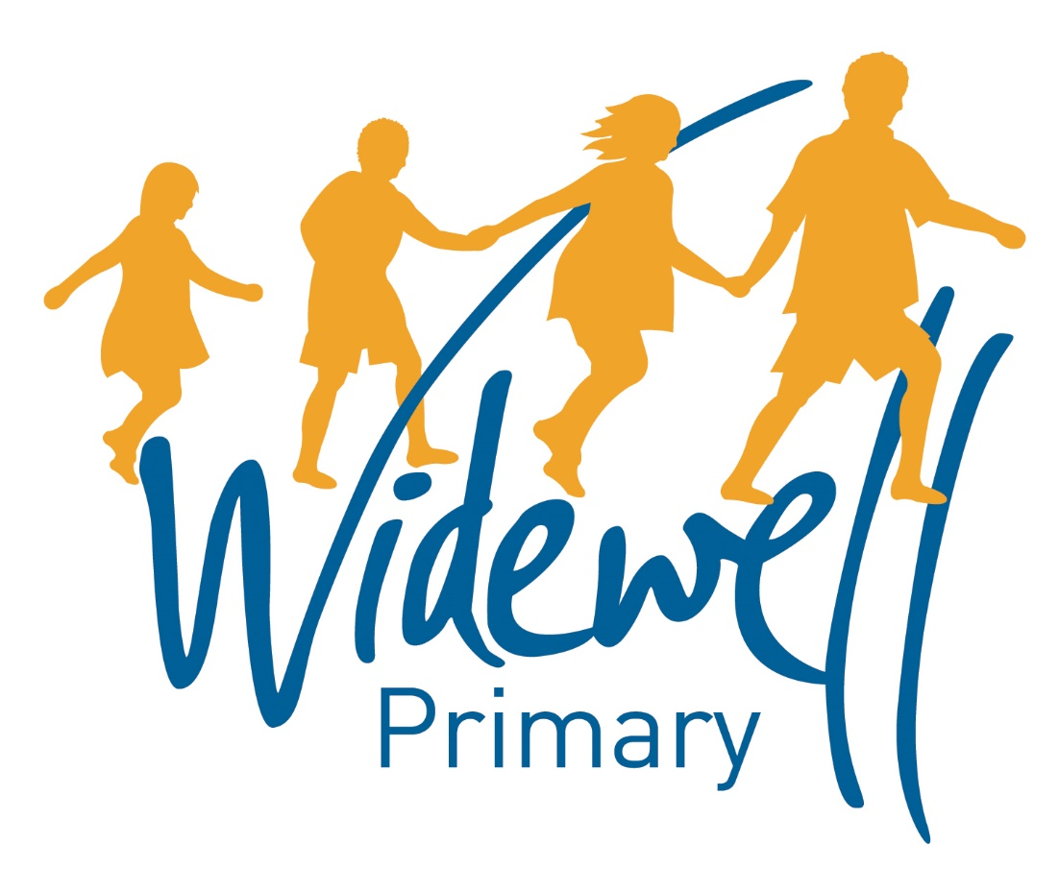
KS2
Homework Card
Autumn Term 2 2017

Name: ______________________
Class: Kestrel Year 5

Reading, spelling and maths activities are starred and must be completed each week as they support your learning in class.
Topic activities are optional and you may choose to complete them as they will also help your learning in your class topic this term.
Wow activities can be filled in by you to show us what else you do outside school e.g. taking part in a club; cooking a meal with your family; building a den; playing an instrument.
Homework club is taking place every Friday from 3.30pm to 4.30pm. You can drop in to get advice about your homework or stay for the hour and complete lots of your homework before the weekend!

Set – Due in | 30.10.17 – 3.11.17 |  |  |  |  |  |  | 6.11.17 – 10.11.17 |  |  |  |  |  |  |  | 13.11.17 – 17.11.17
Reading  At least 5 times each week | Please add your comments to the reading record each week and encourage your child to add their own comments. These should be brought to school daily.
 | TICK
 | Parent Signature |  |  |  |  |  |  | Parent Signature |  |  |  |  |  |  |  | Parent Signature
 | Teacher Signature |  |  |  |  |  |  | Teacher Signature |  |  |  |  |  |  |  | Teacher Signature
Spellings | Looking at words ending in:  -able  e.g.  enjoyable  reasonable |  |  |  |  |  |  | How many words can you find with -able? Can you create a crossword using only -able words? |  |  |  |  |  |  |  | To investigate words with the silent letter t.  e.g.  whistle  fasten  wrestle
 | Test Result |  |  |  |  |  |  | Test Result |  |  |  |  |  |  |  | Test Result
Maths | Complete worksheet on multiplying and dividing by 10,100 and 1000. |  |  |  |  |  |  | Complete statistics homework. |  |  |  |  |  |  |  | Converting between hours and minutes problems.
 | Test Result |  |  |  |  |  |  | Test Result |  |  |  |  |  |  |  | Test Result
Topic activity  (in any order)  Extra house points for extra homework! | Draw, paint or make the Star of David.  Can you research the significance of the Star of David to Judaism after WW2? |  |  |  |  |  |  |  |  |  |  |  |  |  | Research and create a poster, leaflet or fact file about Kindertransport.
Wow Activities!
Let us know what else you’ve achieved this week.

20.11.17 – 25.11.17 |  |  |  |  |  |  | 27.11.17 – 1.12.17 |  |  |  |  |  | 4.12.17 – 8.12.17 |  |  |  |  |  | Set – Due in
Please add your comments to the reading record each week and encourage your child to add their own comments. These should be brought to school daily. |  |  |  |  |  |  |  |  |  |  |  |  |  |  |  |  |  |  | Reading  At least 5 times each week
TICK
Parent Signature |  |  |  |  |  |  | Parent Signature |  |  |  |  |  | Parent Signature
Teacher Signature |  |  |  |  |  |  | Teacher Signature |  |  |  |  |  | Teacher Signature
How many words can you find which contain the silent letter t? Can you write some silly sentences using these words? |  |  |  |  |  |  | Find words ending in:  -ibly and -ably  e.g.  understandably  incredibly |  |  |  |  |  | To investigate homophones. How many can you find?  e.g.  sea and see |  |  |  |  |  | Spellings
Test  Result |  |  |  |  |  |  | Test Result |  |  |  |  |  | Test  Result
Converting between different units of measure.  E.g. converting from grams to kilograms. |  |  |  |  |  |  | Look for different angles around your home. Can you find an example of an acute, obtuse and reflex angle? |  |  |  |  |  | To solve different word problems. |  |  |  |  |  | Maths
Test Result |  |  |  |  |  |  | Test Result |  |  |  |  |  | Test Result
Write a diary entry from a Kindertransport child’s perspective. |  |  |  |  |  |  | French- Draw or paint any scene you like. Label the different colours in French.  Challenge: Can you label the other parts of your picture in French? |  |  |  |  |  | ICT- Go on to https://code.org/learn and have a go at an hour of code. You can choose any of the games to complete your hour of code. |  |  |  |  |  | Topic activity  (In any order)  Extra house points for extra homework!
Wow Activities!
Let us know what else you’ve achieved this week

