Dear Colleague

Product Recall: Le Toy Van – Bunny Train

Name of Product: Bunny Train

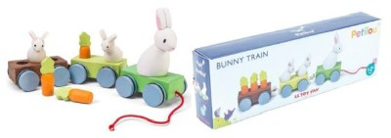

Description
Le Toy Van has become aware that the plastic ears of the two smaller bunnies are breaking off the PL026 Bunny Train. This issue may affect stock of PL026 Bunny Train distributed by Le Toy Van Ltd with the following batch codes:
026/1016/LTV03
026/2316/LTV24
026/4116/LTV59
026/1217/LTV10

Hazard
This may mean the small bunny ears of the PL026 Bunny Train may present a choking hazard.

Remedy

If you believe you have an affected product then remove the toy from use. Affected items should be disposed of or returned to point of purchase.
If you have any queries, please do not hesitate to contact : Le Toy Van customer services on (+44) 0208 979 2036 or email info@letoyvan.com.

Please share this information with parents and carers.

Kind regards

Early Years Safeguarding and Welfare Team

