Robin & Wren Class curriculum letter - Autumn Term 2018

Dear Parents and Carers,
Welcome to what we hope will be a fun and exciting time for your child in our Early Years class. We look forward to working with you over the year and sharing your child’s learning journey with you.
This term our main topic will be ‘What’s it like to be a pirate?’ To launch our topic enquiry, we will be generating our own questions and exploring pirate related objects before having our pirate day…you never know we might even have a visit from a pirate!
Our curriculum overview for this term is as follows:
Literacy  Daily RWI sessions to develop our understanding of letters and their sounds and the reading and writing of words.  Learning how to recognise and write our names  Creating a class story though story bag sessions.  Creating lists and labels  Using images as a stimulus to write initial sounds and simple words.  Practise handwriting and letter formation.  Independent writing opportunities through provocations and environment enhancements.  Explore a variety of topical and seasonal texts (BV)  Role play and drama activities related to our topic | Communication & Language  Maintaining attention, listening and concentrating on topical stories and rhymes (BV)  Talking about their knowledge of pirates  Making predictions and discussing what we have found out  Looking at our topic vocabulary  Developing our questioning and reasoning skills  Learning forums to discuss our successes and next steps |  | Maths  Counting up and back from 10  Recognising and ordering numbers to 10  One more and one less than with numbers to 10  Addition and subtraction within numbers to 10  Recognising, naming and describing the properties of 2D shapes  Exploring and measuring size, weight and capacity of objects  Exploring and using money and everyday language associated with it  Recreating and describing simple patterns
What’s it like to be a pirate?
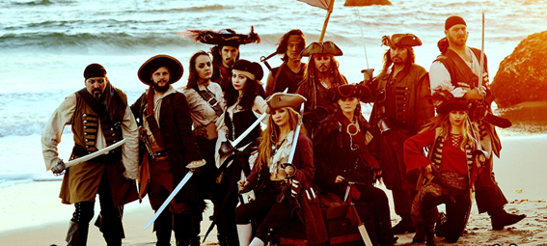

Personal, Social & Emotional Development  Creating and following class rules and learning how to be a successful learner  Woodland School sessions focusing on resilience and confidence building (BV)  Time to talk activities, practising making compromises and working with others (BV)  Exploring, sharing and celebrating differences and similarities (BV)  Making decisions about how to demonstrate our knowledge (BV)  Working with friends to achieve a goal  Performing the Nativity to an audience |  |  | Physical development  Selecting different tools and handling them safely  Developing our fine manipulative skills and pencil control  Managing own risks and how to keep ourselves safe  Building an understanding of how to keep ourselves healthy  Building an awareness of healthy and unhealthy options
 | Expressive Arts & Design  Making pirate treasure maps Creating paintings of the sea inspired by famous artists work  Weaving with sea coloured materials  Observational drawing and painting of objects from the sea  Designing and making a floating boat  Using natural resources and participating in woodland crafts  Participating in the Christmas Nativity | Understanding the World  Exploring objects that float and sink  Learning about Autumn celebrations, seasons and weather (BV)  Exploring and sorting objects by their different properties  Using technology to support and record our learning

The Nursery children will have the opportunity to take home library books that you can share with them as part of the expectation to read with your child daily. These will be changed as you finish with them or at least weekly.

The Foundation children, once we start issuing reading books in week 3, will have the opportunity to change their books up to three times a week (Monday, Wednesday and Friday). We expect the children to read at least 5 times a week, although this does not have to be a whole book each time and for an adult to complete and sign their reading record. Please make sure your child’s reading book and reading record comes to school every day.

The class will have their PE lessons on Monday this term, run by Premier Sport. Please make sure that full PE kit is at school as it is vital that the children have their PE kit for all PE sessions. Your child can leave it at school and it will be sent home for washing during each holiday or in between times if we think it needs it!

Forest school will be on Wednesday this term. Again please make sure the children have their full kits.

Please make sure that everything is named, including footwear!

Your child will have a homework card which needs to be signed and sent into school each Friday, along with any homework completed. For additional ideas to help your child’s learning at home, please visit our class page on the school website to access other learning support resources.

Finally, just a reminder that your child should bring a clearly named drinks bottle with them daily containing only plain water (not fizzy or flavoured). Fruit and milk is provided daily for your child’s snack.

If you have any questions, please come and ask, we are available on the playground in the mornings or after school. It is vital that your child feels happy coming to school and we work closely together for their best interests.

We are very much looking forward to another successful year.

Mrs Hambly, Miss Webb & Mr Murphy

