Widewell Primary Academy Knowledge Organiser

Topic: What can I do now that I couldn’t do when I was a baby? |  |  | Year EYFS |  | Term Autumn 1  cycle A
Vocabulary bank
Key vocabulary | Definition | Key vocabulary |  | Definition
Younger | Someone who has been alive for a short time. | Movement |  | To move a body part to change position or place.
Older | A person that has lived for a long time; no longer young. | Nutrition |  | Eating and drinking things to help us to be healthy and grow.
Baby | A very young child. | Communication |  | How we let other people know things using our body and our voices.
Toddler | A young child who is just beginning to walk. | Independent |  | Being able to do something by yourself with no help.
Child | A person not fully grown. | Dependent |  | Having to have help from someone to be able to do something.
Adult | A person who is fully grown. | Change / Changes |  | When something becomes different.

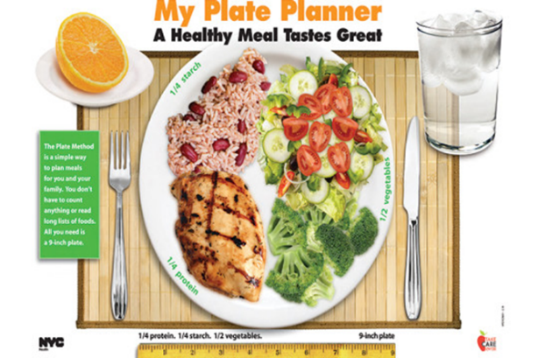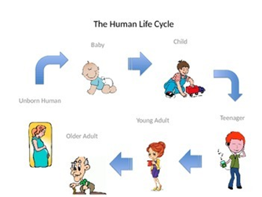
Nutrition Change

Did you know…
Babies have 30000 taste buds and adults only have 10000!
The height that you are at 2 years old if doubled, will be the height you will be as a fully grown adult.
Your ears and nose never stop growing!

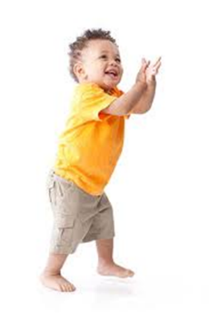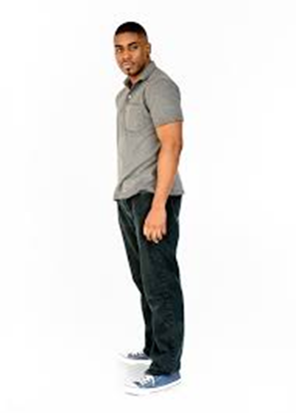
Baby Toddler Child Adult

Widewell Primary Academy Knowledge Organiser

Topic: How is where I live different to where other people live? England - Plymouth & South Africa – Cape Town |  |  | Year EYFS |  | Term Autumn 2  cycle A
Vocabulary bank
Key vocabulary | Definition | Key vocabulary |  | Definition
Same | When things are the same. | Landmark |  | An object or feature of a place that helps you to identify where you are.
Different | When things are not the same. | Language |  | How we use words and body language to tell people things.
Similar | Looking or being almost the same, but not exactly the same. | Education |  | When we learn new things.
Culture / Cultural | The ideas, customs and celebrations that different people have. | Population |  | All the people that live in one place.
Traditions | Something special that has been done for a long time in a family. | Housing |  | Buildings that people live in.

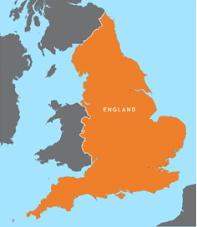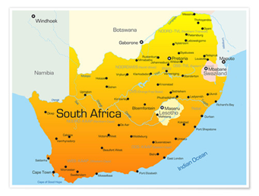

Fact file
England | South Africa
Population: England 55 million  Plymouth 230000  Size: England 50000 square miles  Plymouth 30 square miles | Population: South Africa 56 million  Cape Town 430000  Size: South Africa 460000 square miles  Cape Town 154 square miles

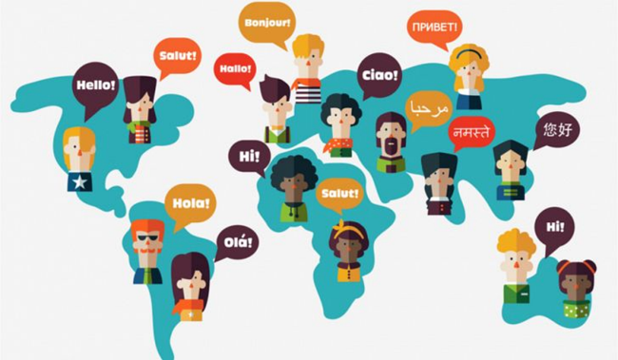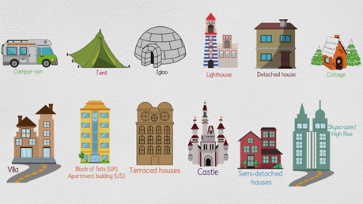
Language Housing

