Nightingale Class Newsletter – Summer Term 2018
Welcome back. I hope everyone had a relaxing Easter break and is ready for the summer term. We study two topics during the summer. Term 1 takes us back to the Tudor period where we will be finding out whether Sir Francis Drake was a pirate or not. We will be learning more about Tudor times, concentrating on seafarers and pirates. We will be finding out about the life of Sir Francis Drake and his link to Plymouth. During term 2 we find out about Dartmoor. This is a whole school project so we will share our findings with other classes. Our science topic this half term is habitats. After half term, we look at plants. We would also like to welcome Miss Russell who is a student teacher. She will be teaching year 3 for the majority of this term. She looks forward to meeting you all.
Our curriculum overview is as follows:
TOPIC 1 - HISTORY Was Sir Francis Drake a pirate?
TOPIC 2 – GEOGRAPHY Dartmoor

ENGLISH
Traditional tales
Playscripts
Diary entries

MATHS
Volume, mass, measuring, statistics

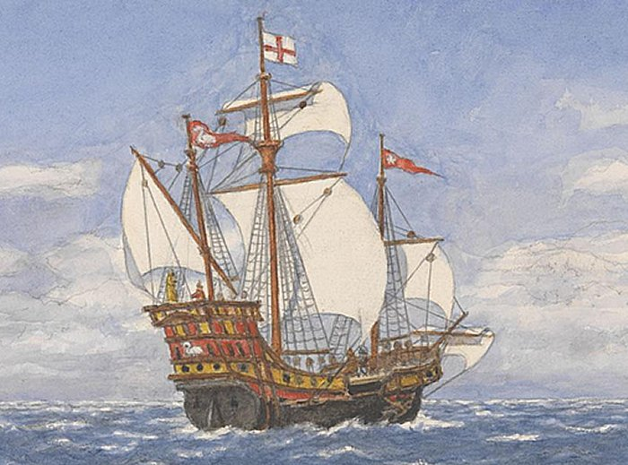
PE Athletics, rounders and tennis
SCIENCE
Habitats and plants

Sir Francis Drake

COMPUTING
We are opinion pollsters

ART
Tudor portraits
Clay habitats

MUSIC
Brass/ukulele
RE/PSHE
Judaism

The class will continue to have their PE lessons on a Monday and a Wednesday. It is likely that the majority of PE lessons this term will be outside so please make sure your child has suitable trainers. If the weather gets warmer please include some sun cream, a hat and a water bottle. It is vital that the children have their PE kit in school for all PE sessions. Please make sure that everything is named.
A quick reminder that homework cards should be signed by an adult and handed in every Friday. Reading records should be brought to school every day. They also need to be signed by an adult every week and handed in with the homework cards.
If you have any queries or concerns please come and see me on the playground in the morning or after school. If you would like a longer appointment this can be arranged via the school office.
Yours sincerely,

Mrs Heard
Year 3 Class Teacher
Widewell Primary School, Lulworth Drive, Roborough, Plymouth PL6 7ER 01752 778796 / widewell.primary.school@plymouth.gov.uk Mrs Claire Prynne, Headteacher

