WEEK A
MONDAY | TUESDAY | WEDNESDAY | THURSDAY | FRIDAY
English | English | English | English | English
Break Time
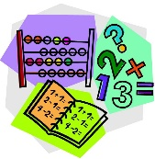Maths | Maths | Maths | Maths | Maths
Lunch Time
Computing | PE | 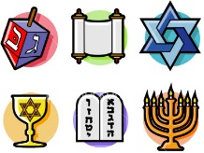RE | Topic
French |  | 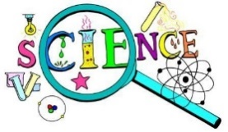 Science | Art | Music
WEEK B
MONDAY | TUESDAY | WEDNESDAY | THURSDAY | FRIDAY
English | English | Maths | English | English
Break Time
Maths | Maths | PE | Maths | Maths
Lunch Time
 |  | English
Computing |  |  | Topic | Music
French | PE | Science | Art | 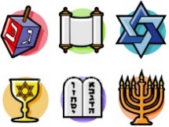RE

