Set – Due in | 2.11.18 – 7.11.18 |  |  |  |  |  | 9.11.18 – 14.1118 |  |  |  |  |  | 16.11.18 – 21.11.18 |  |  |  |  |  |  | 23.11.18 – 28.11.18 |  |  |  |  |  | 30.11.18 – 5.12.18 |  |  |  |  |  | 7.12.18 – 12.12.18 |  |  |  |  |  | Set – Due in
Reading | Please add your comments to the reading record each week and encourage your child to add their own comments. These should be brought to school daily. |  |  |  |  |  |  |  |  |  |  |  |  |  |  |  |  |  |  | Please add your comments to the reading record each week and encourage your child to add their own comments. These should be brought to school daily. |  |  |  |  |  |  |  |  |  |  |  |  |  |  |  |  |  | Reading
 | Parent Signature |  |  |  |  |  | Parent Signature |  |  |  |  |  | Parent Signature |  |  |  |  |  |  | Parent Signature |  |  |  |  |  | Parent Signature |  |  |  |  |  | Parent Signature
 | Teacher Signature |  |  |  |  |  | Teacher Signature |  |  |  |  |  | Teacher Signature |  |  |  |  |  |  | Teacher Signature |  |  |  |  |  | Teacher Signature |  |  |  |  |  | Teacher Signature
Spellings | ibly / ably suffix |  |  |  |  |  | Mixed practise |  |  |  |  |  | ent suffix |  |  |  |  |  |  | y5/6word list spellings |  |  |  |  |  | enc letter string |  |  |  |  |  | year 5/6 word list spellings |  |  |  |  |  | Spellings
 | Test Result |  |  |  |  |  | Test Result |  |  |  |  |  | Test Result |  |  |  |  |  |  | Test Result |  |  |  |  |  | Test Result |  |  |  |  |  | Test Result
Maths |  |  |  |  |  |  |  |  |  |  |  |  |  |  |  |  |  |  |  |  |  |  |  |  |  |  |  |  |  |  |  |  |  |  |  |  |  | Maths
 | Test Result |  |  |  |  |  | Test Result |  |  |  |  |  | Test Result |  |  |  |  |  |  | Test Result |  |  |  |  |  | Test Result |  |  |  |  |  | Test Result
Topic activity | Write a fact-file about the First World War |  |  |  |  |  | Design a poster for anti-bullying week |  |  |  |  |  | Survival Snacks – bring in a snack bar wrapper that would be good for a natural disaster survival pack |  |  |  |  |  |  | design a maths game using multiplication |  |  |  |  |  | Write a story inspired by the visit from Steve Clifford |  |  |  |  |  | research Christmas traditions around the world |  |  |  |  |  | Topic activity
Wow Activities!  Let us know what else you’ve achieved this week. |  |  |  |  |  |  |  |  |  |  |  |  |  |  |  |  |  |  |  |  |  |  |  |  |  |  |  |  |  |  |  |  |  |  |  |  |  | Wow Activities!  Let us know what else you’ve achieved this week.

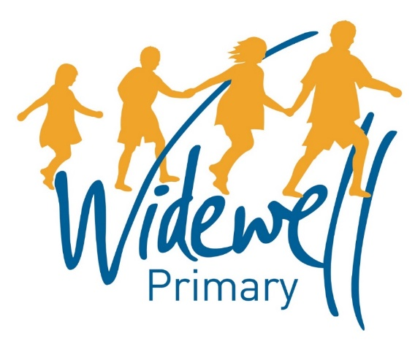

KS2
Homework Card
Autumn Term 1 2018

Name: ______________________
Class: Kestrel Year 5

Reading, spelling and maths activities are starred and must be completed each week as they support your learning in class.
Topic activities are optional and you may choose to complete them as they will also help your learning in your class topic this term.
Wow activities can be filled in by you to show us what else you do outside school e.g. taking part in a club; cooking a meal with your family; building a den; playing an instrument.
Homework club is taking place every Friday from 3.30pm to 4.30pm. You can drop in to get advice about your homework or stay for the hour and complete lots of your homework before the weekend!

