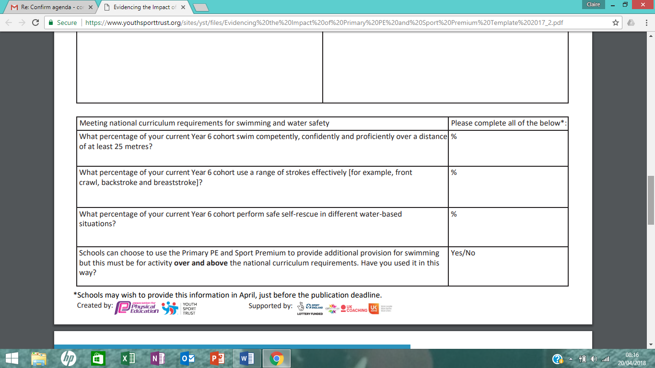

We will use the funding for top up swimming in the summer term.

100 %

78%

77 %