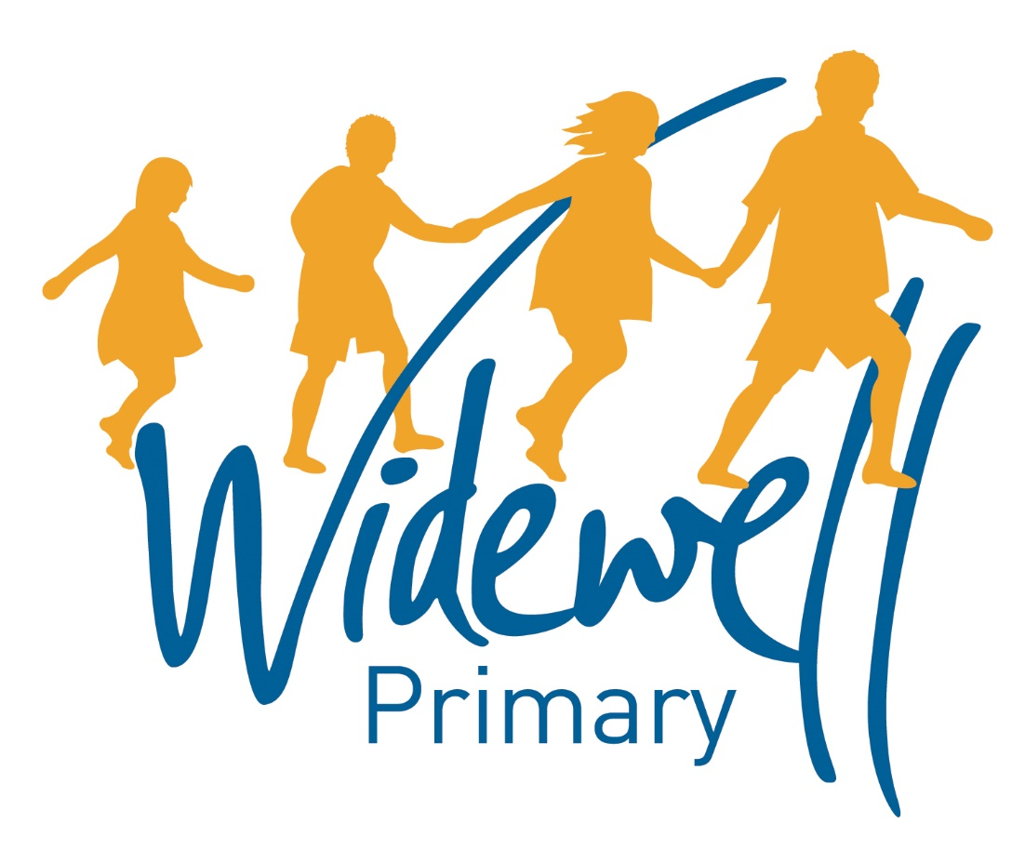

Foundation Stage
Homework Card
Autumn 1

Name _________________________________
Class: Robin

Reading is starred and must be completed each week as this supports your child’s learning in class.

Set – Due in: | 9.09.2019 |  | 16.09.2019 |  | 23.09.2019
Reading  At least 5 times each week | Please record reading in the Reading Record.
 | Reading Record completed (home) |  | Reading Record completed (home) |  | Reading Record completed (home)
 | Reading Record checked (school) |  | Reading Record checked (school) |  | Reading Record checked (school)
Sounds and  Talk Time | Talk Time  Tell an adult about something you have really enjoyed playing with at school. |  | Sounds  Play a rhyming game  (see attached guidance sheet) |  | Talk Time  Play ‘Favourite Things’ with your family.  “My favourite. (place/toy/song) is........... because …........”
Maths | Counting  Can you sing some counting songs and practise showing the numbers using your fingers? Try and sing some with an adult every week |  | Number recognition  Can you go on a number hunt around your house or where you live? What numbers do you recognise? How could you record numbers you find? |  | Shape recognition  Can you go on a shape hunt to look for circles, squares, rectangles and triangles? Talk with an adult about the shapes – What do they look like? What do they have?
Topic activity
 | Look at baby photos/ videos of yourself or your family members.  Talk about how different you look and how much you have changed. |  | Using technology or a book with an adult helping, can you find out an interesting fact about babies? |  | Talk with an adult what food you ate when you were a baby.  Can you try some now?  Do you think you would still like it?
Wow Activities!
Let us know what else you’ve achieved this week.

30.09.2019 |  | 7.10.2019 |  | 14.10.2019
Please record reading in the Reading Record. |  |  |  |  |  | Reading  At least 5 times each week
Reading Record completed (home) |  | Reading Record completed (home) |  | Reading Record completed (home)
Reading Record checked (school) |  | Reading Record checked (school) |  | Reading Record checked (school)
Talk  Read one of your favourite stories with an adult.  Can you retell the story by yourself but looking at the illustrations?  Can you retell the story without looking at the illustrations? |  | Sounds  Play an alliteration game  (see attached guidance sheet) |  | Sounds  Go on a listening walk around your local area. What sounds can you hear? Are they all different? |  | Sounds and  Talk Time
Counting  Ask an adult to show or say a number, can you count out that amount of objects? You could count your toys, fruit, stones or whatever you like! |  | Number recognition  Using numbered pieces of paper from 1 to 5 or magnetic numbers, can you put the numbers in the correct order? |  | Counting  Using amounts of objects up to 5, can you practise touching each object as you count? |  | Maths
 |  |  |  |  |  | Topic activity
Using the provided activity sheet, can you put the children into a line of youngest to oldest.  Do you think the baby can do all the things the bigger children can do? |  | Talk to your adults about what babies need every day such as; sleep, milk, tummy time.  Do you still need all these things every day?  What things do you need now? |  | Using different materials that you have at home, can you design a baby onesie?  Talk about the clothes you wear now you’re older, are these clothes different to when you were a baby?
Wow Activities!
Let us know what else you’ve achieved this week.

Please record and share photos or videos of these activities using Tapestry.

The topic activity is optional, and you may choose to complete it as it will also help your learning in your class topic this term.

Wow Activities can be filled in by you to show us what else you do outside school e.g. taking part in a club; cooking a meal with your family; building a den; playing an instrument.

Thank you for your support.

