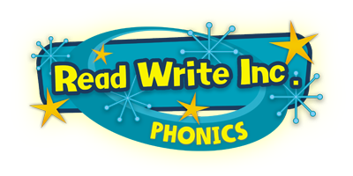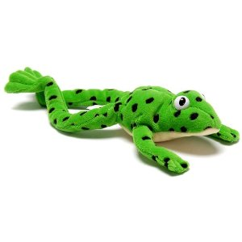

Fred frog helps children to Fred talk each sound and make into a word. Green words can be sounded out.
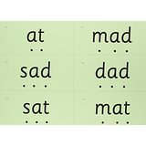

Fred helps children learn to read.
Fred can only talk in sounds... (Fred can only say h_a_t, he can’t say hat).
We call this Fred Talk… h-a-t sh-i-p s-igh-t

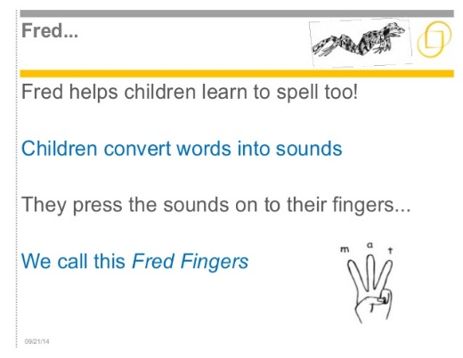
Red words we just have to know.

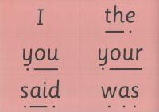

Alien words do not make any sense! 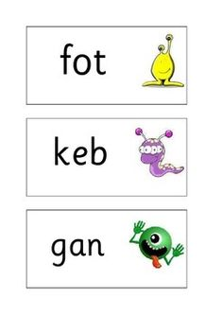

Reading
When using Read Write Inc. to READ the children will:
Learn 44 sounds and the corresponding letter/letter groups using simple picture prompts.
Learn to read words using sound blending (Fred talk) read lively stories featuring words they have.
Learn to sound out and show that they comprehend the stories by answering ‘Find It’ and ‘Prove It’ discussion questions.
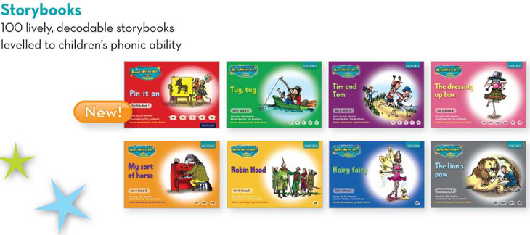
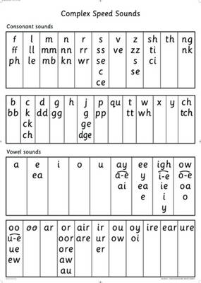
Sounds we learn at School.

Writing
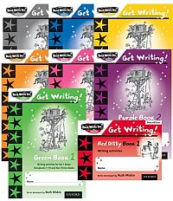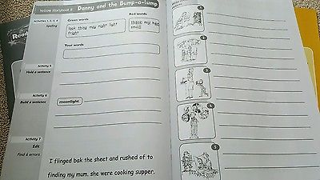

When using Read Write Inc. to write the children will:
Learn to write the letters/letter groups which represent the 44 sounds.
Learn to write words by saying the sounds and graphemes (Fred fingers).
Learn to write simple then more complex sentences.
Use power words to enhance quality of writing.
Edit sentences by correcting.
Spelling and punctuation.
Compose stories based on picture strips.
Compose a range of texts using discussion prompts.

Letter Formation-Handwriting
Nursery and Foundation stage do basic handwriting forms.
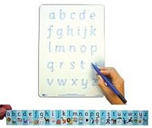

Read Write Inc. Letter Rhymes

Here is a list of the letter sounds and their rhymes to help the children with writing letters at school:

a Round the apple down the leaf (apple).
b Down the laces to the heel, round the toe (boot).
c Curl around the caterpillar (caterpillar).
d Round his bottom up his tall neck and down to his feet (dinosaur).
e Lift off the top and scoop out the egg (egg).
f Down the stem, and draw the leaves (flower).
g Round her face down her hair and give her a curl (girl).
h Down the head to the hooves and over his back (horse).
i Down his body, and dot for his head (insect).
j Down his body curl and dot (jack-in-the box).
k Down the kangaroo’s body, tail and leg (kangaroo).
l Down the long leg (leg).
m Down Maisie, over the mountain over the mountain (Maisie and
mountains).
n Down Nobby, over his net (football net).
o All around the orange (orange).
p Down his plait and around his head (pirate).
q Round her head, up past her earrings and down her hair (queen).
r Down his back, then curl over his arm (robot).
s Slither down the snake (snake).
t Down the tower across the tower (castle tower).
u Down and under, up to the top and draw the puddle (umbrella).
v Down a wing, up a wing (vulture).
w Down up down up (worm).
x Down the arm and leg and repeat the other side (exercise).
y Down a horn up a horn and under his head (yak).
z Zig-zag-zig (zip).

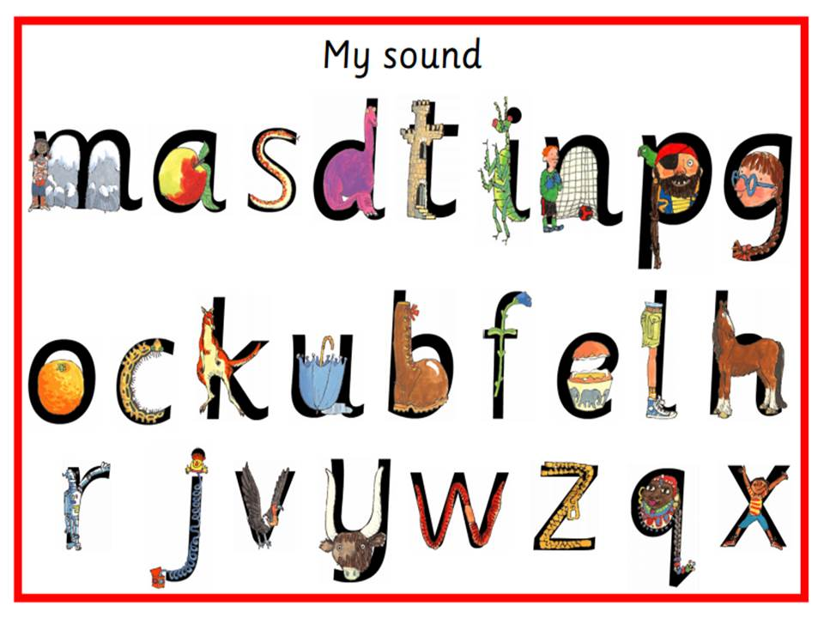
(Year 1 onwards use cursive scripts.)

Talking
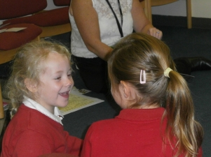
When using Read Write Inc the children will also work in PAIRS:
To answer questions
To practise every activity
To take turns talking to each other
To give positive praise to each other

What can I do to help my child?
By having a look at the parents’ information for tips and resources for supporting your child at home:
https://global.oup.com/education/content/primary/series/rwi/parents/
http://www.oxfordowl.co.uk/home/reading-site/expert-help/ruth-miskinsvideo-page?region=uk

And... By reading your child lots of different stories and asking lots of questions!
What is the character thinking?
How is the character feeling?
What do you think the character might be saying?
What is happening now?
How do you think the story should end?
Also talking to your child as much as possible and developing their vocabulary
I’m hungry, actually I’m ravenous!
If you require any other information please speak to your child’s teacher and take a look at Read Write Inc. website for parents’ information on how to support your child at key stage 1 and key stage 2 with reading and sound work.
http://www.ruthmiskin.com/en/parents/

