Wednesday 12th September 2018
Dear Parents and Carers,

Welcome to year 5, Kestrel Class. Your child’s teachers are Mrs Clewer, Miss Luscombe and Mrs Dunne. This year we have got a two weekly timetable which will be on the class website and displayed in the classroom.

This term our topic is ‘Angry Earth’. We will be finding out about volcanoes, earthquakes and tsunamis. We will be learning how they happen and how they affect local people. We will also be using our topic to inspire art this term. If you have any photographs or artefacts relating to this topic we would love to see them.
Children will need to bring their reading book and reading record in every day. Please also make sure that they have a waterproof coat and a water bottle with them.

Maths and spellings homework will be sent home every Friday for a test the following Wednesday. The results of these tests are always recorded in your child’s homework card. You can continue to support your child by listening to them read as often as you can and by encouraging them to practise their times tables at home. Could you please sign your child’s reading record to validate any reading that they have done at home. We would love to be the first class in the school to achieve 100% of homework handed in.

The children will have PE on Tuesday and Wednesday every week – please ensure that they have their PE kit in school. These lessons will be taught by Mr Hilling.

If you have any queries or concerns please call into school, write a note or leave a message with reception. Keep checking our class webpage (on the school website) for information, news and photographs throughout the term.

Mrs Clewer, Miss Luscombe and Mrs Dunne

English

- Instructions

- Narrative

- Journalistic writing

Science
- Investigating conductors
- Dissolving and separating materials
- Irreversible changes

Topic
- How volcanoes are formed
- Why tsunamis occur
- The human impact

Music

- tempo, pace and duration

- Composition inspired by Angry Earth

Computing
- Understanding how to code
- Applying coding knowledge to create a game

French
- Numbers to 100
- Basic conversational phrases
- Classroom vocabulary

RE
- Understanding how religion is expressed through art
- Reflecting on types of religious expression

Why is the Earth angry?

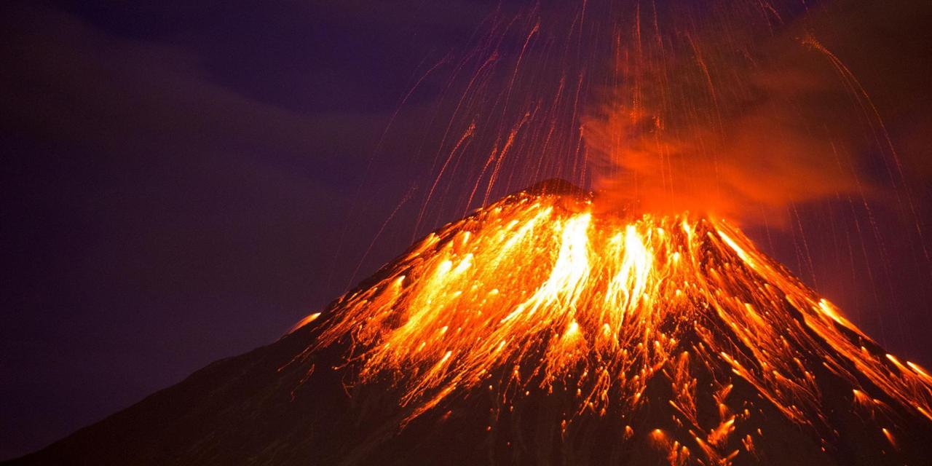

PE
- Invasion games
- Dance
- Outdoor education

Maths
- Place value
- Addition and subtraction
- multiplication

Art
- Looking at the work of Hokusai
- Exploring print techniques
- Creating their own designs

