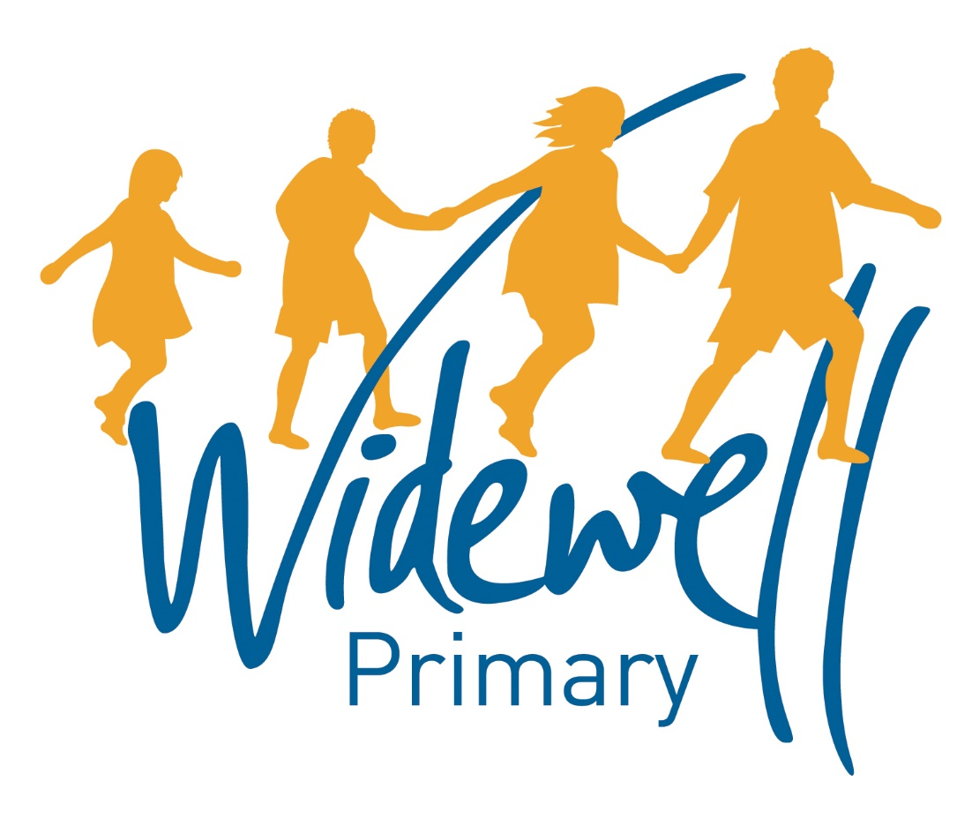

Nursery
Homework Card
Spring 1

Name _________________________________
Class: Robin

Reading is starred and must be completed each week as this supports your child’s learning in class.

Set – Due in: | 6.01.20-13.01.20 |  | 13.01.20-20.01.20 |  | 20.01.20-27.01.20
Reading  At least 5 times each week | Please record reading in the Reading Record.
 | Reading Record completed (home) |  | Reading Record completed (home) |  | Reading Record completed (home)
 | Reading Record checked (school) |  | Reading Record checked (school) |  | Reading Record checked (school)
Sounds and  Talk Time | Talk  Discuss Fire Safety at home. Do we touch fire?  Do you have a fire place?  Do you have hobs for cooking?  What is your fire alarm for? |  | Mark Making  Can you practise writing your name?  Can you say the first sound in your name? |  | Talk  Discuss dental health at home.  Why do we have teeth?  What do we use them for?  Why do we need to brush them?  What happens if we don’t?
Maths | Number  Can you count all the way up to ten?  Can you count backwards like an astronaut? |  | Shape  Using objects from your house, can you build a house? Make a den? Build a tower? |  | Measure  Can you play ‘hide the toy’ with your adult and give them clues using positional language: over, under, above, next to, in front, behind.
Topic activity | How can people help us? |  | How can people help us? |  | How can people help us?
 | Have you ever seen a Fire Engine? What colours does it have? What sound does it make?  Using materials from home, can you make your own? |  | Have you ever heard your fire alarm in your house? What noise do you think it makes?  Ask an adult to help you find it in your own. |  | What do dentists do?  Have you been to a dentist before?  Using materials from home, can you make a tooth brush for a Gruffalo?
Wow Activities!
Let us know what else you’ve achieved this week.

27.01.20-3.02.20 |  | 3.02.20-10.02.20 |  | 10.02.20-14.02.20
Please record reading in the Reading Record. |  |  |  |  |  | Reading  At least 5 times each week
Reading Record completed (home) |  | Reading Record completed (home) |  | Reading Record completed (home)
Reading Record checked (school) |  | Reading Record checked (school) |  | Reading Record checked (school)
Sounds  Can you list, or draw pictures, of all the things you can think of that begin with:  ‘s’ ‘a’ and ‘m’ |  | Talk  Discuss with an adult what you need to buy from the shop.  What do you eat lots of in your home?  What would you like to cook at home?  What would you like to try that’s new? |  | Mark Making  With an adult, try and write (or draw) a list of food you need from the shop. |  | Sounds and  Talk Time
Number  Can you count your:  eyes, nose, ears, hands, fingers, toes, feet? |  | Shape  Using different shapes, can you make a: robot, a flower, a car, a house? |  | Measure  Using food in your house, can you talk about how many cans you have, how much fruit you have, how many cereal boxes you have, how many bottles you have?  What do you have the most of? |  | Maths
How can people help us? |  | How can people help us? |  | How can people help us? |  | Topic activity
How do we keep our teeth clean?  Can you make your own toothpaste mixture at home? |  | Where do we buy our food from?  What shops do you use?  Can you draw a picture of your shop and all the food you love to buy? |  | Can you help your adult to buy food from a shop?  Can you write a list?  Can you help to pack the food in bags?  Can you help to put it away at home?
Wow Activities!
Let us know what else you’ve achieved this week.

Please record and share photos or videos of these activities using Tapestry.

The topic activity is optional, and you may choose to complete it as it will also help your learning in your class topic this term.

Wow Activities can be filled in by you to show us what else you do outside school e.g. taking part in a club; cooking a meal with your family; building a den; playing an instrument.

Thank you for your support.

