

**Prospectus 2017 – 18**

**Widewell Primary Academy**

Widewell Primary Academy

Lulworth Drive

Roborough

Plymouth

PL6 7ER

Tel: 01752 778796

Fax: 01752 770962

Email: [widewell.primary.school@plymouth.gov.uk](mailto:widewell.primary.school@plymouth.gov.uk)

Website: <http://widewellprimary.eschools.co.uk/website>

Facebook page [www.facebook.com/WidewellPrimary](http://www.facebok.com/WidewellPrimary)

Twitter Account twitter.com/widewellprimary



Dear Parent / Carer

**Welcome to Widewell Primary Academy**.

At Widewell we welcome all and believe everyone matters. This prospectus has been put together to help you gain an understanding of how our school is organised, and to appreciate the exciting opportunities on offer to children in our care. All schools have their own distinctive ‘feel’ which makes each one unique. We believe that the ‘special feel’ at Widewell Primary Academy is linked with our positive, caring but challenging learning environment. Our school continues to develop in many exciting and innovative ways as part of the Horizon Multi-Academy Trust, providing an even more enriching experience for our pupils.

I am extremely proud to lead a team that is committed to achieving high standards and providing the very best opportunities for the children in our care. Staff, supported by governors, work hard to deliver a rich and challenging curriculum; to prepare children for future education; and to help them acquire the skills and enthusiasm needed to pursue learning for the rest of their lives. We encourage high standards from everyone academically, socially, physically, emotionally and spiritually.

Education is a partnership between home and school and the best way to find out about our school is to come and visit, to see us in action and meet staff and children. A telephone call to the school office on 01752 778796 is all that is needed to arrange this. We look forward to welcoming you to our school, and to a happy and successful partnership with all our new children and families.

Yours sincerely

Claire Prynne Paul Gale

Headteacher Chair of Governors

**About our school**

**OUR VISION**

**A place of excellence and innovation, where children’s skills, knowledge and values grow.**

THE STRATEGIC VISION FOR WIDEWELL PRIMARY ACADEMY:

• A stimulating environment in which children are nurtured, feel secure, confident, enthused and motivated to learn through a distinctive curriculum.

• Highly trained and caring teachers, and support staff, who are dedicated to maximising the individual talent and capability of every child.

• Provision of high quality facilities and tools essential to an enhanced learning environment.

• Open to, and embracing of, the hopes and ambitions of the parent body and encouraging their engagement in the school.

• Providing pupils with the skill sets and motivation to be able to achieve in the next stages of their education, by providing a foundation for life beyond Widewell.

• A respect for the natural environment and the world around them.

• To be a congregational focus at the heart of the Widewell community that contributes to its opportunities and cohesion.

WIDEWELL PRIMARY ACADEMY WILL BE A CENTRE:

• for learning where high standards are pursued with consistency and enthusiasm.

• where individuals are valued and helped to achieve their personal best.

• where effective partnerships secure the success of the school.

**OUR ETHOS**

Widewell Primary Academy serves its community by working in partnership to provide an education of the highest quality with an understanding of shared values. As a school, we celebrate the diversity of the wider community and are committed to the principles of inclusion and equality of opportunity.

**OUR VALUES**

Values are fundamental expressions of what we think and believe. As a school, we encourage children to think about personal and social values, to become aware of and involved in the life and concerns of their community and society, and so develop their capacity to be active and effective future citizens

AT WIDEWELL PRIMARY ACADEMY OUR CORE VALUES ARE:

FRIENDSHIP

We value friendship as fundamental to the development and fulfilment of ourselves and others, and the good of the community.

RESPECT

Develop self-respect and respect for others. Promote inclusion, and appreciate and value the diversity of people’s circumstances and backgrounds.

RESPONSIBILITY

Take responsibility for the way we lead our lives and how we use our talents, rights and opportunities.

PERSEVERANCE

Maintain a ‘can do’ attitude and aspire to achieve goals.

KINDNESS

Show care and concern, and exercise goodwill towards others.

**OUR AIMS**

Our aims reflect our beliefs and values, and represent our vision of what we want to achieve as a school community. Our aims are translated into priorities to move the school forward and meet the challenges of an ever changing world.

CELEBRATE SUCCESS

Nurture self-esteem through the celebration of children’s achievements.

VALUES CENTRED

Promote inclusive values and foster positive attitudes to all people, races, religions and ways of life.

DYNAMIC AND INNOVATIVE

Deliver a dynamic and innovative curriculum that challenges, excites and inspires children to achieve their best.

ACCOUNTABLE AT ALL LEVELS

Promote collective responsibility for raised standards and improved pupil outcomes by ensuring that everyone understands their role in contributing to the success of the school.

LEARNING CENTRED

Create an inclusive learning culture where children and others within the school community are challenged in their thinking, strive for continuous improvement and are committed to life-long learning.

COMMUNITY ORIENTATED

Help children develop an understanding of citizenship and empower them to make valuable contributions locally and globally. Engage with the school and wider community to enrich and enhance children’s achievement and personal development.

HIGH EXPECTATIONS

Set high expectations to enable pupils to become effective, enthusiastic, independent learners.

CARING AND SUPPORTIVE

Create a happy, caring and supportive environment based on a spirit of co-operation between the school and the local community. Ensure the safety of every child and promote opportunities to adopt a healthy and active lifestyle.

INCLUSION

Treat children and others fairly, equitably and with dignity and respect, to maintain an inclusive school culture.

WELL ORGANISED AND SYSTEMATIC

Embed consistently applied policies and practices that ensure the effective day-to-day running of the school and support strategic leadership and management.

**School Organisation**

The school is currently completing a redecoration programme to ensure the learning environment reflects the high standards we expect from our staff and pupils. As the building work for our new roof and the refurbishment of the junior toilet block and many of the classrooms are now complete, the school is beginning to have a much more modern feel.

Our Foundation Unit and outside learning environment for our children in Nursery and Reception already lend themselves to high quality provision and the provision of a wide range of opportunities for our youngest pupils. We benefit from a large hall with an inbuilt stage area, a well-equipped library, spaces for group work and meetings. We have also developed a nurture room where our PSA is based.

We have extensive grounds with hard surface areas, a spacious playing field, adventure playground pirate ship and a woodland conservation area.

NURSERY

Children are entitled to spend up to five terms in the Nursery, accessing morning or afternoon sessions (mornings: 8.45-11.45am and afternoons: 12.30-3.30pm) from the start of the term after their third birthday. Some parents choose for their children to stay all day and pay an additional charge for lunchtime provision. Some children may be eligible for 30 hours free childcare and the information can be found at <https://www.gov.uk/government/publications/30-hours-free-childcare-eligibility>

CLASS ORGANISATION

We are a single form entry school with a maximum of 30 children in each class. In September 2017 we have 7 classes, plus the nursery offering part time places for up to 25 children per session.

Each class is taught by a fully qualified teacher who is often assisted by a Teaching Assistant. All our teachers have half a day each week to support planning and assessment. Our pupils also have additional opportunities to be taught by specialist staff, especially in music (brass, ukulele and guitar), PE and outdoor education.

Organisation of NURSERY AND PRIMARY EDUCATION

|  |  |  |  |
| --- | --- | --- | --- |
| Age | Class | Stage | Class Name |
| 3 - 4 years | Nursery | Foundation Stage | Robin |
| 4 - 5 years | Reception | Wren |
| 5 - 6 years | Y1 | Key Stage 1 | Starling |
| 6 - 7 years | Y2 | Kingfisher |
| 7 - 8 years | Y3 | Lower Key Stage 2 | Nightingale |
| 8 - 9 years | Y4 | Owl |
| 9 - 10 years | Y5 | Upper Key Stage 2 | Kestrel |
| 10 - 11 years | Y6 | Falcon |

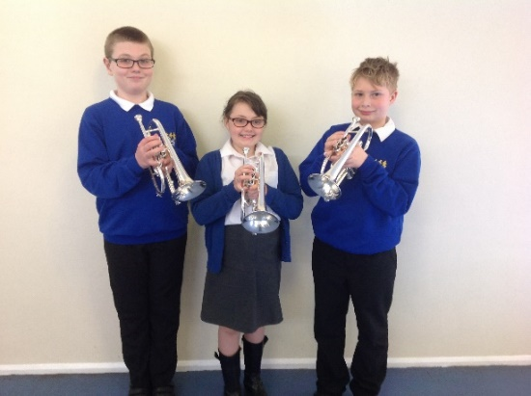 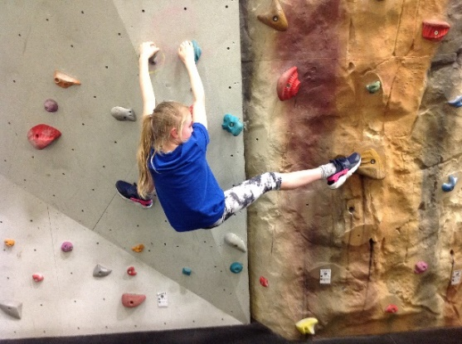

**Parents in partnership**

We welcome parents and carers into Widewell Primary Academy, believing we are partners in the education of your children. There are many opportunities for parents to become involved in the life of the school and to gain a greater understanding of its work. Parents’ support and expertise can be used in many ways and is greatly valued. Police checks and DBS checks are carried out on all adults working in school including regular volunteers. If you are able to volunteer your time, please talk to your child’s teacher or our PSA. We appreciate parents listening to children read, offering DIY skills and to attend school and WPTA events.

COMMUNICATION WITH PARENTS

We communicate with parents and carers in various ways, for example through our fortnightly newsletters, school Facebook page, Twitter posts, questionnaires, workshops and informal social events. Parents are regularly invited to assemblies, Open Afternoons and to Parents’ Evenings. Every year parents and others are invited to attend our Sports’ Day as well as children’s performances.

Staff are always happy to meet with parents and carers to share any concerns. The school’s website has a wealth of information including our newsletters, class pages, copies of key policies and our latest Ofsted report (May 2016).

WIDEWELL PARENT TEACHER ASSOCIATION (WPTA)

The WPTA exists to support the life and work of the school, is open to all members of the school community and is a great way for parents to get more closely involved with the school.

Fundraising is clearly an important part of the WPTA, who provide invaluable support to the school through organising many fun social and fundraising events involving parents and the wider local community including Bingo, Discos, Summer Fairs, and quiz nights. Money raised provides extra facilities and equipment for the pupils, including the overhead projector in the hall, days out excursions, the pirate ship, a PA system plus additional little extras to benefit the children who attend. The group holds regular meetings in school, with dates and details published in the school’s newsletter. The WPTA identifies long and short-term projects for its fundraising which enables us to buy ‘special’ extras to enhance pupils’ school experience.

The WPTA needs the support of parents to ensure it is able to continue to enrich the lives of children. As a new member of our school community we hope you will be able to add your support to the work of the Association.

GOVERNANCE

The Local Governing Body of the school is made up of people from a variety of backgrounds. The school governors are a group of individuals, who are elected, nominated or co-opted and are representative of parents and staff, and the local community. School Governors work with the Headteacher and are responsible for setting the strategic direction of the school. Meetings are usually held once each half term. The Trust Board is made up of key people with set skills who have an oversite of the multi-academy trust as a whole.

Our current Local Governing Body consists of:

Mr Paul Gale Chair Mrs Jenny Kerr Staff Governor Mr Matthew Maclean Parent Governor

Mr Chris Phillips Vice Chair Mrs Beverley Holder Staff Governor Mr Allan Evans Parent Governor

Mrs Claire Prynne Headteacher Mrs Georgina El Morshdy Governor Mr Scott Kerrison Governor

Mrs Jackie Carter Governor

The Trust Board of the Horizon Multi-Academy Trust consists of

Stu Jones: Chairperson Funding and project consultant and former manager of several Outdoor Education centres. Currently on the national board of the National Schools Sailing Association.

Paul Gale: Finance Director, Business/Finance/ Management Skills. Regional Finance Director [Retired] at Westcountry Publications Ltd.,

Frieda Court: Business and former Legal Secretary Business Skills – PA/Office Manager mainly within the construction industry,

Chris Redding: Business/Finance Skills as CEO at Peninsula Enterprise (SERCO subdivision),

Emma Roberts: HR Skills UK, HR manager at West Pharmaceutical Services Cornwall Ltd,

John Dobson: Business and Building, Former CEO of Construction Company,

Allan Evans: Currently a sergeant in the Ministry of Defence Police and based in Plymouth.

Sue Shelley: Education, SEND Leadership Advisor Plymouth City Council,

David Bradford CEO: NLE and has been head of 2 schools. Currently head of Elburton Primary School.

**Joining the school**

ADMISSION ARRANGEMENTS

Administration of admission arrangements to Plymouth schools is dealt with centrally by Plymouth City Council. A booklet, ‘Starting School’, setting out the Reception admissions procedures and criteria for each school, together with an application (Common Admission Preference Form) is available from the City Council Admissions Team. Completed forms, or online admissions must be returned to the School Admission Team or first preference school by the submission date in the Autumn Term prior to starting. The Horizon MAT admissions policy is published annually on the website.

Parents and carers of children seeking to join the school in other years, should in the first instance contact the In-year Admissions Team of the City Council on 01752 307170 / 307467 or at inyear.admissions@plymouth.gov.uk

Widewell Primary Academy welcomes children regardless of special needs or disability. Pupils with additional needs may have extra visits before starting school and there will be close liaison with parents to ensure that the correct arrangements are in place.

APPEALS

Every effort is made to make a place available for your child in our school. However, all schools have a limit on the number of children they can take. In the case of Widewell Primary Academy this is 30 in each year group.

If the number of children wanting a place is below the set figure, your child will be offered a place. There may, however, come a point when there are too many children of that year group for them all to be given a place. If a place is not available on application you have the right to appeal to Plymouth City Council Education Authority. Appeals are heard by an independent panel. A Guide to Admission Appeals can be obtained from the Admissions Team via the City Council website: www.plymouth.gov.uk

STARTING SCHOOL FOR THE FIRST TIME

Starting school is a very important time for you, your child and the school. We all need to work together to make the transition smooth and rewarding. In the term prior to their entry, pupils are invited into school for visits and parents are offered home visits. This will help them become familiar with the surroundings and routines of school. During this period, there will be meetings for parents to discuss our partnership with you and talk about any concerns you might have.

Pupils will be admitted to Widewell Primary Academy in the September of the academic year in which they are five. The Early Years Curriculum is grounded in active learning. Through practical activities, purposeful play and talk, pupils develop an understanding of the world and the basic concepts they will need for their later learning. Parents can play a major role in fostering good attitudes to learning, developing language skills and promoting good behaviour.

Every child deserves the best possible start in life and the support that enables them to fulfil their potential. Children develop quickly in the early years and a child’s experiences between birth and age five have a major impact on their future life chances. A secure, safe and happy childhood is important in its own right. Good parenting and high quality early learning together provide the foundation children need to make the most of their abilities and talents as they grow up.

The Early Years Foundation Stage (EYFS) sets the standards that all Early Years’ providers must meet to ensure that children learn and develop well and are kept healthy and safe. It promotes teaching and learning to ensure children’s ‘school readiness’ and gives children the broad range of knowledge and skills that provide the right foundation for good future progress through school and life.

At Widewell Primary Academy we value the potential of home-school links and make every effort to involve parents in the learning and development of their child. At the start of each new school year, class teachers run workshops about the curriculum and how parents can help their child at home.

JOINING THE SCHOOL LATER ON

Sometimes children join the school later on in their school life. We make every effort to ensure they are welcomed, looked after, and monitored so that they quickly make friends and can find their way around the school. Children’s academic abilities are assessed soon after their entry to school. This assessment, together with records from the previous school, will enable your child to have the best start in our school. You will be contacted by our PSA or ELSA TA a few weeks after your child has started school but parents and carers are asked to contact the school if their child has difficulty settling.

MOVING ON - TRANSFERRING TO SECONDARY SCHOOL

At the end of primary school, children transfer to a secondary school. The large majority of children go on to Tor Bridge High School, however our pupils also transfer to Plymouth High School for Girls, Devonport High School for Girls, Devonport High School for Boys, Sir John Hunt Community Sports College, Notre Dame Roman Catholic School, St Boniface’s Roman Catholic College, Plymouth College and the School for Creative Arts. We have strong links with both Tor Bridge and Sir John Hunt through the curriculum and community events. Year 6 pupils have opportunities to meet staff from their chosen secondary school and to spend at least a day at their new school as part of an induction programme. This is seen as a very positive process ensuring a smooth transfer.

**The curriculum**

The school curriculum comprises all learning and other experiences that we plan for our pupils. The central aims of our curriculum are to work in collaboration with families and the local community to provide opportunities for all pupils to learn and to achieve; to promote pupils’ spiritual, moral, social and cultural development and prepare all pupils for the opportunities, responsibilities and experiences of life. The curriculum of the school is organised so that children are stimulated, encouraged and challenged to develop their individual potential and personality to the full.

At Widewell our curriculum comprises all the learning and other experiences that we plan to meet the needs and interest of our pupils. It is constantly evolving to develop the skills needed for children to become successful learners, help prepare them for life in modern Britain and empower them to achieve success in the future. Our aim, to deliver a dynamic and innovative curriculum that challenges, excites and inspires children to become successful and confident learners and achieve their best, is the main driving force behind how we design and deliver our curriculum.

The school’s curriculum promotes and sustains a thirst for knowledge and understanding, and a love of learning. It covers a wide range of subjects and provides opportunities for academic, technical, creative and sporting excellence. It has a very positive impact on all pupils’ behaviour and safety, and contributes very well to pupils’ academic achievement, their physical well-being, their understanding of British and world values and their spiritual, moral, social and cultural development.

Our curriculum is planned in themes, with topics chosen to capture the interests and imaginations of our children.

**N/R**

|  |  |  |  |  |  |
| --- | --- | --- | --- | --- | --- |
| CYCLE 1 | | | | | |
| TERM 1 | TERM 2 | TERM 3 | TERM 4 | TERM 5 | TERM 6 |
| Once Upon a Time | | Who lives here? | | The Very Hungry Caterpillar | Olympics (2020)  Dartmoor (2018) |
| CYCLE 2 | | | | | |
| TERM 1 | TERM 2 | TERM 3 | TERM 4 | TERM 5 | TERM 6 |
| Our World | | Winter Explorers | | The Magic Seed | Rainforests (2019)  Oceans and Seas (2017) |

**Y1/2**

|  |  |  |  |  |  |
| --- | --- | --- | --- | --- | --- |
| CYCLE 1 | | | | | |
| TERM 1 | TERM 2 | TERM 3 | TERM 4 | TERM 5 | TERM 6 |
| From Sea to Tor | | Carnival of the Animals | | Plymouth, Pirates and Pollard | Olympics (2020)  Dartmoor (2018) |
| CYCLE 2 | | | | | |
| TERM 1 | TERM 2 | TERM 3 | TERM 4 | TERM 5 | TERM 6 |
| London’s Burning | | Books! Books! Books! | | The Secret Garden | Way Up High in the Tall Green Grass (2019)  Under the Sea (2017) |

**Y3/4**

|  |  |  |  |  |  |
| --- | --- | --- | --- | --- | --- |
| CYCLE 1 | | | | | |
| TERM 1 | TERM 2 | TERM 3 | TERM 4 | TERM 5 | TERM 6 |
| Invaders! | | Passport to the World | | Don’t Lose Your Head! | Olympics (2020)  Dartmoor (2018) |
| CYCLE 2 | | | | | |
| TERM 1 | TERM 2 | TERM 3 | TERM 4 | TERM 5 | TERM 6 |
| Wild Weather | | We Are Not Amused | | Temples and Tombs | Rainforests (2019)  Oceans and Seas (2017) |

**Y5/6**

|  |  |  |  |  |  |
| --- | --- | --- | --- | --- | --- |
| CYCLE 1 | | | | | |
| TERM 1 | TERM 2 | TERM 3 | TERM 4 | TERM 5 | TERM 6 |
| The World at War | | To Infinity and Beyond | | People who Shaped History | Olympics (2020)  Dartmoor (2018) |
| CYCLE 2 | | | | | |
| TERM 1 | TERM 2 | TERM 3 | TERM 4 | TERM 5 | TERM 6 |
| Angry Earth | | Heroes and Villains in Ancient Times | | Kayaks, Speedboats and Jet Skis | Poison Dart Frogs (2019)  Shipwrecked (2017) |

Themes are often introduced through a Curriculum Launch Day which is designed to engage children in their learning, and finish with a grand finale to celebrate all that has been achieved. Cross curricular learning is developed by linking subjects such as history, geography, art, design technology and music to the topic being studied. This allows children to make purposeful links in their learning. We also use every opportunity to make further links through reading, writing, maths, science and computing where relevant. PE and RE are often taught as discrete subjects to allow coverage of the main objectives and age appropriate skill development.

In addition to our exciting and stimulating themes, we also provide further opportunities to enhance children’s learning wherever possible. These include:

WHOLE SCHOOL THEMED DAYS/WEEKS

Throughout the year, themed days/weeks are planned to interweave into the curriculum to extend the breadth and balance of opportunities we offer our pupils. These include – Antibullying Week and eSafety Day, Creative Arts Week, World Book Day, Black History Day, Sport & Health Week, Mini-enterprise Days, Fair Trade Fortnight and Science Week.

OUTDOOR EDUCATION

Outdoor learning is designed to encourage and inspire individuals of any age through an innovative, long term, educational approach to outdoor play and learning in a woodland environment. As a school we are very fortunate in having our own woodland conservation area and a teacher trained to deliver Forest School activities. Many areas of the National Curriculum are intrinsically covered in the Forest School experience, without the programmes needing to be curriculum led.

Teamwork skills are developed through games and activities. Individual skills and self-esteem are heightened throughout activities such as hide and seek, shelter building, tool skills, lighting fires or environmental art, the list is endless. Each activity develops intra and inter-personal skills as well as practical and intellectual skills.

EDUCATIONAL VISITS

School trips and visits are an integral part of the education of children at Widewell Primary Academy. We value the opportunities such visits offer our pupils and the commitment of staff and adults undertaking them. Trips include class visits aimed at bringing learning alive and providing first-hand experience; extra-curricular outings such as activities with the school band or sporting events; and attending or taking part in performances or competitions. We are currently reviewing our residential opportunities to make them affordable for all families.

VISITORS INTO SCHOOL

Visitors have a valuable role to play and can contribute to many aspects of the life and work of the school. They deliver talks, workshops and full day activities across a wide range of subjects, giving pupils access to outside experiences and expertise. Visitors provide a link with the wider community – children have the opportunity to work alongside artists, musicians, authors, health professions and others.

EXTRA CURRICULAR CLUBS

As a school we offer pupils opportunities to participate in extra-curricular activities after school. At any time a wide range of clubs is on offer – our programmes of clubs and activities available is revised termly depending on the time of year and other commitments children may have.

PE & SPORT PE is delivered by class teachers with some support and training from PE specialists. Children in Year 6 also benefit from swimming lessons at a local indoor pool.

MUSIC, ART & DRAMA

We provide opportunities for children to take part in a wide range of musical activities and performances where they are encouraged to sing, compose and work creatively with sound. Through active listening, pupils’ awareness, understanding and appreciation of a wide variety of music are developed. A range of opportunities are provided within and beyond the curriculum for children to showcase their musical skills and talents.

As a school we appreciate and understand the importance of drama within our curriculum. Research reveals that drama had a positive impact on children’s physical, emotional, social and cognitive development. Drama is developed across the whole school in a variety of ways including story-telling, and through class and key stage performances.

OPPORTUNITIES TO VOLUNTEER

Volunteering is an activity that everyone can get involved in and benefit from. At Widewell Primary Academy we promote and encourage pupils’ active citizenship and positive contribution to the school and wider community. We offer lots of opportunities for pupils to take on new responsibilities and be involved in successfully supporting the life and work of the school. These include elected representatives on our School Parliament and an elected Head and Deputy for the day. Older pupils can also apply and be interviewed for positions such as Club Leaders and Librarians, and within classes children can volunteer to take on various responsibilities ranging from lunch duties, to collecting and distributing registers, to helping with the organisation of equipment in assemblies.

Pupils tell us that they enjoy the opportunity to volunteer to help make their school an even better place to be, and rising to the challenge that additional responsibility brings.

ASSEMBLIES

A rounded programme of assemblies help to promote pupils’ spiritual, moral, social and cultural development, and British and world values. Once a week assemblies are led by members of our local church, and once each week we have a story assembly. Friday’s assembly is one of celebration and is led by each class once a year.

HOMEWORK

Homework can make an important contribution to a child’s progress at school. As well as reinforcing learning in the classroom, homework helps children to develop the skills and attitudes they will need for successful independent lifelong learning.

Homework is set in-line with the school’s policy, with tasks planned to appropriately challenge all pupils. Weekly activities are set out on the Homework card given out each half term and focus on reading, spelling and number facts such as times tables, to reinforce and consolidate basic skills taught in school. In addition children have a choice of activities linked to their current theme, from which to choose. This provides an opportunity for children to think creatively and produce their own form of response for example a model or piece of art work, a project, an IT presentation, a recount following a family visit. We also encourage the children to share things they are doing outside of school so this can be celebrated.

**Subject statements**

ENGLISH

English is a vital way of communicating in school, in public life and internationally. Literature in English is rich and influential, reflecting the experience of people from many countries and times. In studying English, pupils develop skills in speaking and listening, reading and writing. It enables them to express themselves creatively and imaginatively and to communicate with others effectively. The effectiveness of literacy teaching determines the success of the whole curriculum. Language is cross-curricular - it is an essential element of learning in all areas of the curriculum. We follow the Primary National Curriculum 2014 and believe the development of literacy skills is best ensured by providing a rich and varied linguistic environment. Talking is fundamental to a pupil’s learning. Pupils are encouraged and helped to talk clearly and confidently and with expression in order to communicate ideas and feelings. Similarly, and just as importantly, is the need to listen to others and respond appropriately. All children are provided with opportunities in all areas of the curriculum to develop skills in speaking and listening.

At Widewell Primary Academy our aim is not only to teach children the skills to read with confidence, fluency and understanding but also to foster a genuine desire to read for pleasure and purpose. We want our pupils to become enthusiastic and critical readers of stories, poetry and drama as well as non-fiction and media texts. All children are encouraged to take books home each evening to practise and reinforce the skills taught in school. Guidance is provided on how parents can best support their children’s learning in this area. Pupils are helped to develop the ability to express their thoughts and ideas and communication skills through the written word. We believe it is important that children see their writing as having purpose and that they regard themselves as authors of their work. Opportunities are provided for children to develop the necessary writing skills required for different purposes and audiences. The link between reading and writing is strongly emphasised.

MATHEMATICS

Mathematics is essential to everyday life. Through teaching and learning in this area we aim to ensure that all pupils become confident and fluent in the fundamentals of mathematics, including through varied and frequent practice with increasingly complex problems over time. Our teaching programme is based on the Primary National Curriculum 2014 and sets out what children learn on a year-by-year basis in the areas of:

• Number – place value; addition & subtraction; multiplication & division; fractions, decimals and percentages

• Measurement

• Geometry – properties of shape; position & direction

• Statistics

New mathematical areas are introduced to the children using equipment and apparatus. When the children are familiar with these ideas they move on to a pictorial way of learning, for example using diagrams and pictures. Finally the children develop their abstract learning which leads to the development of mastery.

SCIENCE

Science stimulates and excites pupils’ curiosity about events and things in the world around them. It also satisfies this curiosity with knowledge. Because science links direct practical experience with ideas, it can engage learners at many levels. Scientific method is about developing and evaluating explanations through experimental evidence and modelling. Teaching and learning in science reflects our belief that children have a natural sense of awe and wonder in the world around them. We aim to provide the children with a science knowledge base, and encourage them to ask questions, make predictions and then to test these in order to discover more about the world around them. We hope also to foster responsible attitudes towards the environment and all living things.

COMPUTING

Computing prepares pupils to participate in a digital world in which work and other activities are increasingly transformed by access to varied and developing technology. Pupils use ICT tools to find, explore, analyse, exchange and present information responsibly, creatively and with discrimination. They learn how to employ computing to enable rapid access to ideas, information and experiences from a range of sources, people, communities and cultures. Increased capability in the use of computing promotes initiative and independent learning, with pupils being able to make informed judgements about when and where to use computing to best effect, and to consider its implications for home and work both now and in the future. At Widewell Primary Academy we acknowledge that computing and e-learning makes a massive contribution to all aspects of school life, for pupils, staff, governors, parents and the wider community, in this ever changing technological world. We believe that all children should be given opportunities to engage in a broad computing curriculum that ensures they are responsible, competent, confident and creative users of information and communication technology. We are currently improving our technological capability within school with planned purchasing for improved IT infrastructure including laptops, iPads and interactive technology in all classrooms.

GEOGRAPHY AND HISTORY

The teaching and learning of geography and history is through planned themes which are incorporated into an overall curriculum framework. Through the study of geography, children are given opportunities to develop an awareness of their immediate surroundings, other places and how people have used their environment. Through this they will be introduced to the techniques necessary to undertake fieldwork and geographical enquiries. Children are encouraged to broaden their knowledge of places and environments throughout the world; develop an understanding of maps, and a range of investigative and problem-solving skills both inside and outside the classroom. As pupils study geography they encounter different societies and cultures. This helps them realise how nations rely on each other. It can inspire them to think about their own place in the world, their values and their rights and responsibilities to other people and the environment. Environmental work is an important aspect of the geography curriculum will be further enhanced by our planned Sustainability Club next year.

History fires pupils’ curiosity about the past in Britain and the wider world. Pupils consider how the past influences the present, what past societies were like and what beliefs and cultures influenced people’s actions. As they do this, pupils develop a chronological framework for their knowledge of significant events and people. In history, pupils find evidence, weigh it up and reach their own conclusions. To do this they are encouraged to research, evaluate evidence, and engage in active discussion - skills that will prepare them for adult life.

DESIGN & TECHNOLOGY (DT)

Design & Technology helps to prepare pupils to participate in tomorrow’s rapidly changing technologies. Children are helped to develop the skills that enable them to think creatively and imaginatively to design, make and evaluate products that solve real and relevant problems within a variety of contexts.

MUSIC

Music is essentially a practical subject. Children are encouraged to sing, compose and work creatively with sound. Through active listening, pupils’ awareness, understanding and appreciation of a wide variety of music are developed. The school provides opportunities for children to take part in a wide range of musical activities and performances, all KS2 children will learn how to play a musical instrument (brass and ukulele)

ART

Art is a natural form of expression and can be a source of great pleasure. We encourage children to develop their creative and imaginative talents through learning skills and techniques and using a variety of materials and tools. Pupils have opportunities to work with professional artists and crafts people. They learn to appreciate works of art and use artistic language to describe paintings, sculptures and other artefacts.

MODERN FOREIGN LANGUAGES (MFL)

Learning a language enriches the curriculum. It provides excitement, enjoyment and challenge for children and teachers, helping to create enthusiastic learners and to develop positive attitudes to language learning through life. French is taught to all classes in KS2. The emphasis is on active learning to engage motivation and develop oracy (listening, speaking and spoken interaction) through the use of games, songs and activities. Y6 pupils also write to and receive letters from a school in France.

RELIGIOUS EDUCATION (RE)

Religious Education is not part of the National Curriculum but must be taught in schools by law. RE is provided in accordance with the Local Authority Agreed Syllabus – this is a new syllabus in 2014 and draws from the most recent practice and educational thinking. It is enquiry based and provides opportunities for all pupils, regardless of the personal background and beliefs, to explore questions, experiences and concepts related to identity and what it means to be human, whilst at the same time developing a good knowledge and understanding of the principal faiths in Britain. The syllabus promotes an inclusive and educational approach to RE, which is of increasing importance to help people understand modern society and critical issues in the world, as well as promoting understanding and respect. It enables teachers to develop key skills, attitudes and dispositions in their pupils, such as critical thinking, empathy and conceptual creativity, which will equip them better to be able to grapple with the questions that life throws at us. Through RE we aim to enable children to understand the nature of religion, its beliefs and practices. Parents have the right to withdraw their child from RE lessons and collective worship and should talk to the Headteacher if this is their intention.

PE & SCHOOL SPORT

Physical Education is concerned with the promotion of positive attitudes towards physical activity and well-being. At Widewell Primary Academy children are helped to acquire the skills needed to participate with confidence and enjoyment in a range of individual team activities at school and in the wider community, and to appreciate the place of regular exercise as a way of keeping fit. All children take part in a minimum of two hours of high quality PE, sporting and outdoor activities each week. A well-balanced programme of sporting activities is provided for the children that includes opportunities for expressive and creative movement through dance, as well as gymnastics, swimming, athletics, games and outdoor and adventurous pursuits.

Learning through co-operative and competitive activities helps to promote an understanding of inter-personal relationships. Children have the opportunity to take part in sporting activities within the school, and with other schools, including local and county tournaments and competitions.

Physical Education is enriched through a wide range of well-attended extra-curricular clubs and activities. Such opportunities enable pupils to develop personal and social skills as well as preparing them for leisure activities in adult life. All pupils in Year 6 have the opportunity to take part in a residential visit. A range of outdoor and adventurous pursuits are offered including abseiling, climbing, kayaking, orienteering, cycling and archery. We value these opportunities for our pupils to participate in physically challenging land and water-based activities, believing they can make an important contribution to children’s personal and social development.

PERSONAL, SOCIAL, HEALTH EDUCATION (PSHE)

Personal, Social, Health Education is an important area of the curriculum that helps children grow and develop as individuals and as members of families and communities. Through PSHE pupils will have the knowledge, understanding, skills and attitudes they need to lead confident, healthy, independent lives and to become informed, active and responsible citizens. Pupils are encouraged to take part in a wide range of activities and experiences across and beyond the curriculum, contributing fully to the life of their school and communities. They reflect on their experiences and understand how they are developing personally and socially, tackling many of the spiritual, moral, social and cultural issues that are part of growing up. They learn to understand and respect our common humanity, diversity and differences so that they can go on to form the effective, fulfilling relationships that are an essential part of life and learning. The personal and social development of pupils is a central aim of our curriculum.

Through a carefully planned programme, supported by all who work in or with the school, we want children to leave Widewell Primary Academy able to:

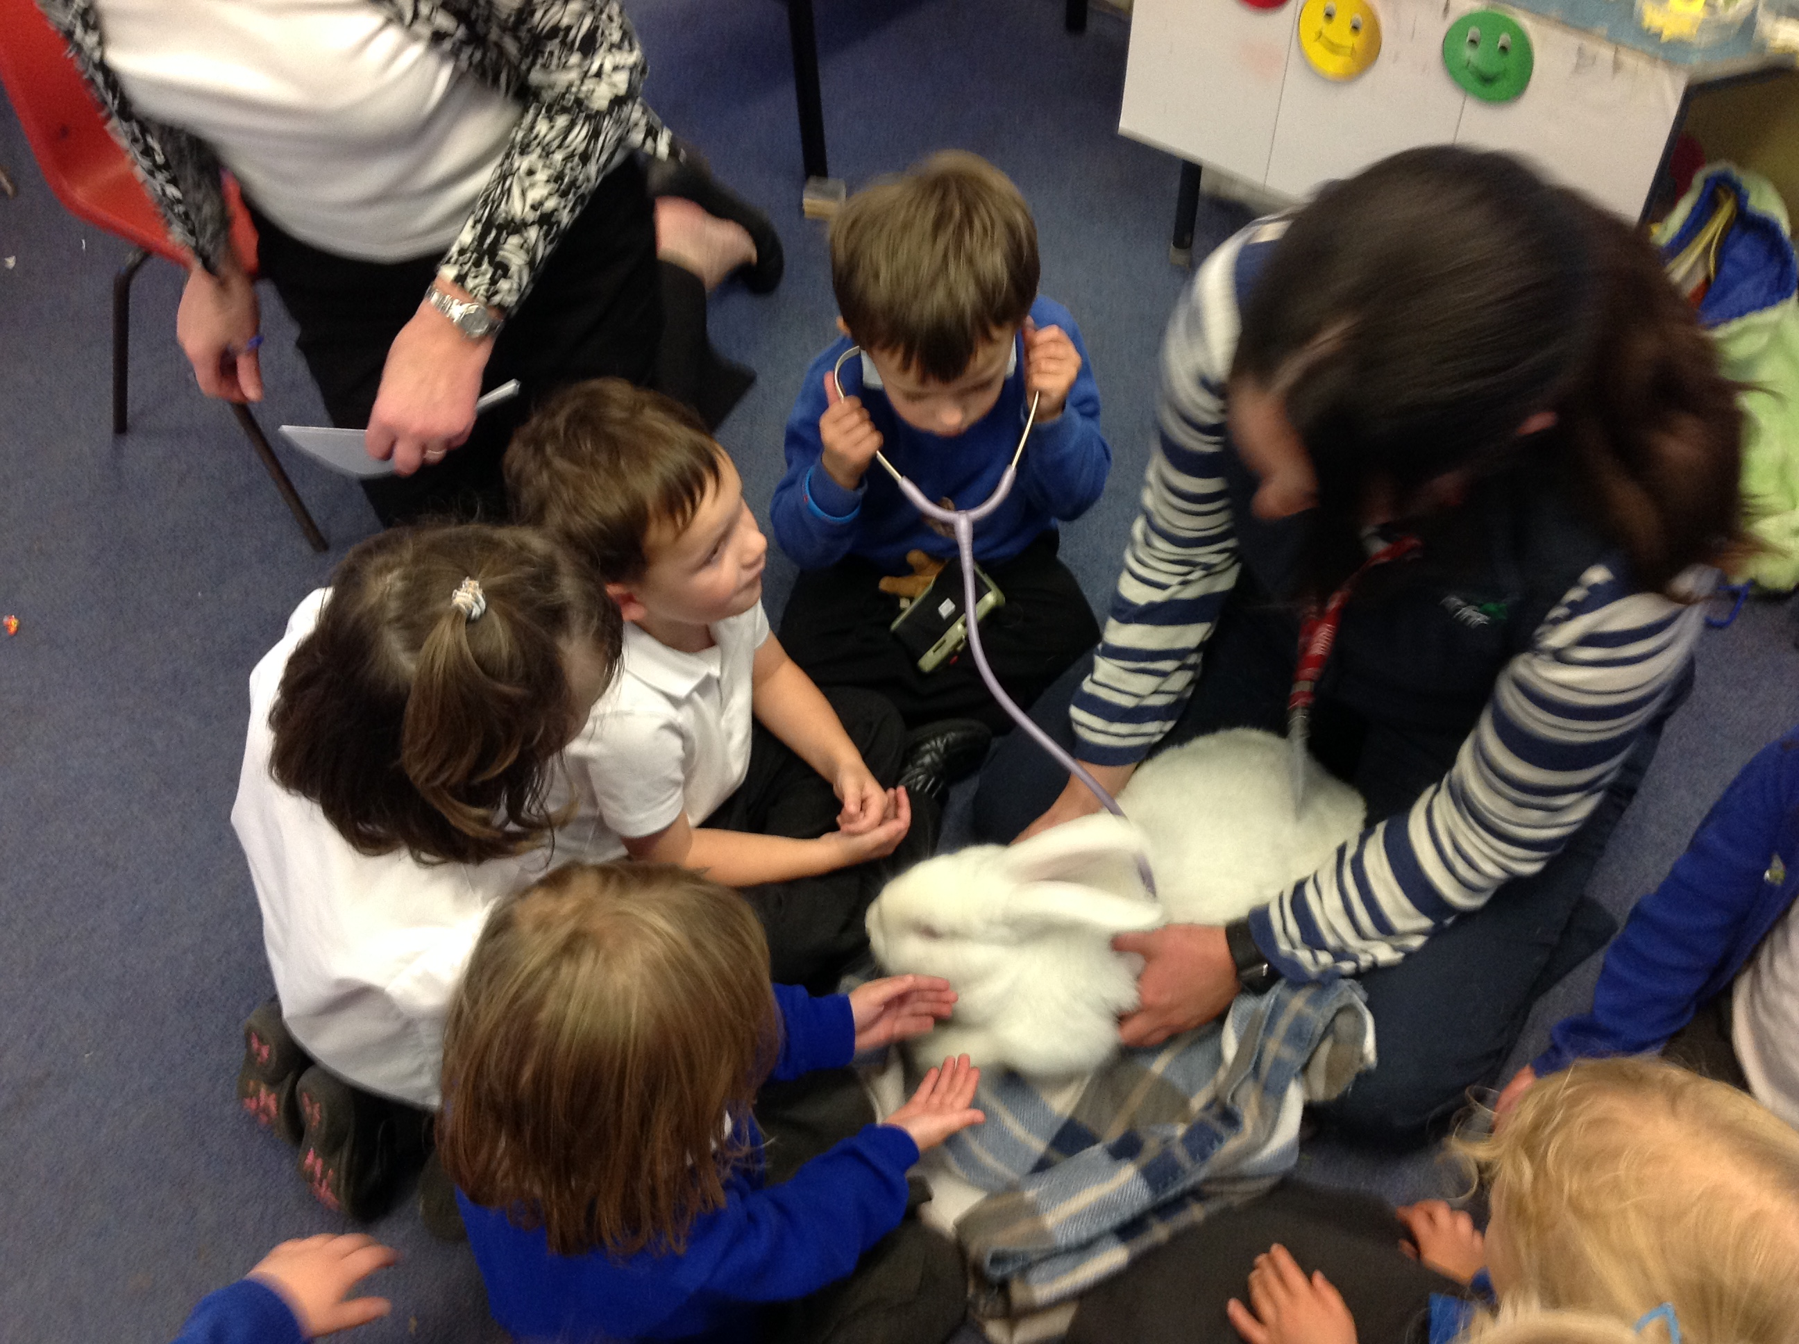

• Think critically

• Express opinions confidently

• Be self-reliant

• Be self-motivated

• Be self-disciplined

• Take responsibility

• Make choices within a moral context

• Have clear values and attitudes

• Be able to co-operate with others

• Make and sustain good relationships

• Have a healthy lifestyle

• Be safe

• Understand and be able to articulate British Values

Whole school systems emphasising praise, recognition and reward exist to promote and celebrate positive behaviour and sustained effort and hard work. Perhaps, most importantly, we want pupils to leave our school with feelings of self-confidence, self-worth and high self-esteem. We are committed to the health, safety and emotional well-being of all our pupils and staff and are proud to be recognised as a Healthy Child School having met national standards. The National Healthy Schools Programme supports the link between health, behaviour and achievement and is about creating healthy and happy children who do better in learning and life.

We have a School Parliament recognising the importance of pupils having a voice in decisions that affect them. The Parliament is made up of elected members from each class, and representatives from the staff. It represents the pupils and puts forward new ideas, suggestions and ways of solving issues. The children have recently reviewed the House Point system and the prizes given out for accumulation of points.

RELATIONSHIPS & SEX EDUCATION

Effective Relationships & Sex Education (R&SE) is crucial to developing and maintaining emotional and physical health. At Widewell Primary Academy, R&SE is provided through the Personal, Social and Health Education & Citizenship Framework. The curriculum for R&SE is planned to ensure pupils receive their sex education in the wider context of relationships, and are prepared for the opportunities, responsibilities and experience of adult life. We believe that the teaching of sex education should be complementary and supportive to the role of parents, and should have regard to parents’ views on its content and presentation. Our R&SE programme is designed to meet DFE guidance and is set within the context of the National Healthy School Programme (NHSP) to ensure effective provision. For Year 6 pupils Sex Education is provided by class teachers with the support of health professionals in a way that encourages pupils to consider morals and the value of family life.

As a school we have a legal duty to ensure that children are protected from teaching and materials which are inappropriate, having regard to the age, religion and cultural background of our pupils. Parents are informed in writing prior to the teaching of Sex Education and will be given the opportunity to see teaching materials to be used, and receive explanations of the way in which it is proposed to use them in the classroom Teachers are trained and appropriately supported, to be able to teach R&SE with confidence. Parents have the right to withdraw their children from all or part of any Sex Education provided, but not from teaching of the biological aspects of human growth and reproduction necessary under National Curriculum Science. If a parent wishes to withdraw their child they should put their request in writing to the Headteacher - a reason for this decision is not necessary.

**Early years curriculum**

The Early Years Foundation Stage (EYFS) Framework, sets out the standards for development, learning and care of children from birth to five. It is important that all children are given the opportunity to experience the best possible start to their education. We need to ensure that our children enter school having established solid foundations on which they can build. Children will start in our Nursery Class having had a range of different experiences. Within the Nursery Class and Reception Year, learning experiences of the highest quality are planned, considering children’s needs and achievements and the range of learning experiences that will help them make progress. Well-planned play is a key way in which children learn with enjoyment and challenge, both within the indoor and outdoor learning environments. The Foundation Stage prepares children for learning in Key Stage 1 and is consistent with the National Curriculum. In the Nursery Class and the Reception Year, the curriculum is planned and resourced to take children’s learning forward and to provide opportunities for all children to succeed in an atmosphere of care and of feeling valued. The curriculum for the Foundation Stage is designed to ignite children’s curiosity and enthusiasm for learning, and to build their capacity to learn, form relationships and thrive. The curriculum is planned in seven areas of learning and development; all areas are important and inter-connected. There are three prime areas which are:

• Communication and Language Development involves giving children opportunities to experience a rich language environment; to develop their confidence and skills in expressing themselves; and to speak and listen in a range of situations.

• Physical Development involves providing opportunities for young children to be active and interactive; and to develop their co-ordination, control, and movement. Children must also be helped to understand the importance of physical activity, and to make healthy choices in relation to food.

• Personal, Social and Emotional Development involves helping children to develop a positive sense of themselves, and others; to form positive relationships and develop respect for others; to develop social skills and learn how to manage their feelings; to understand appropriate behaviour in groups; and to have confidence in their own abilities. There are four specific areas through which the three prime areas are strengthened and applied. These specific areas are:

• Literacy Development involves encouraging children to link sounds and letters and to begin to read and write. Children must be given access to a wide range of reading materials (books, poems, and other written materials) to ignite their interest.

• Mathematics involves providing children with opportunities to develop and improve their skills in counting, understanding and using numbers, calculating simple addition and subtraction problems; and to describe shapes, spaces, and measures.

• Understanding the World involves guiding children to make sense of their physical world and their community through opportunities to explore, observe and find out about people, places, technology and the environment.

• Expressive Arts and Design involves enabling children to explore and play with a wide range of media and materials, as well as providing opportunities and encouragement for sharing their thoughts, ideas and feelings through a variety of activities in art, music, movement, dance, role-play, and design and technology.

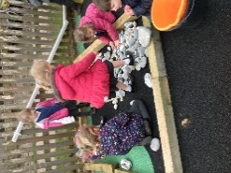 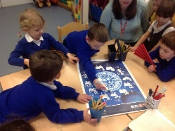 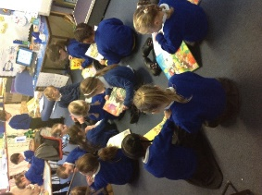

**Inclusion and equality**

At Widewell Primary Academy we are committed to ensuring equality of education and opportunity for all pupils, staff, parents and carers receiving services from the school, irrespective of race, gender, identity, disability, faith or religion or socio-economic background. We aim to develop a culture of inclusion and diversity in which all those connected to the school feel proud of their identity and able to participate fully in school life. The school recognises it has to make special efforts to ensure that all groups prosper.

The achievement of pupils is monitored by such factors as gender, mobility and home language and we use this data to support pupils, raise standards and ensure inclusive teaching. We tackle discrimination by the positive promotion of equality, challenging bullying and stereotypes and creating an environment which champions respect for all. As a school we believe that diversity is a strength, which should be respected and celebrated by all those who learn, teach and visit us. As a school we try to ensure that pupils with disabilities can play as full a part as possible in school life. We implement accessibility plans, which are aimed at:

• Increasing the extent to which pupils with disabilities can participate in the curriculum.

• Improving the physical environment of schools to enable pupils with disabilities to take better advantage of education, benefits, facilities and services provided.

• Improving the availability of accessible information to pupils with disabilities.

CATERING FOR THE NEEDS OF ALL CHILDREN

At Widewell Primary Academy we believe that every child is unique and special, and we aim to provide a broad and balanced curriculum for all. We are committed to developing cultures, policies and practices that are inclusive. We have systems to identify when children have barriers affecting their learning and tailor specific interventions to enable pupils to overcome their barriers. This practice of personalising learning applies to all pupils across the learning spectrum including pupils who are identified as academically more able. Children succeed highly at our school in many aspects. Excellence is encouraged and celebrated in all areas of learning and behaviour. Work is well planned, challenging and differentiated appropriately and the whole-school curriculum is planned to provide exciting and creative learning opportunities. Expectations are consistently high across the school and children are encouraged to be independent thinkers and learners, and to have enquiring minds.

Where children are identified as needing additional learning or behavioural support, the school adheres to the 2014 SEND Code of Practice. We ensure that each child’s needs are individually and appropriately catered for, and that any relevant outside agencies are involved in providing guidance and support. Through assessments and/or observations a teacher may feel a child needs to be placed on the Special Needs Register. With support from the Special Educational Needs Co-ordinator (SENCO), provision is carefully planned. Provision strategies to help support the child in class and notes from discussions with parents form a ‘Pupil Profile’. The SENCO is responsible for supporting, planning and monitoring interventions and pupil profiles. This monitoring is used to ensure systems are effective and impact positively on pupil progress. Following discussions with parents and carers, pupils may be placed onto the SEN Register at some point in their school career. For many, this involves a short burst of targeted intervention which may lead to them being removed again, while for others the support process is a longer one. In all cases our aim is to provide the very best education for pupils, allowing all children to fully achieve their potential. Our Policy for Inclusion and Special Educational Needs and Disability can be accessed via the school’s website.

**Safeguarding**

Widewell Primary Academy is committed to safeguarding and promoting the welfare of children and expects all staff and volunteers to share in this commitment. Staff work hard to maintain an environment where children feel safe and secure. The curriculum is designed to ensure opportunities for children to develop the skills they need to recognise and stay safe from abuse. Children know that they can approach any of the adults in school if they are worried and that they will receive a consistent supportive response.

We have a Safeguarding Policy which explains how the school works to ensure that children are thriving and safe. We take safeguarding and the protection of children very seriously. If we have any concerns about a child’s welfare it is the Headteacher’s responsibility, as Designated Person for Safeguarding, to contact Social Services. If you have any concerns about the well-being of a child please inform us in confidence immediately. The Deputy Headteacher should be spoken to in the Headteacher’s absence and the Chair of Governors can also be contacted via the school office should this be necessary.

In recognising our responsibilities for Safeguarding and Child Protection, as a school we:

• Have clear staff recruitment and selection procedures, ensuring that all staff (including volunteers) who have unsupervised access to children, have been appropriately checked for their suitability through the DBS procedure.

• Aim to raise awareness of child protection issues and equip children with the skills needed to keep them safe.

• Develop and implement procedures for identifying and reporting cases, or suspected cases of abuse.

• Support children who have been abused in accordance with his/her Child Protection Plan.

• Establish a safe and nurturing environment free from discrimination or bullying where children can learn and develop happily.

If you would like to know more about our policy or procedures for Safeguarding, please speak to the Headteacher who is our designated person for Child Protection.

At Widewell Primary Academy we believe that children learn best in a well-organised, calm and secure environment where purposeful and self-disciplined behaviour is expected. We want every child in our school to feel confident, happy and safe. As a caring school we have the highest of expectations in terms of learning, behaviour and attitudes, and encourage our children to develop similar beliefs in their own potential, together with pride in their achievement.

The aims of the school, and the rules of behaviour consistently promoted in each classroom, are ones that emphasise positive behaviour and collaboration in striving for excellence. These are embodied in the principles of our Code of Behaviour:

• Every pupil has an entitlement to learning without being distracted by the negative behaviour of others.

• Every child in our school is valued. Abuse of any kind will not be tolerated.

• We strive to develop the full potential of every individual in our school, therefore, we do not accept discrimination in any form.

• Everyone in our school community should be happy. Bullying is completely against our ethos and will be dealt with firmly and fairly if it occurs.

• All children should respect school property and the property of others.

Whole-school systems emphasising praise, recognition and reward exist to promote and celebrate sustained effort and hard work, and contributions towards the school community. All forms of bullying and harassment are considered to be unacceptable and are not tolerated within the school environment. All incidents will be taken very seriously and followed up in accordance with our Anti-bullying Policy which is available via the school’s website. The school’s abhorrence of such behaviours is communicated to pupils, parents and staff, for example through the curriculum, the prospectus and weekly newsletters, and staff training. All staff are expected to deal with any discriminatory incident that may occur. They are expected to know how to identify and challenge prejudice and stereotyping; and to support the full range of diverse needs according to a pupil’s individual circumstances.

As a school we believe bullying is best prevented through an ethos based on mutual respect and equality. The raising of children’s self-esteem and self-confidence is central to the work and life of the school. We recognise that in the school environment bullying can have a devastating effect on learning and the emotional health and well-being of pupils. Challenging bullying effectively will improve the safety and happiness of pupils, show that the school cares and make clear to children who bully that such behaviour is unacceptable. It is important to us that these children are given the support they need to change their behaviour as well as implementing the sanctions which follow any incidents. In addition, these benefits translate into improved life outcomes for pupils, a more satisfying working life for staff, and a more successful and inclusive school community.

MOBILE PHONES

We ask that all mobile phones are put away when you are in school and not used around other people’s children. We do allow parents to use their phones to take photographs of their children in performances etc but ask that you focus on your own child, as not all parents have given permission for their children to appear in photographs whilst at school.

VOLUNTEERS

We welcome parents and grandparents to work alongside the staff in school and such involvement is invaluable for all concerned. There is an open invitation for volunteers to let us know when they can come and how they can help. All volunteers working in school are required to have an enhanced Disclosure & Barring Service check (formerly Criminal Records Bureau or CRB).

**School uniform**

What a child wears to school reflects his/her learning. It also portrays the school’s ethos and shared positive values. We have a smart but simple uniform that we encourage all pupils to wear. This is a royal blue sweatshirt/jumper/cardigan, a white polo shirt/blouse and grey/black school trousers or skirt. Ties are worn by some pupils and add to the smartness of the uniform.

School uniform, including sweatshirts, ties, polo shirts and PE kit are sold at cost and can be purchased from the school office. All items of uniform should be clearly named. Children are asked to wear white/grey/black socks and sensible black shoes - not trainers, open toed sandals or high heels please.

Jewellery, other than watches, is not permitted and studs only are to be worn in pierced ears but must be removed for all PE.

PE & GAMES KIT

It is important for pupils to wear correct clothing for physical activities. For PE children need a royal blue t-shirt, navy blue shorts and trainers. Track suits, preferably royal blue, or fleeces may be worn for KS2 games during winter months. All clothing should be clearly labelled. Jewellery must not be worn for sporting activities and long hair should be tied back.

**Healthy Eating**

We are an accredited National Healthy School and are committed to promoting and monitoring healthy food at break and lunch times. Different teaching styles and learning opportunities are offered to pupils to develop their awareness and understanding of healthier eating and basic food safety practices

WATER

Research shows that our brains need water to stay active and alert. All children are encouraged to bring water into school daily, in a spill-proof plastic bottle that they can take home at night to rinse and refill. Children, parents and staff speak highly of the benefits.

SNACK TIME

You may like your child to have a mid-morning snack. We welcome fruit and vegetables, and would ask you not to send your child with chocolate, crisps or sweets of any kind. Children in the Foundation Stage and KS1 are provided with fruit every day as part of the National Fruit Scheme. All children may purchase a small bag of fruit each day for £1 per week, payable on a Monday, from the school kitchen.

SCHOOL MEALS

All pupils in Reception, Year 1 and Year 2 are offered a free school meal which are prepared freshly on site each day. Schools are legally required to provide meals that comply with the School Food Standards. These standards are intended to ensure that children get the nutrition they need across the whole school day and govern all food and drink on offer within the school. We work closely with parents to cater for any pupils with special dietary needs. Menus are supplied to parents in advance so that meals can be pre-ordered; parents can choose not to take-up a school lunch for their child, in which case children should bring a healthy packed lunch into school. Any packed lunches brought in to school should be healthy in content and we ask parents not to include sweets, chocolate, crisps or fizzy drinks.

**As we have a number of children and staff who suffer from nut allergies, we also ask that no products containing nuts are included in lunch boxes.**

One significant change in the new School Food Standards is that from January 2015, lower fat milk or lactose reduced milk must be available for drinking at least once a day during school hours. Milk will be offered free of charge to pupils entitled to free school meals, and to all pupils where it forms part of the free school lunch to infants.

If you think your child is eligible for free school meals, please collect a form from the school office because this could lead to support from the school in other areas of school life. It is therefore important that parents of Infant children inform us too so we can support you better from the start of your child’s time with us.

**Additional Information**

LOST PROPERTY

Naming all items reduces the risk! Any items of lost property are put in a central ‘Lost Property Box’ in the junior cloakroom - if your child has lost something then please check there. We do keep lost property for a reasonable period of time; but it is often difficult to identify items that are not named. Displays of lost property are made at the end of each term. Buying a ‘Sharpie’ pen to label your child’s clothes is a very worthwhile investment.

ABSENCE

If your child is unable to attend school or nursery for any reason please telephone or e-mail the school office to let us know. If your child has sickness or diarrhoea we ask that he/she does not return to school for 48 hours as this type of illness can be very infectious. To encourage high levels of attendance, certificates are awarded to children at the end of the Summer Term for 100% attendance. The school’s attendance data for 201/15 is included at the end of the Prospectus. Attendance is monitored regularly through the year by the Education Welfare Service.

PUNCTUALITY

The school day begins promptly at 8.45am and we ask that children arrive promptly to ensure a positive start to their learning. Please ensure your child is not late for school. Children who arrive late are asked to report to the school office on arrival. Any late attendance is recorded on the end of year school report to parents. This is also monitored by the Education Welfare Service and may lead to fines. If you have difficulty getting your children to school for exceptional reasons please contact our PSA as we may be able to help.

HOLIDAYS DURING TERM TIME

From 1 September 2013 new DfE regulations came into force regarding leave of absence for children from school. The current law does not give any entitlement to parents to take their child on holiday during term time. Any application for leave must be in exceptional circumstances and the Headteacher must be satisfied that the circumstances warrant the granting of leave. This is closely monitored by the city’s Education Welfare Team each half term.

TIMES OF THE SCHOOL DAY

Children should not arrive unaccompanied before 8.35 am as there is no-one available to supervise them. Football and other games are not allowed before school because of younger children and adults’ presence on the playground at this time. All children should be ready to go into their classroom by 8.45 am at the latest for a prompt start to the school day. The school gates are locked at 9.00 am and reopened at 3.20 pm. Nursery children should be collected from the nursery entrance at 11.45 am for those attending morning sessions, and at 3.30 pm in the afternoon.

MEDICAL & OTHER ISSUES

When children start school parents are asked to complete a form outlining any medical history including any allergies suffered, that we should be aware of. It is important that this record, including contact details, is kept up-to-date.

FIRST AID

Basic first aid is given at school when necessary by qualified First Aiders. If an accident needs hospital attention we will make every effort to contact parents. We ask parents to ensure all contact details are kept up-to-date so that we can contact you in an emergency. All injuries are recorded.

MEDICINES

The school has responsibility for the safety and welfare of pupils and regularly reviews arrangements to ensure that the medical needs of the pupils are met at school. There may be times when children attending school need to take prescribed medication. Any such medicines needed by a child during the school day should be brought to school in the smallest practicable amount by the parent/carer, not the pupil, and be delivered personally to the Administrative Officer or Headteacher. These medicines must be in the original bottle/packaging in which prescribed, clearly labelled with the:

• Pupil’s name

• Contents

• Dosage

• Date

Parents will be asked to complete a written request for the school to administer medication. Medicines in school are kept in a locked cupboard or in a refrigerator, away from the pupils. A record is kept of all medicines administered. Asthma inhalers are prescribed medication and parents are asked to complete a Parent Request Form on their child’s entry into school. As children may need immediate access to their inhaler (Blue Relievers) they are kept on the child’s person or in a safe and readily accessible place. Inhalers should be taken to sporting events and used prior to or during exercise if an episode of asthma occurs. Parents are encouraged to provide the school with full information about their child’s medical needs so that staff can exercise appropriate levels of care.

SUN PROTECTION

During warm summer months all children should have a named sun hat in school which they will be encouraged to wear when playing outside. School hats are available from the school uniform supplier or you may provide your own. School staff are not permitted to apply sun cream to children, but we would ask that you apply a long lasting sunscreen before school in sunny weather. Children may reapply their own sun cream which must be provided in a clearly named container and should not be shared with other children.

SMOKING

We operate a no-smoking policy - smoking is not permitted anywhere within the school or grounds; this includes the use of e-cigarettes.

MONEY

We aim to become a cashless school and encourage parents to make use of Parent Pay in the first instance. If you have to send cash to school please ensure that all monies are in a sealed envelope marked with your child’s name, amount and the purpose of the money. All monies should be given to the class teacher or teaching assistant.

COMPLAINTS

Any complaints about school matters should first be discussed with class teachers or brought to the attention of the Headteacher. If the complaint is not resolved, a formal complaint may be made firstly to the Governing Body and secondly to the Department for Education. The procedure to register a complaint is available from the school’s Administrator.

CHARGING POLICY

At Widewell Primary Academy we are constantly seeking to enrich the children’s learning experiences through trips; by inviting visitors and experts to talk to the children; and by running activities and workshops. The children always feedback that these activities bring learning to life and are some of their most memorable experiences of primary school. Where possible, teachers look for free activities or apply for grants that will enable the school to provide enrichment opportunities at no cost to families. Where we have to charge it is important that the money collected matches the cost of the activity, otherwise these cannot take place. We are able to support pupils eligible for free-school meals (unfortunately this does not include Universal Free School Meals given to all infant children) with some remission of charges for these additional opportunities, which is why it is important you apply for free school meals if your circumstances mean you are eligible.

FAMILY SUPPORT

We have a dedicated Parent Support Advisor who is working closely with parents, pupils, staff and the family workers (Jenn, Zoe and Fran) from The Ark, to give the best possible support to our families. There are a variety of different activities parents and pre-schoolers can join in with during the week at The Ark (in the Naval Welfare House in but you can also make an appointment for more individual or confidential support.

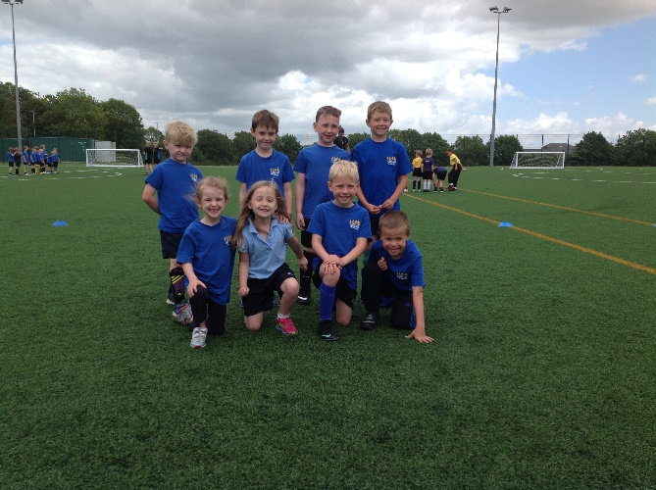 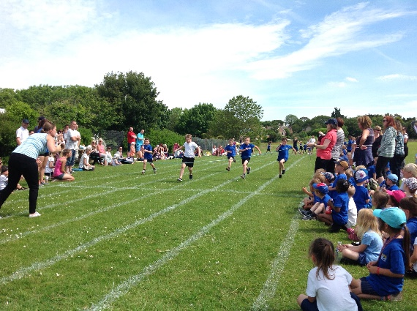 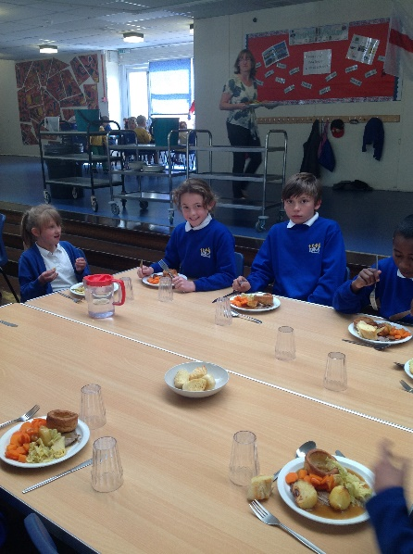

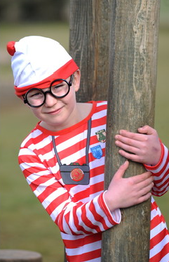 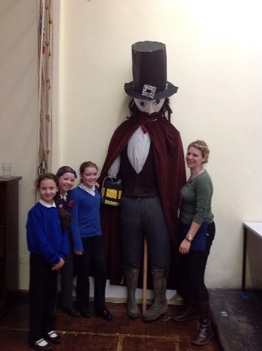 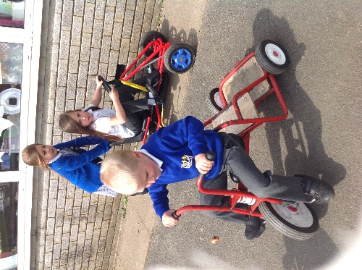

**Staffing**

Everyone who works at Widewell Primary Academy has an important part to play and is a valued member of staff. The emphasis at the school is on team work.

|  |  |  |  |
| --- | --- | --- | --- |
| Mrs C Prynne | Headteacher | | Designated Child Protection Officer / Geography |
| Mrs B Holder | Deputy Headteacher + Class Teacher | | Deputy Child Protection Officer / Maths / MFL |
|  |  | |  |
| Mrs T Hambly  Mrs H Gifford  Mrs L Giles  Mrs E Heard  Mrs J Kerr  Mrs R Robinson  Miss V Williams  Miss C Smith  Mrs S Clewer | Class Teacher  PPA & Management release time (0.6)  Class Teacher  Class Teacher  Class Teacher  Class Teacher  Class Teacher + SENCO  Class Teacher  Class Teacher (0.5) | | Art  D&T  Science  Music  English  RE / PSED  Computing  PE  History |
|  |  | |  |
| Mrs K Edmonds  Miss A Rockey | Senior Administrator  Administrative Assistant | |  |
|  |  | |  |
| Miss E Clarke  Mrs E Dunne  Mrs D Jarvis  Mrs A Pegg  Mrs A Rebhan  Mrs L Tucker | Speech & Language Therapist  Teaching Assistant + ELSA TA (0.6)  Teaching Assistant  Teaching Assistant  Teaching Assistant (0.5)  Teaching Assistant | |  |
| Miss L Tunney  Mrs S Turner  Mrs J Waters  Miss R Winters | Teaching Assistant  Teaching Assistant + ELSA  Teaching Assistant  Teaching Assistant | |  |
| Mrs M Wright  Mrs L Trend | Teaching Assistant  Parent Support Adviser | |  |
|  |  | |  |
| Mr A McQuillan  Mrs L Tucker | Caretaker  Cleaner | |  |
| Mrs J Keith | Cleaner | |  |
|  |  | |  |
| Mrs S Roberts | Catering | |  |
| Mrs J Keith | Catering | |  |
|  |  | |  |
| Mrs K Wills | Senior Mealtime Assistant | | |
| Mrs J Lloyd  Mrs A Pegg  Mrs L Tucker | Catering/Mealtime Assistant  Mealtime Assistant  Mealtime Assistant |  | |
| Mrs J Waters  Mrs B Ingram | Mealtime Assistant  Mealtime Assistant |  | |

**The school day**

NURSERY

Morning Session

08.45 Start of Session

11.45 End of Session

Afternoon Session

12.30 Start of Session

15.30 End of Session

RECEPTION - YEAR 6

08.45 Start of School Day

10.15 Morning Break

10.30 Back to Classes

12.00 Lunch

13.00 Start of Afternoon Session

14.15 - 14.30 KS1 Play Time

15.30 End of School Day

**Statutory assessment & test results 2016**

**Attainment**

|  |  |  |
| --- | --- | --- |
| Writing (TA), Reading and Maths Test | Expected Level | High Level |
| School | 52% | 4% |
| National | 53% | 5% |

|  |  |  |
| --- | --- | --- |
| Writing (Teacher Assessed) | Expected Level | High Level |
| School | 74% | 7% |
| National | 74% | 15% |

|  |  |  |
| --- | --- | --- |
| Reading | Expected Level | High Level |
| School | 59% | 22% |
| National | 66% | 19% |

|  |  |  |
| --- | --- | --- |
| Maths | Expected Level | High Level |
| School | 59% | 4% |
| National | 70% | 17% |

|  |  |  |  |
| --- | --- | --- | --- |
| Grammar, Punctuation and  Spelling | Expected Level | High Level |  |
| School | 56% | 19% |  |
| National | 72% | 23% |  |
|  |  |  |  |
| Average scaled score in test | Maths | Reading | Grammar, Punctuation and  Spelling |
| School | 100 | 101 | 102 |
| National | 103 | 103 | 104 |

**Progress**

|  |  |  |  |
| --- | --- | --- | --- |
|  | Writing | Reading | Maths |
| School | 1.9 | 1.6 | -0.4 |
| National | 0 | 0.5 | 0.3 |

**Other information**

RATES OF AUTHORISED & UNAUTHORISED ABSENCE

We are required by law to publish details of absence rates for

2015-2016. For Reception - Year 6 these were:

Attendance Rate 95.7%

Authorised Absence 3.8%

Unauthorised Absence 0.5%

School attendance is above the National Average.

**Highlights of 2016-2017**

Activities and events change from year to year; this information is designed to give you a flavour of what goes on in school.

VISITORS

• Dawn Getley

• Life Education Caravan

• Plymouth Aquarium

• Members of the Royal Navy helping with a Y6 STEM project

• Marjon students running Bushcraft sessions for Y4 and Y5

• Marjon staff running an archaeological dig with Y5 and Y6

• Chinese New Year speakers

TRIPS

• Half Marathon

• Bull Point for Junior Life Skills

• Plymouth University for maths days

• Brickfields Primary Athletics

CHARITY EVENTS

• Children in Need

• Retiring collections for Prader-Willi Syndrome association

• Comic Relief

• Harvest Festival collection for Plymouth Food Bank

COMMUNITY

• Harvest Festival

• Christingle

• HKC Heroes events throughout Plymouth

• Choir singing at the switching on of the Christmas Lights

• Easter Breakfast

OTHER EVENTS

• Book Fair & World Book Week

• Science Week

• Infant Nativity

• Y3, 4, 5 Show ‘Happy Ever After!’

• Music exams for brass instruments

• Force 8 workshops for service children

• Y5 creating a Key0Hole garden