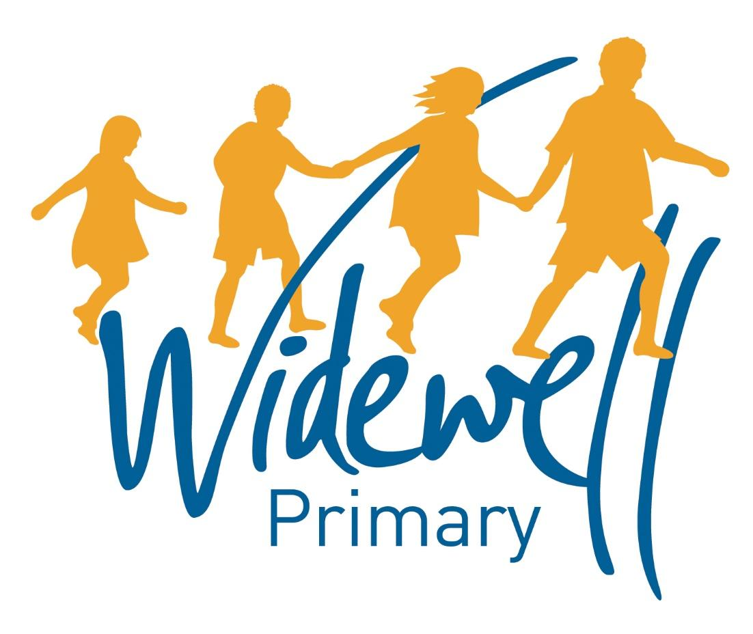

Foundation Stage
Homework Card
Summer Term 2

Name _________________________________
Class: Robin
Reading is starred and must be completed each week as this supports your child’s learning in class.

Set – Due in: | 9.6.17-16.6.17 |  | 16.6.17-23.6.17 |  | 23.6.17-30.6.17
Reading  At least 5 times each week | Please record reading in the Reading Record. |  | Please record reading in the Reading Record. |  | Please record reading in the Reading Record.
 | Reading Record completed (home) |  | Reading Record completed (home) |  | Reading Record completed (home)
 | Reading Record checked (school) |  | Reading Record checked (school) |  | Reading Record checked (school)
Sounds  Talk Time | X  Describe your favourite sea creature |  | -ng (thing, string)  Look at images of sharks and find out some shark facts |  | -nk (think, sink)  Look in your fridge or freezer. Do you have any food from the sea?
Maths | Look at a top or shirt and count how many buttons you have on it. |  | How many fish can you draw in 1 minute? |  | How many tentacles does an octopus have?
Topic activity  (If you have any seaside or navy related pictures can you please bring them in) | Can you design your favourite sea creature? |  | What can you find out about seahorses? |  | Can you make something with a shell?
Wow Activities!
Let us know what else you’ve achieved this week.

30.6.17-7.7.17 |  | 7.7.17-14.7.17
Please record reading in the Reading Record. |  | Please record reading in the Reading Record. |  | Reading  At least 5 times each week
Reading Record completed (home) |  | Reading Record completed (home)
Reading Record checked (school) |  | Reading Record checked (school)
m a s d  Can you make some words with the sounds? |  | t i n p  Can you make some words with the sounds? |  | Sounds  Word Time
Ask an adult for a handful of 1p coins and count them together. |  | How many soft toys do you have? |  | Maths
Can you find out what food we get from the sea? |  | Can you make a sunny seaside picture? |  | Topic activity
Wow Activities!
Let us know what else you’ve achieved this week

The topic activity is optional and you may choose to complete it as it will also help your learning in your class topic this term.

Wow activities can be filled in by you to show us what else you do outside school e.g. taking part in a club; cooking a meal with your family; building a den; playing an instrument.

Thank you for your support.

