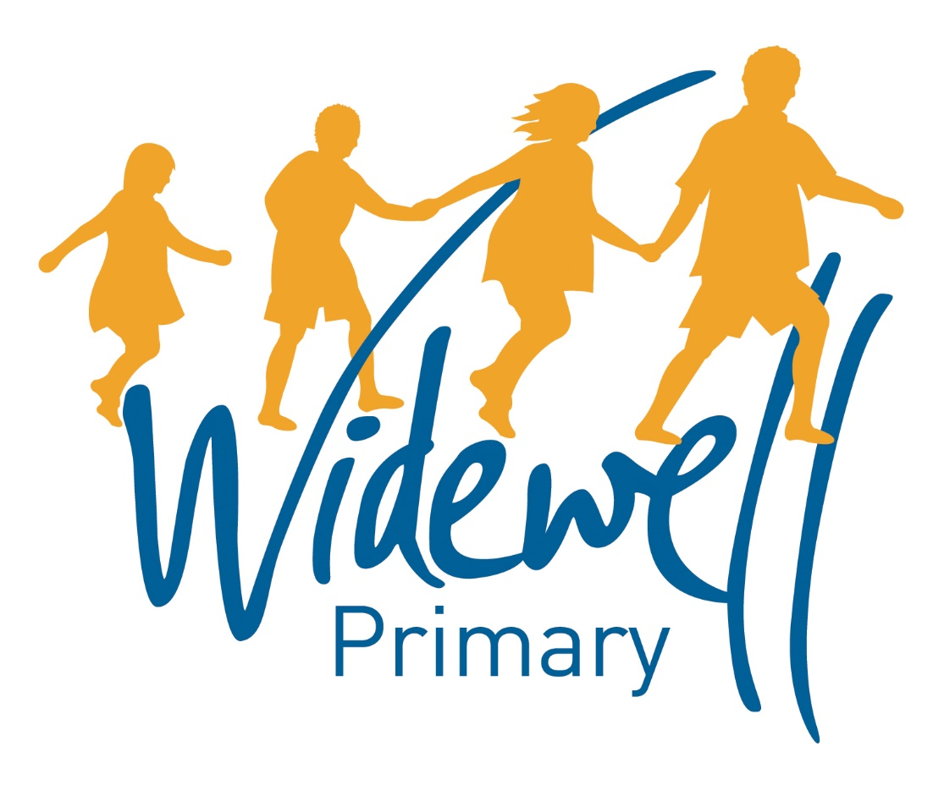

Foundation Stage
Homework Card
Autumn Term 1

Name _________________________________
Class: Robin
Reading is starred and must be completed each week as this supports your child’s learning in class.

Set – Due in: | 8.9.17-15.9.17 |  | 15.9.17-22.9.17 |  | 22.9.17-29.9.17
Reading  At least 5 times each week | Please record reading in the Reading Record. |  | Please record reading in the Reading Record. |  | Please record reading in the Reading Record.
 | Reading Record completed (home) |  | Reading Record completed (home) |  | Reading Record completed (home)
 | Reading Record checked (school) |  | Reading Record checked (school) |  | Reading Record checked (school)
Sounds and  Talk Time | Tell an adult about something you have really enjoyed playing with at school. |  | Go over your favourite nursery rhymes with an adult. |  | M  How many things can you find with that sound?
Maths | Who can do the longest superhero jump in your family? |  | Use your super hero stop watch. How many jumps can you do in 30 seconds?  How many in 1 minute? |  | Use your superhero x ray vision to recognise numbers in your environment.
Topic activity | My super family  Can you create something to tell us about your family (photos who`s who) |  | Can you make a superhero cape? |  | Can you research all about your favourite superhero and tell your class about it?
Wow Activities!
Let us know what else you’ve achieved this week.

29.9.17-6.10.17 |  | 6.10.17-13.10.17 |  | 13.10.17-20.10.17
Please record reading in the Reading Record. |  | Please record reading in the Reading Record. |  | Please record reading in the Reading Record. |  | Reading  At least 5 times each week
Reading Record completed (home) |  | Reading Record completed (home) |  | Reading Record completed (home)
Reading Record checked (school) |  | Reading Record checked (school) |  | Reading Record checked (school)
a  Can you make a picture with lots of a things? |  | s  Can you make a snake or sun? |  | d  How many different d pictures can you find? |  | Sounds
Look at some coins with your parents. Can you use your super powers to sort them in different ways? |  | Can you use 2D shapes to make a superhero picture? |  | How many arms and legs does your superhero family have altogether? |  | Maths
Can you create your own super villian ?  What evil powers do they possess? |  | Can you use your super senses to collect some signs of Autumn? |  | Can you record a sound or video clip of you singing a superhero song? |  | Topic activity
Wow Activities!
Let us know what else you’ve achieved this week

The topic activity is optional and you may choose to complete it as it will also help your learning in your class topic this term.

Wow activities can be filled in by you to show us what else you do outside school e.g. taking part in a club; cooking a meal with your family; building a den; playing an instrument.

Thank you for your support.

