Set – Due in: | 3.11.17-10.11.17 |  | 10.11.17-17.11.17 |  | 17.11.17-24.11.17
Reading  At least 5 times each week | Please record reading in the Reading Record. |  | Please record reading in the Reading Record. |  | Please record reading in the Reading Record.
 | Reading Record completed (home) |  | Reading Record completed (home) |  | Reading Record completed (home)
 | Reading Record checked (school) |  | Reading Record checked (school) |  | Reading Record checked (school)
Sounds | i  What begins with the i sound? |  | n  How many n things can you find? |  | P  Can you make a picture with P things?
Maths | Can you look at money in your house?  Who can you play shops with? |  | Can you count all the beds in your house? |  | Can you find any numbers in your street?  Do you recognise any of the numbers 1 2 3 4 and 5?
Topic activity | Please can you make a firework for our class bonfire display? |  | Have you got any things in your house that shine in the dark? |  | Can you talk about the things you like to celebrate as a family?
Wow Activities!
Let us know what else you’ve achieved this week.

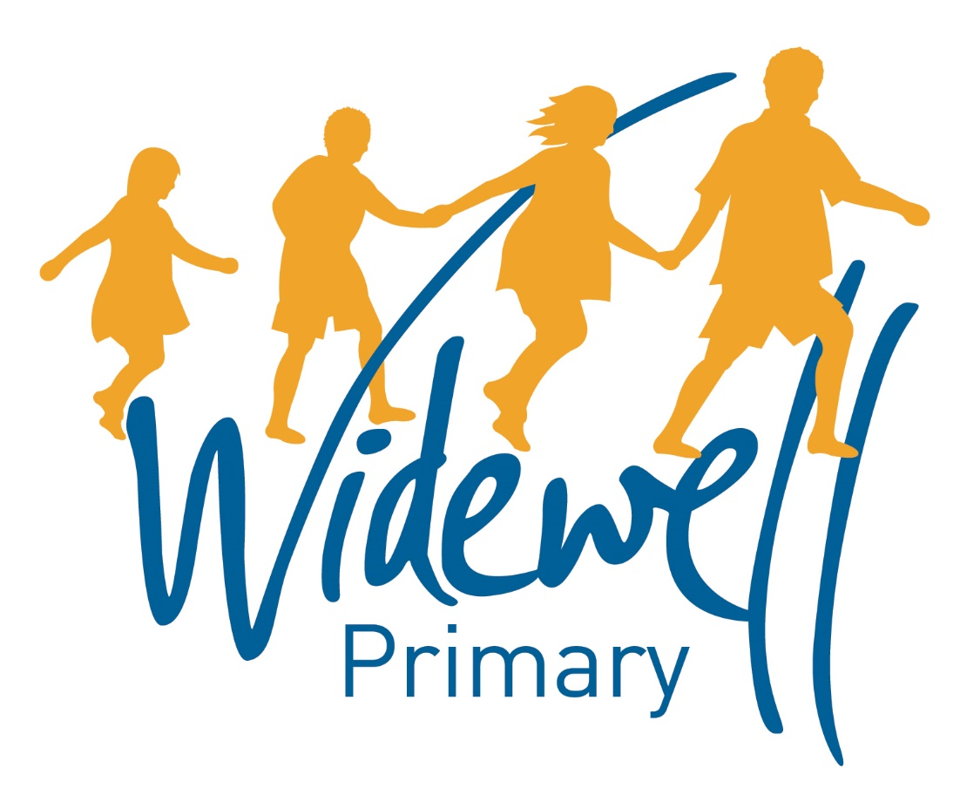

Foundation Stage
Homework Card
Autumn Term 2

Name _________________________________
Class: Robin
Reading is starred and must be completed each week as this supports your child’s learning in class.

24.11.17- 1.12.17 |  | 1.12.17-8.12.17 |  | 8.12.17-15.12.17
Please record reading in the Reading Record. |  | Please record reading in the Reading Record. |  | Please record reading in the Reading Record. |  | Reading  At least 5 times each week
Reading Record completed (home) |  | Reading Record completed (home) |  | Reading Record completed (home)
Reading Record checked (school) |  | Reading Record checked (school) |  | Reading Record checked (school)
g  What starts with g? |  | O  Can you find lots of o pictures? |  | Can you remember all our sounds this term?  m a s d  t i n p  g o |  | Sounds
Can you use things from your bedroom to make a repeated pattern? |  | Can you find some different size choose and order them from smallest to biggest. |  | How many cups of water fill will fill a small saucepan? |  | Maths
What do you notice if you go on a family walk on a cold day? |  | Can you make a special Christmas list for Father Christmas? |  | If you have been busy baking could you please take a photo and bring the photo in to show us. |  | Topic activity
Wow Activities!
Let us know what else you’ve achieved this week

The topic activity is optional and you may choose to complete it as it will also help your learning in your class topic this term.

Wow activities can be filled in by you to show us what else you do outside school e.g. taking part in a club; cooking a meal with your family; building a den; playing an instrument.

Thank you for your support.

