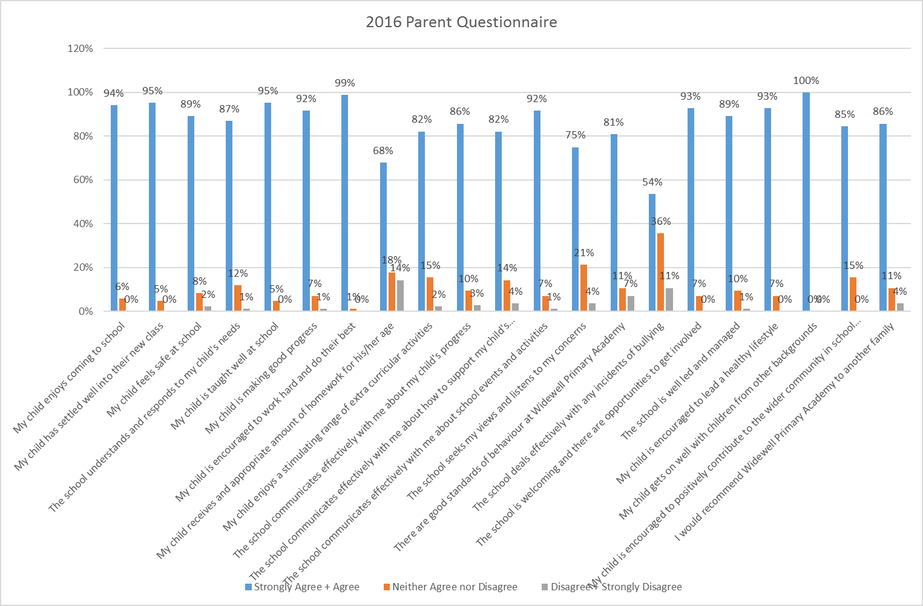

24th November 2016
Dear Parents and Carers,
On the reverse of this letter you can find the results of the Parent Questionnaire, which was completed earlier this term at Parents’ Evenings. Whilst the results remain overwhelmingly positive you have identified areas in which we need to continue to improve.
14% of you still think your child is not receiving the appropriate amount of homework for their age. In discussion at the Parents’ Evenings, some teachers have reported to me that some parents did not understand that the topic work activities are optional, despite this being written on the back of each card. I know this is not the only issue some infant parents have though and, having discussed the matter with the teachers, we have agreed that reading 5 times each week will remain a compulsory expectation for every child in the school. Spelling and maths activities will still be added to the cards each half term, so you can help your children with them if you wish, but the compulsory star will be removed. Weekly test results will continue to be recorded on the cards each week so you are aware of how your child is doing in the tests. I must emphasise that you may see a dip in your child’s performance as a result, as there really is no more time in the day for additional practice in school on top of what is already done in daily English and maths lessons.
It is difficult to respond to comments that were made on some questionnaires in response to the 7% of parents who don’t feel we have good standards of behaviour and the 11% of parents who do not feel we deal with issues of bullying effectively, because of confidentiality for individual children. I can assure you that all incidents are taken very seriously, dealt with and reported to the governors at every governors meeting during the term. A lot of work goes on behind closed doors to help both the victims and the bully. This is frequently done through our trained Emotional Literacy Support Assistant (ELSA) TAs; through sessions with Lorna Trend, our PSA; through report cards being shared between parents and school; through Sue Thompson, our Educational Psychologist; Jo Dale, our learning Mentor. I have also written or phoned parents of children who have made very poor choices with their behaviour at times, in an attempt to work together to help the child make the necessary improvements as quickly as possible. From the nature of the types of incidents involved this is not something that should become public knowledge. It is a private matter between the school and the family and will always remain so. It is unfortunate that any incidents occur, although this has lessened considerably over the last two years, and that you only get to hear about that side of things, but we are unable inform you of the specific steps we are taking to make a lasting difference to all of the children here.
I have tried to give you information about the major negative areas that have been highlighted and hope this information is useful. If you would like to give any further feedback please email the school Widewell.Primary.School@plymouth.gov.uk, write to me or fill in a form at the office and I will get back to you.
Kind regards
Claire Prynne
Headteacher

